Visoka škola strukovnih studija za

informacione i komunikacione

tehnologije

**CarRent**

<http://www.carrent2020.epizy.com/?i=1>

Aleksandar Madić 2/18

Smer: Internet tehnologije

Modul: Web programiranje

Predmet: Praktikum iz Web programiranja PHP

Sadržaj

1. Uvod 3

1.1 Korišćeni programski jezici 3

1.2 Opis funkcionalnosti 3

1.3 Template 4

2. Organizacija 13

2.1 Šema baze podataka 13

2.2 Mapa sajta 14

2.3 Struktura projekta 15

2.4 Opis stranica sajta 22

2.4.1 index strana 22

2.4.2 cars strana 22

2.4.3 carDetails strana 24

2.4.4 about strana 27

2.4.5 autor strana 28

2.4.6 contact strana 28

2.4.7 user strana 28

2.4.8 admin strana 30

3. Kodovi 35

3.1 PHP 35

3.1.1 index.php 35

3.1.2 config/connection.php 38

3.1.3 config/config.php 41

3.1.4 models/account/login.php 42

3.1.5 models/account/register.php 44

3.1.6 models/booking/canceluserBook.php 46

3.1.7 models/booking/getAll.php 47

3.1.8 models/booking/handleBook.php 48

3.1.9 models/booking/handleBookCancel.php 50

3.1.10 models/brands/delete.php 51

3.1.11 models/brands/getAll.php 52

3.1.12 models/brands/getSingle.php 52

3.1.13 models/brands/insert.php 53

3.1.14 models/brands/update.php 55

3.1.15 models/cars/carDetails.php 56

3.1.16 models/cars/delete.php 59

3.1.17 models/cars/filterCars.php 60

3.1.18 models/cars/filterFromIndex.php 63

3.1.19 models/cars/functionsCars.php 64

3.1.20 models/cars/getAll.php 65

3.1.21 models/cars/getSingle.php 65

3.1.22 models/cars/handleBooking.php 67

3.1.23 models/cars/insert.php 69

3.1.24 models/cars/update.php 76

3.1.25 models/reviews/changeState.php 80

3.1.26 models/reviews/getAll.php 81

3.1.27 models/reviews/userDelete.php 82

3.1.28 models/reviews/userInsert.php 83

3.1.29 models/reivews/userUpdate.php 84

3.1.30 models/functions.php 85

3.1.31 models/initApi.php 90

3.1.32 models/createExcel 91

3.1.33 models/createWord.php 92

3.1.34 models/initLoad.php 93

3.1.35 models/statsLog.php 94

3.1.36 views/about.php 95

3.1.37 views/adminPanel.php 97

3.1.38 views/author.php 98

3.1.39 views/carDetails.php 99

3.1.40 views/cars.php 106

3.1.41 views/contact.php 108

3.1.42 views/index.php 110

3.1.43 views/login.php 114

3.1.44 views/logout.php 115

3.1.45 views/profile.php 115

3.1.45 views/register.php 116

3.2 JS 118

3.2.1 main.js 118

3.2.2 admin.js 147

# Uvod

## 1.1 Korišćeni programski jezici

Za izradu sajta korišćene su sledeće tehnologije:

* PHP, MySQL
* HTML 5, CSS 3, Bootstrap
* JavaScript, jQuery, AJAX
* PHPMailer
* Visual studio code

## 1.2 Opis funkcionalnosti

* Registracija i logovanje korisnika uz provere na serverskoj i klijentskoj strani
* Dinamičko ispisivanje menija na svim stranicama iz baze
* Dinamičko ispisivanje automobila iz baze
* Korisnik ima mogućnost da posalje zahtev za iznamljivanje auta, admin treba da odobri u zavisnoti da li je taj auto već iznajmljen za dati datum
* Korisnik ima mogućnost da napiše svoju recenziju samo za automobile koje je iznajmio
* Mogućnost filtriranja automobila putem ajaxa, sa paginacijom
* Statistika pristupa stranicama u txt fajlu
* Logovanje gresaka u log fajl
* Kontakt stranica kojom je omogućeno kontaktiranje admina preko PHPMailera
* Sve forme su proverene i na klijentu i na serveru
* Admin ima da izvrsi CRUD operacije nad automobilima, brendovima, da pogleda statistiku pristupa stranicama, da upravlja iznamljivanjem auta, da izabere koje recenzije ce se prikazivati na stranici
* Export podataka o autoru u word fajl na stranici o autoru
* Export podataka iz baze o automobilima u excel fajl na admin stranici
* Na stranicama admin i user, klikom na ajaxom se dohvata sadrzaj u zavisnoti sta se odabere od linkkova; tako da se ne refresh-uje stranica
* Obrada grešaka, upisavanje u log fajl errors

## 1.3 Template

Index strana

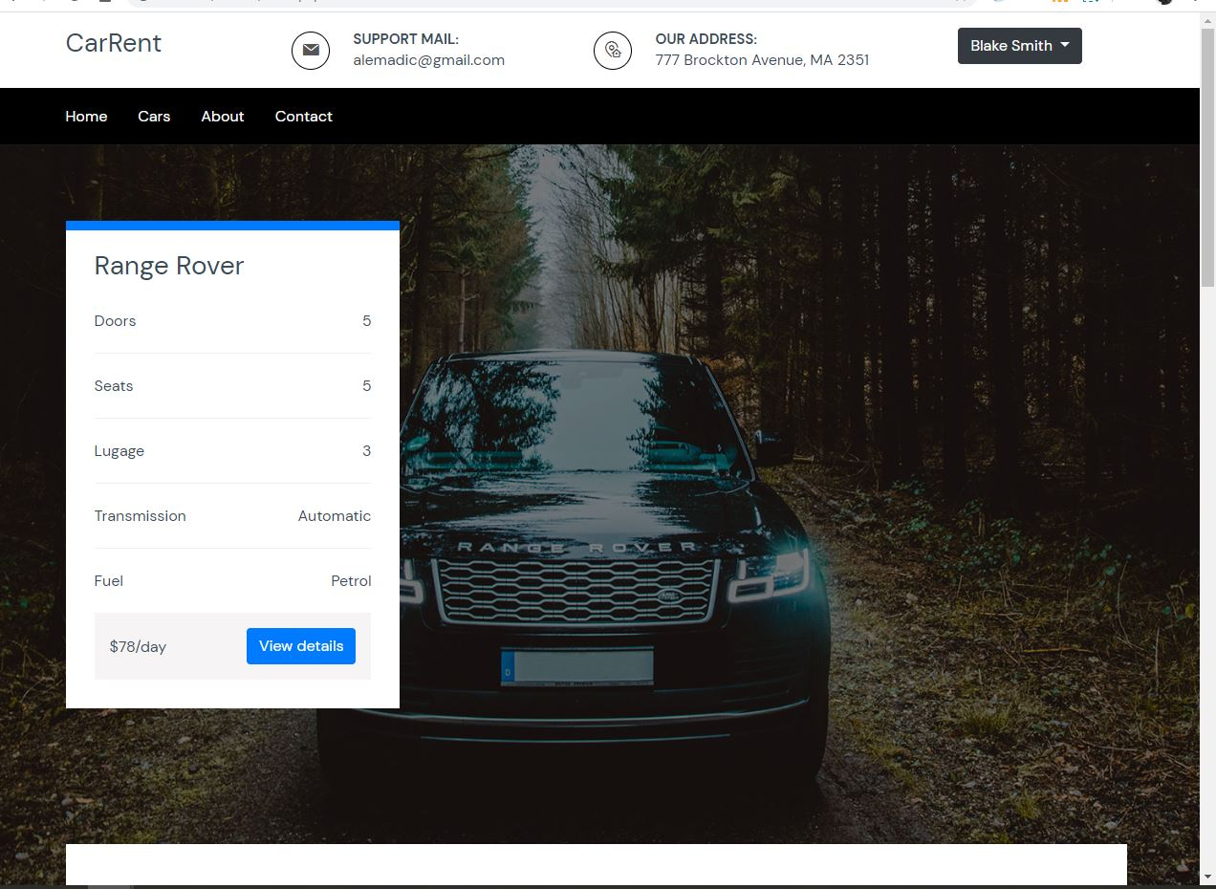

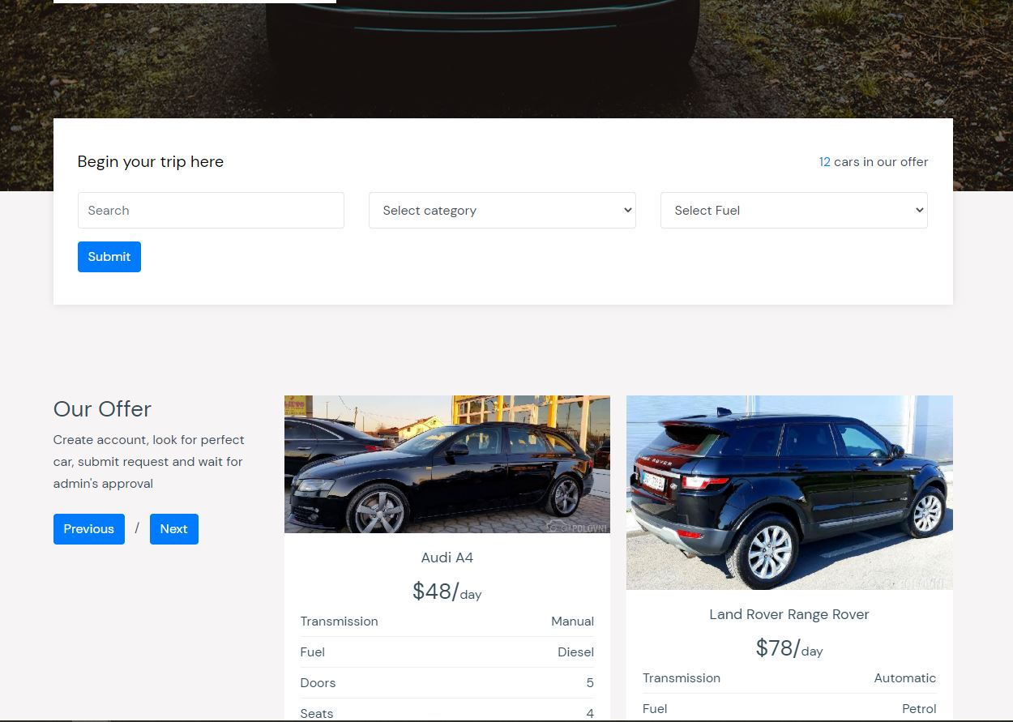

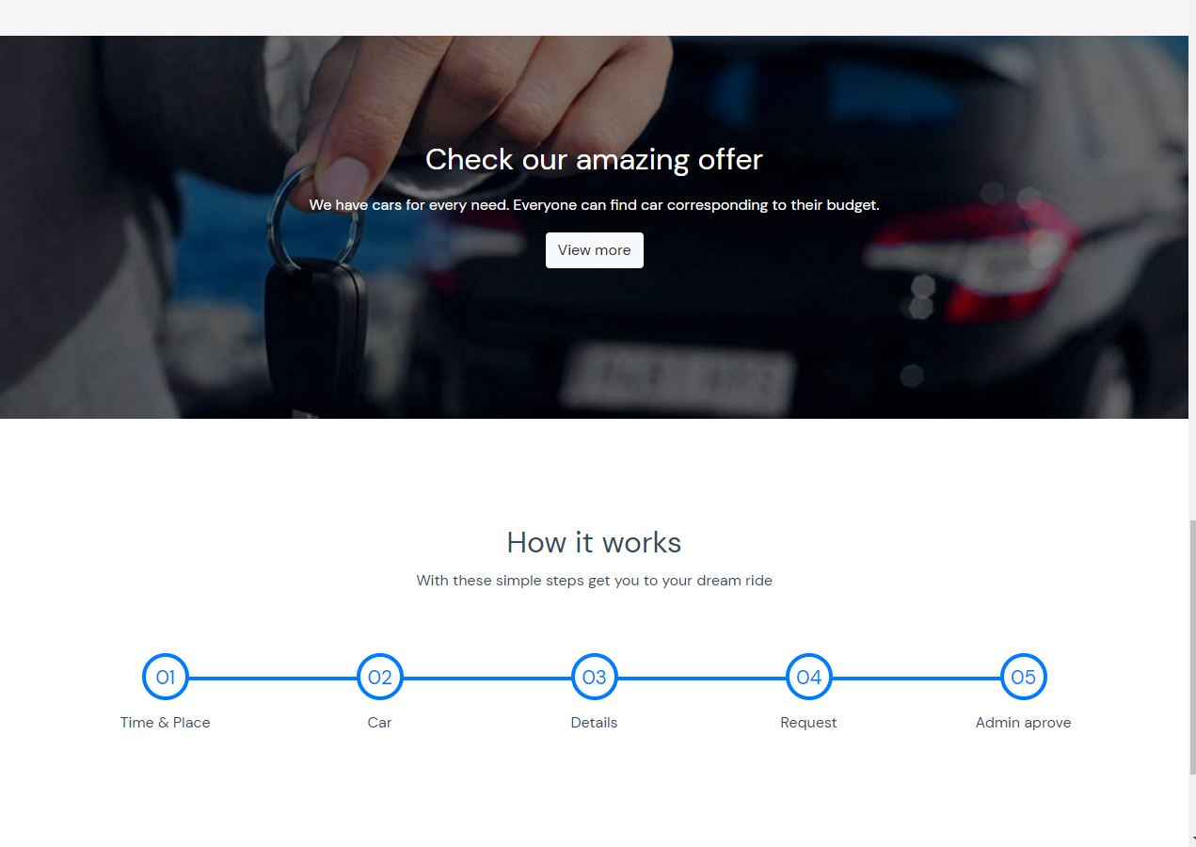

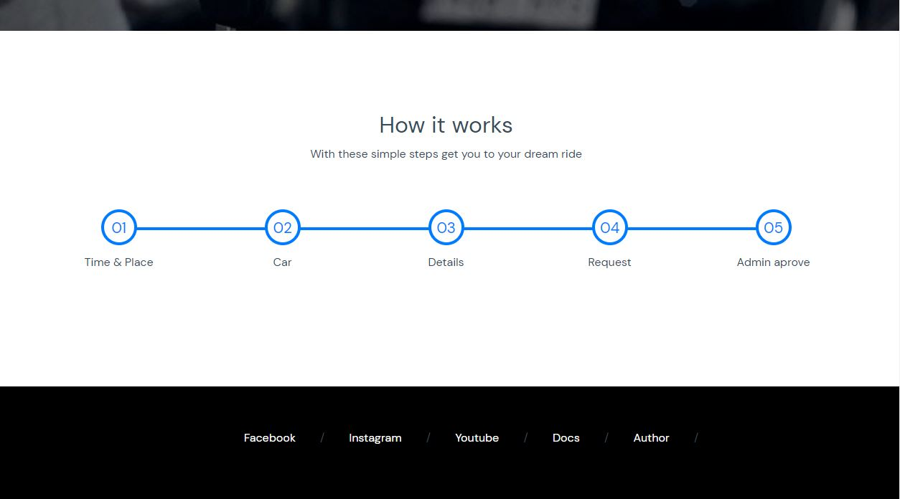

Cars strana

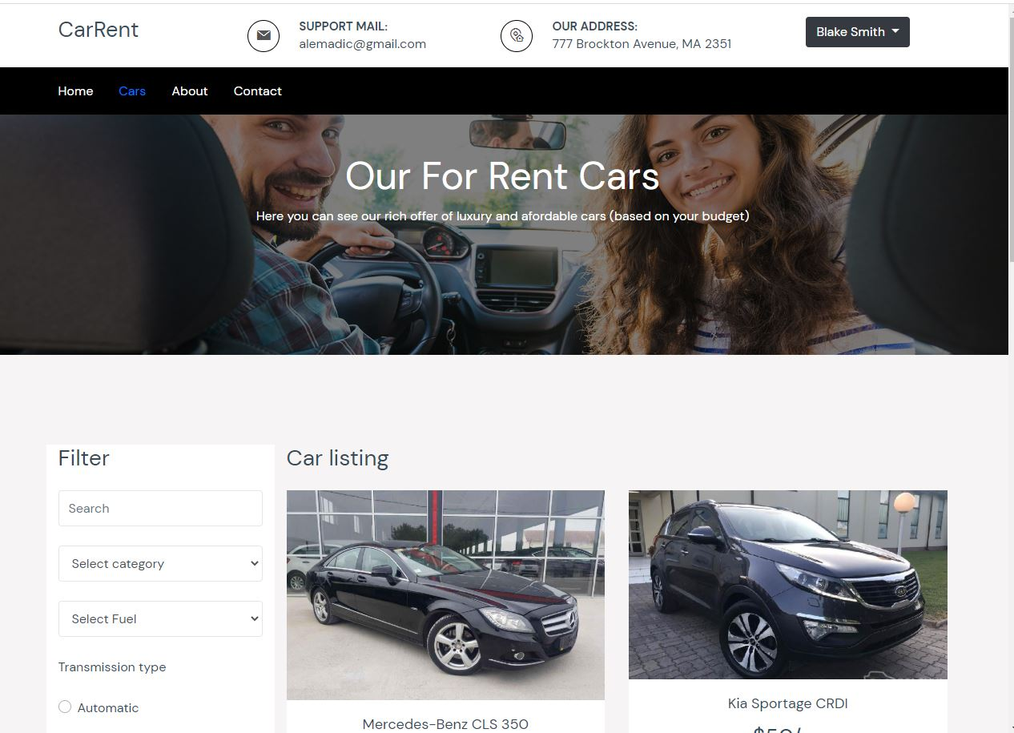

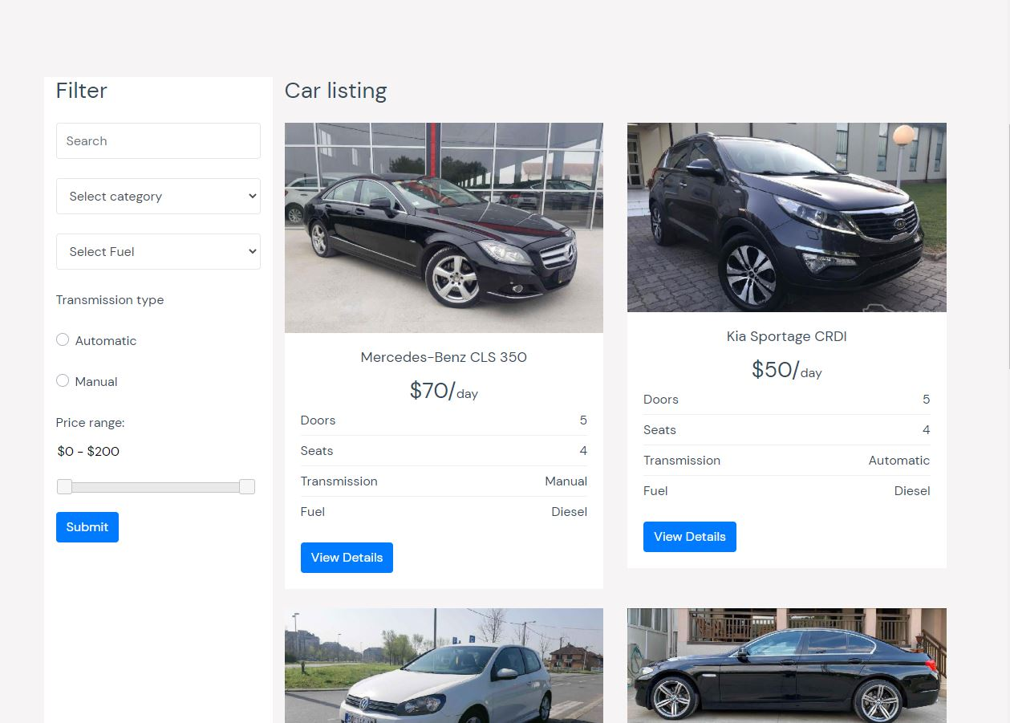

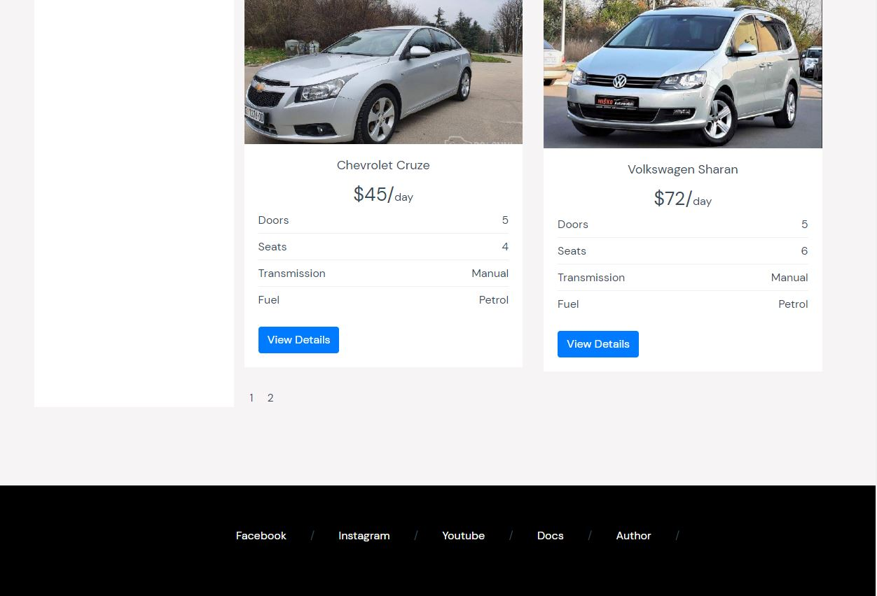

About strana

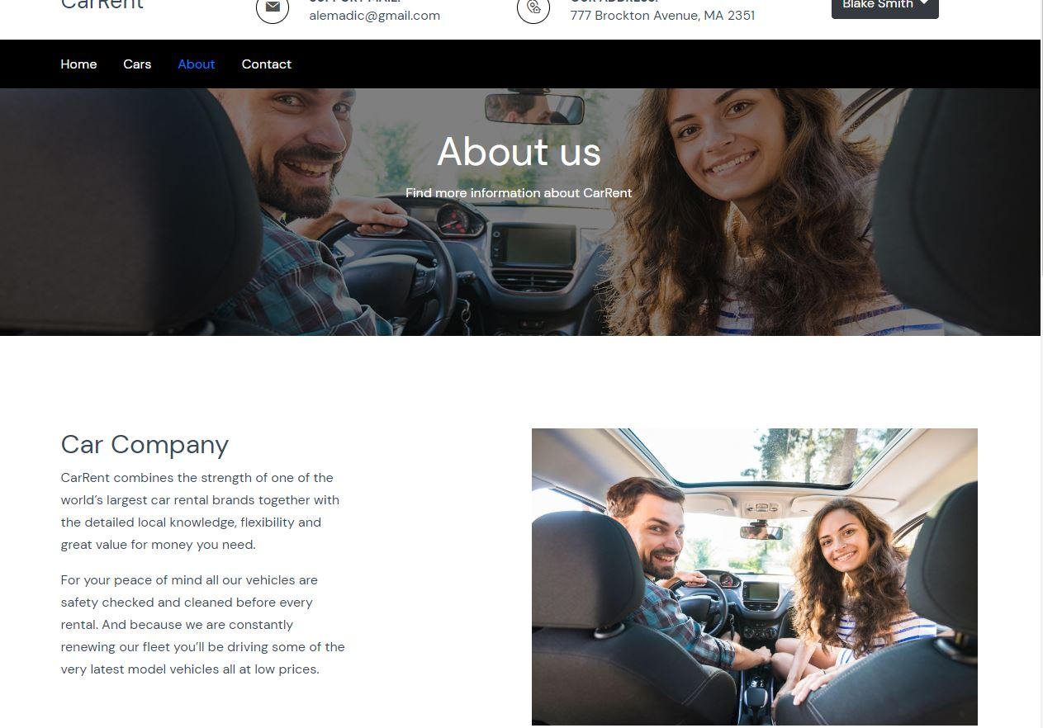

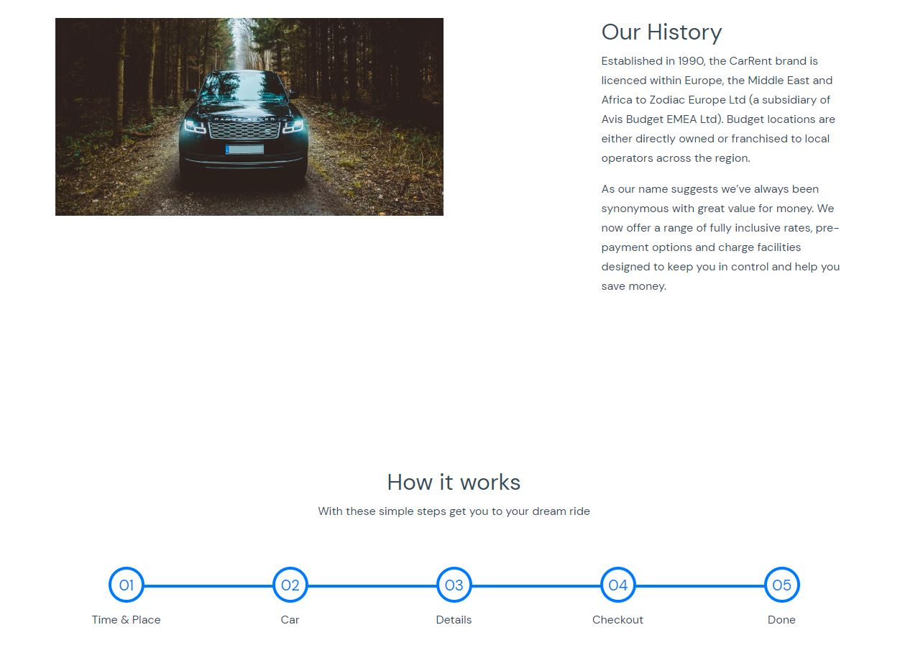

Contact strana

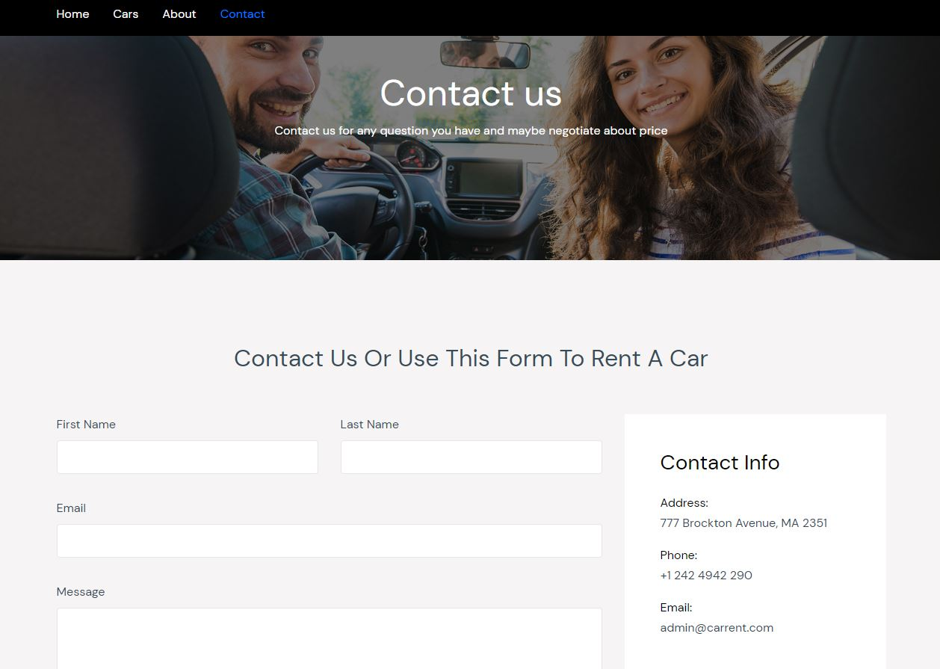

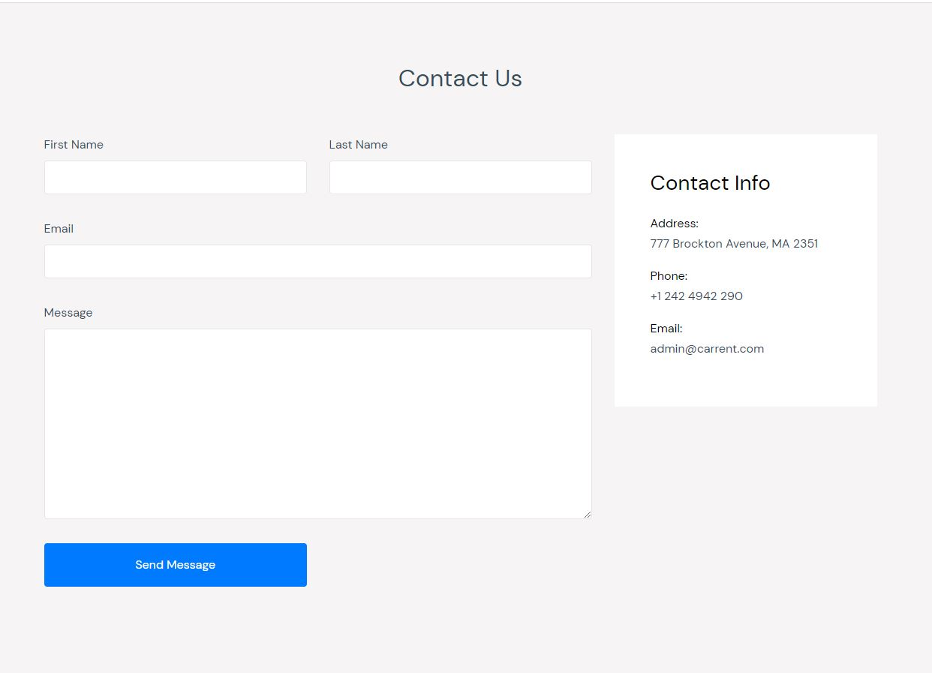

Admin strana

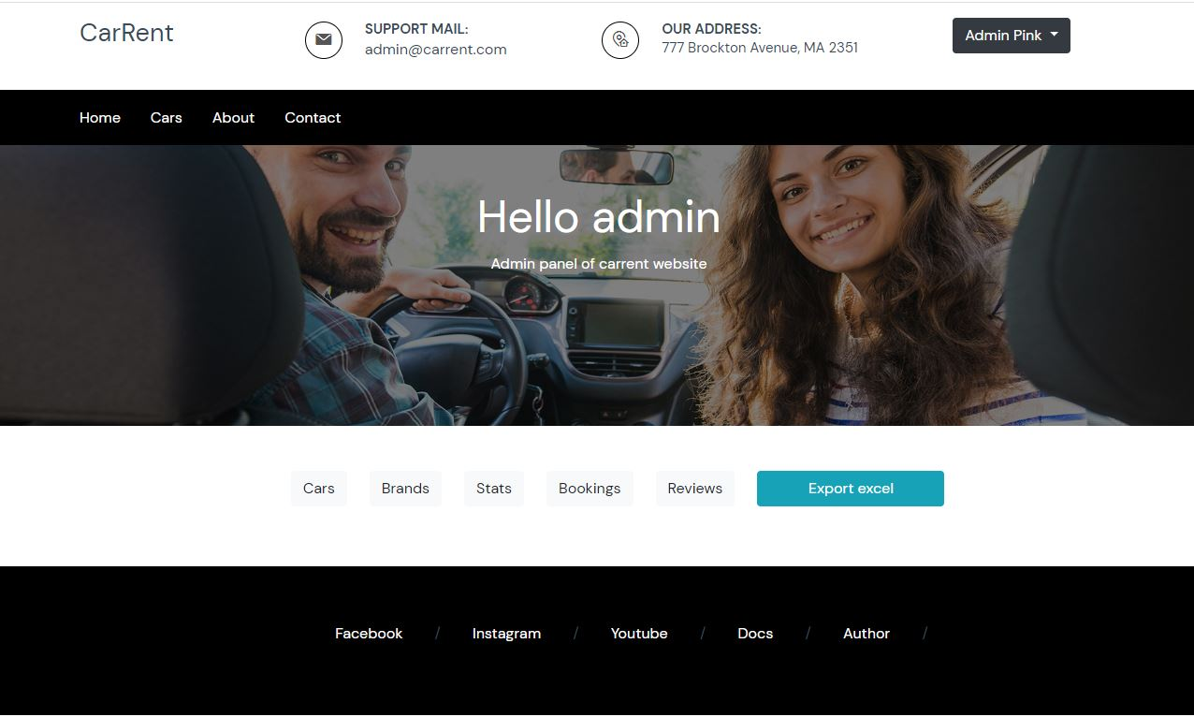

User profile strana

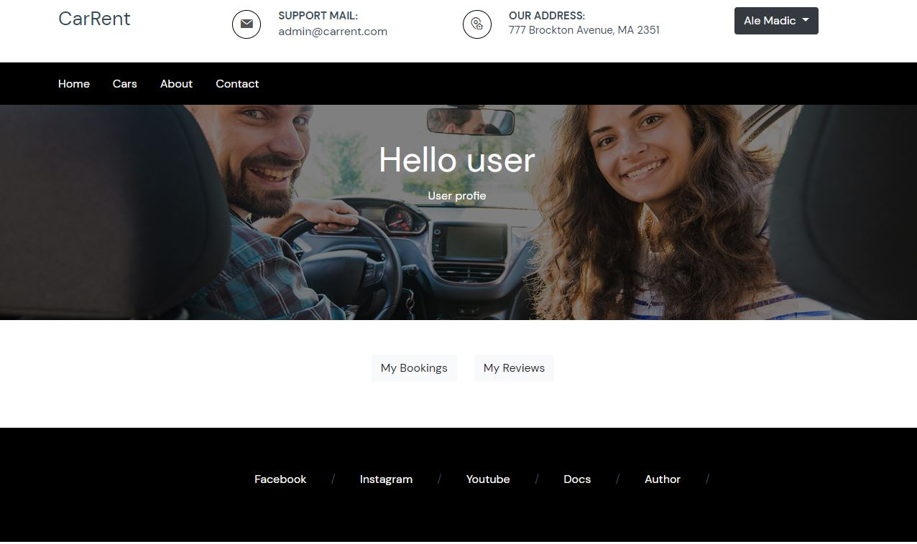

Login strana

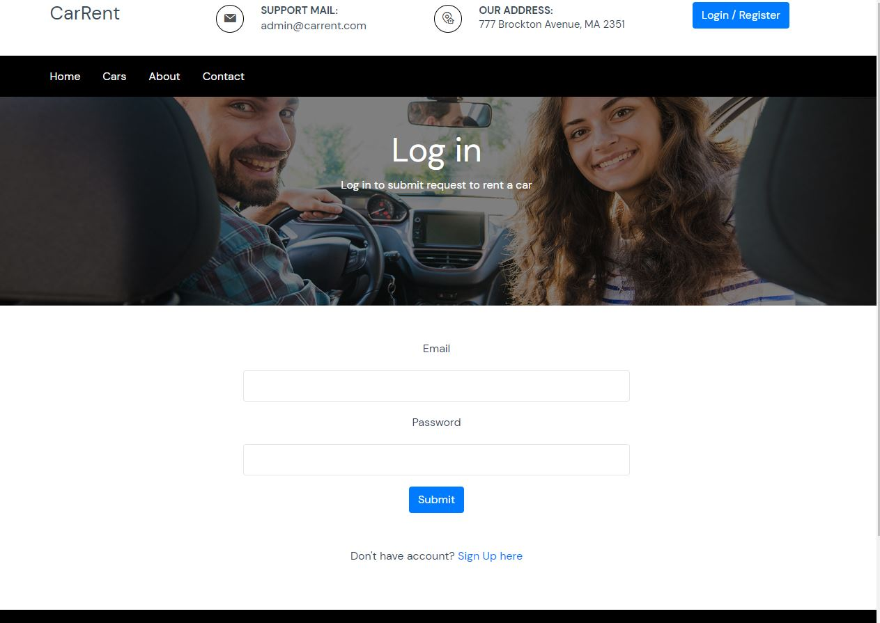

Register strana

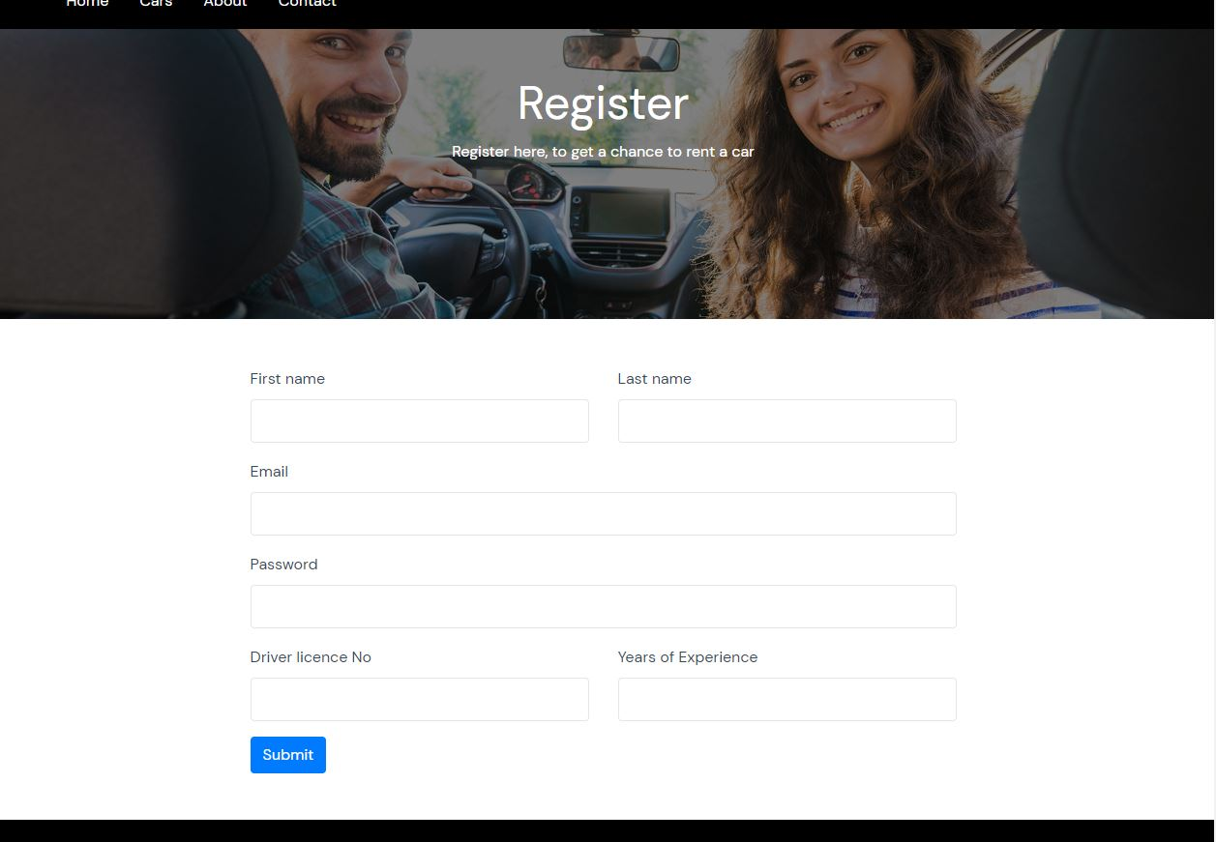

Autor strana



# Organizacija

## 2.1 Šema baze podataka

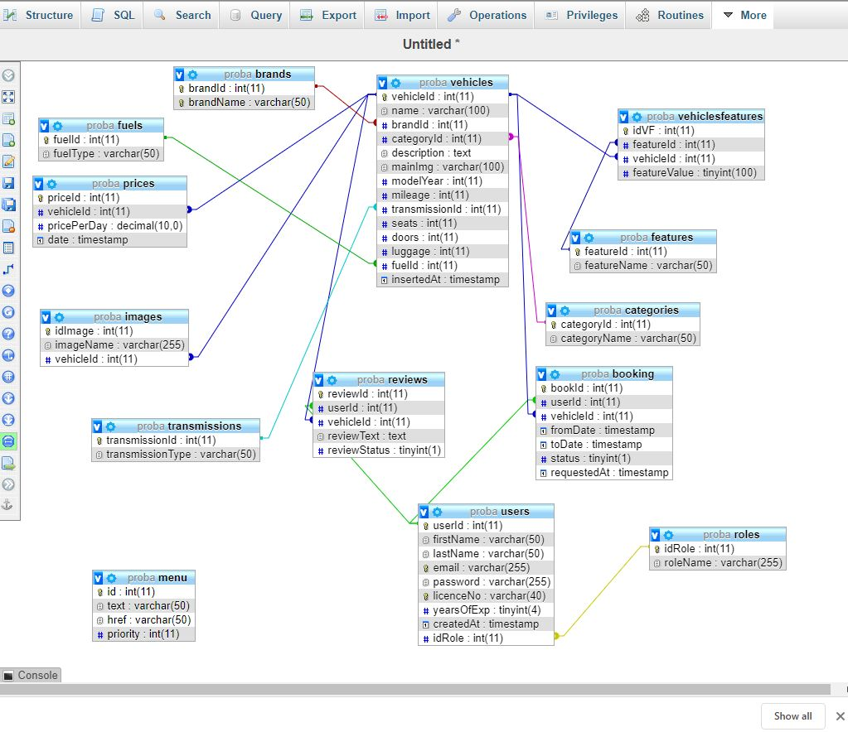

## 2.2 Mapa sajta

<urlset xmlns="http://www.sitemaps.org/schemas/sitemap/0.9">

    <url>

        <loc>https://carrent2020.epizy.com/index.php</loc>

        <lastmod>2020-06-12</lastmod>

        <changefreq>weekly</changefreq>

        <priority>0.95</priority>

    </url>

    <url>

        <loc>https://carrent2020.epizy.com/index.php?page=cars</loc>

        <lastmod>2020-06-14</lastmod>

        <changefreq>weekly</changefreq>

        <priority>0.9</priority>

    </url>

    <url>

        <loc>https://carrent2020.epizy.com/index.php?page=about</loc>

        <lastmod>2020-06-1</lastmod>

        <changefreq>monthly</changefreq>

        <priority>0.7</priority>

    </url>

    <url>

        <loc>https://carrent2020.epizy.com/index.php?page=profile</loc>

        <lastmod>2020-06-1</lastmod>

        <changefreq>monthly</changefreq>

        <priority>0.75</priority>

    </url>

    <url>

        <loc>https://carrent2020.epizy.com/index.php?page=login</loc>

        <lastmod>2020-06-10</lastmod>

        <changefreq>monthly</changefreq>

        <priority>0.65</priority>

    </url>

    <url>

        <loc>https://carrent2020.epizy.com/index.php?page=register</loc>

        <lastmod>2020-06-2</lastmod>

        <changefreq>monthly</changefreq>

        <priority>0.65</priority>

    </url>

    <url>

        <loc>https://carrent2020.epizy.com/index.php?page=admin</loc>

        <lastmod>2020-06-1</lastmod>

        <changefreq>weekly</changefreq>

        <priority>0.6</priority>

    </url>

    <url>

        <loc>https://carrent2020.epizy.com/index.php?page=contact</loc>

        <lastmod>2020-02-5</lastmod>

        <changefreq>yearly</changefreq>

        <priority>0.55</priority>

    </url>

    <url>

        <loc>https://carrent2020.epizy.com/index.php?page=logout</loc>

        <lastmod>2020-02-5</lastmod>

        <changefreq>yearly</changefreq>

        <priority>0.55</priority>

    </url>

</urlset>

## 2.3 Struktura projekta

root

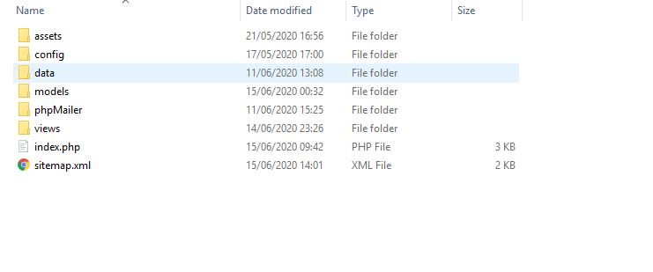

config



assets

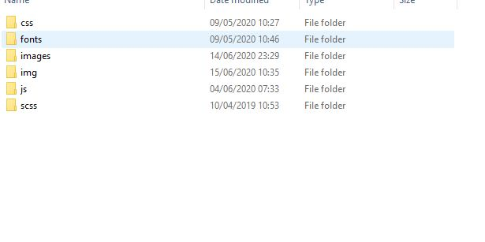

data

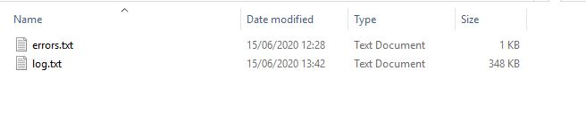

models

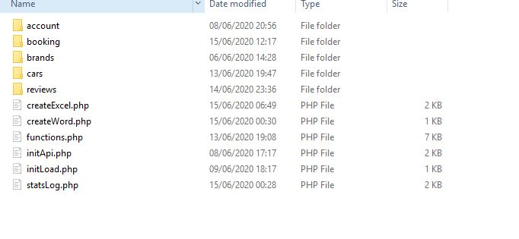

Models/account

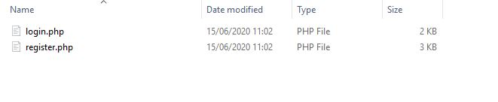

Models/booking



Models/ brand

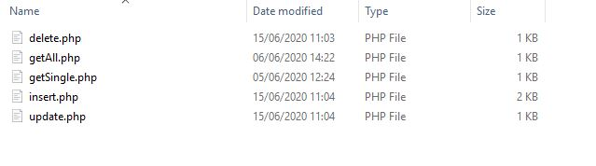

Models/car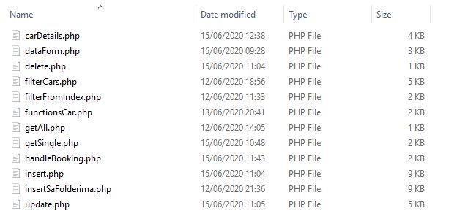

Models/reviews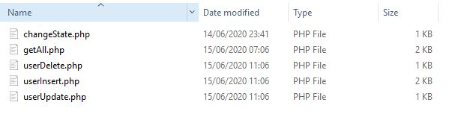

Views/

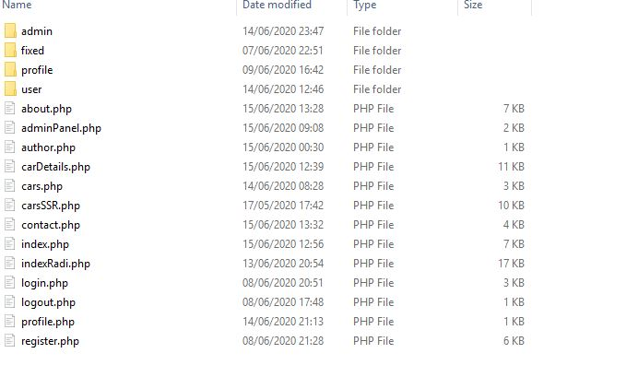

Views/admin

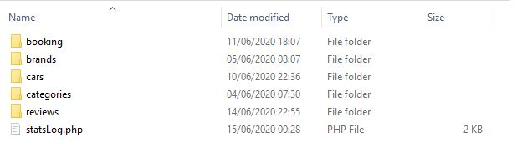

Views/admin/Book



Views/admin/brand



Views/admin/car



Views/admin/reviews



Views/fixed/

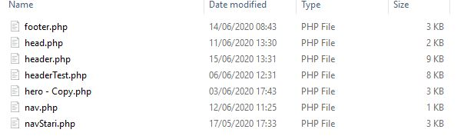

Views/user/



Views/user/booking/



Views/user/review

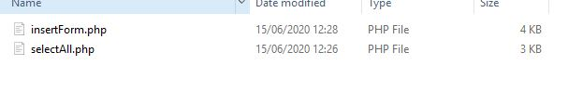

## 2.4 Opis stranica sajta

### 2.4.1 index strana

Dinamicko ispisivanje menija iz baze. popunjavanje filtera sa pretragu “small search” podacima iz baze. Klikom na submit popupice se podaci iz te male forme proslediti stranici cars I tamo ce se prikazati rezultat filtriranja. Ispisuju se automobili iz baze I prikazuju u vidu slidera. Klik na dugme “view more” vodi na stranicu carDetails gde se prikazuju detalji o konkretnom autu.

### 2.4.2 cars strana

Na ovoj strani se ispisuje automobile, I koristi se paginacija. Filterima sa strane se mogu izfiltrirati automobile klikom na taster submit. Klikom na dugme view more vodi na stranicu carDetails gde se nalaze dodatne karakteristike automobile.

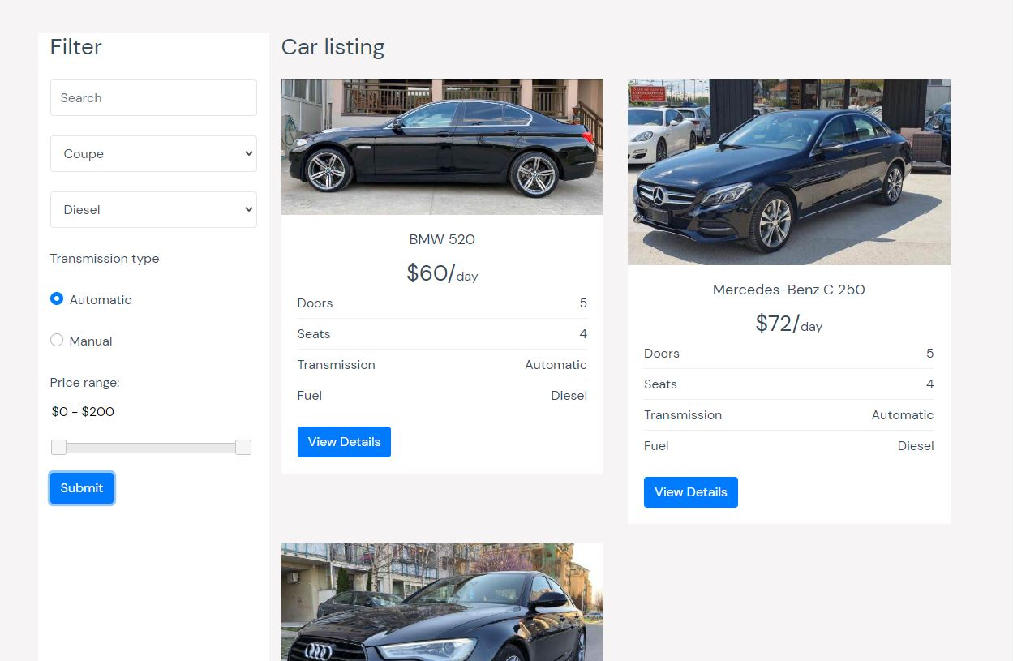

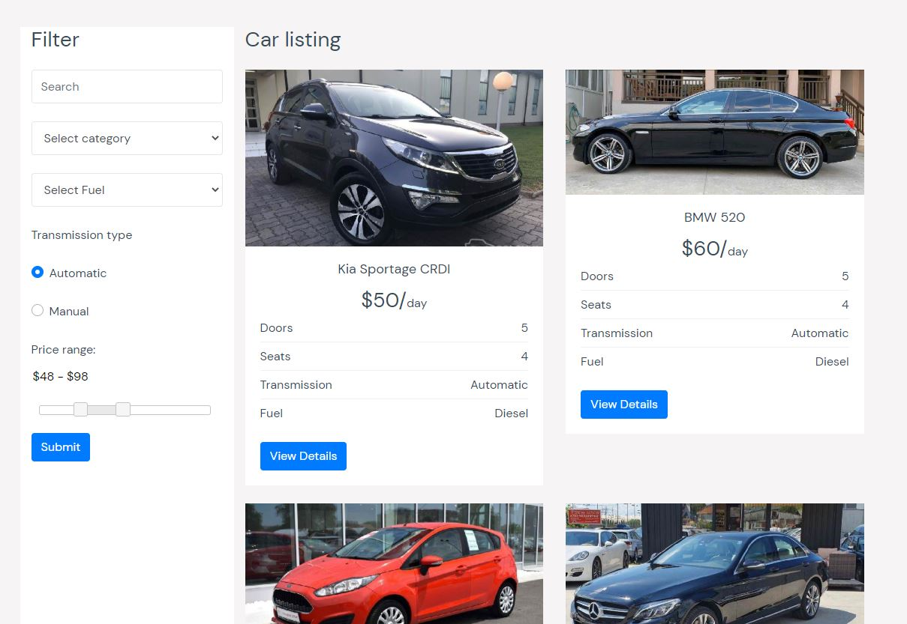

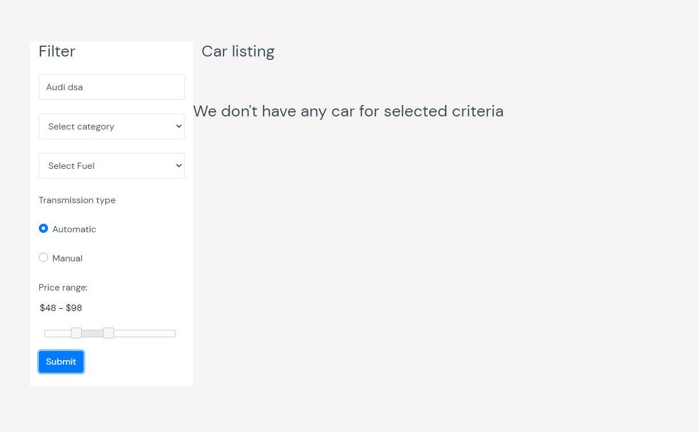

### 2.4.3 carDetails strana

Na ovoj strani se ispisuju dodatne karakteristike automobila. Prikazuje se galerija sa slikama automobila koje je admin uneo prilikom inserta u admin panelu. Prikazuju se opste informacije kao I dodatne informacije o autu sta sadrzi. Takodje se ispisuju recenzije korisnika koji su do sad iznajmili taj auto ukoliko ih ima. Ispisuje se forma u kojoj korisnik treba da izabere datum od i datum do kad zeli da iznajmi auto. Vrsi se provera da ne može da se izabere datum u prošlosti I da datum od mora biti manji od datum do. Kada korisnik ispravno popuni formu upisuje se u bazu podataka njegov zahtev. Na drnu strane se prikazuju automobile koji su po tipu prenosa I goriva slični odabranom autu.

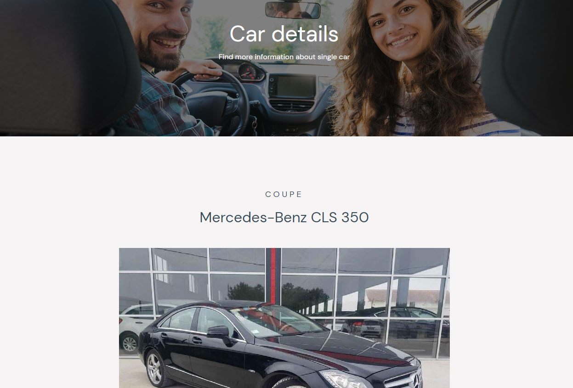

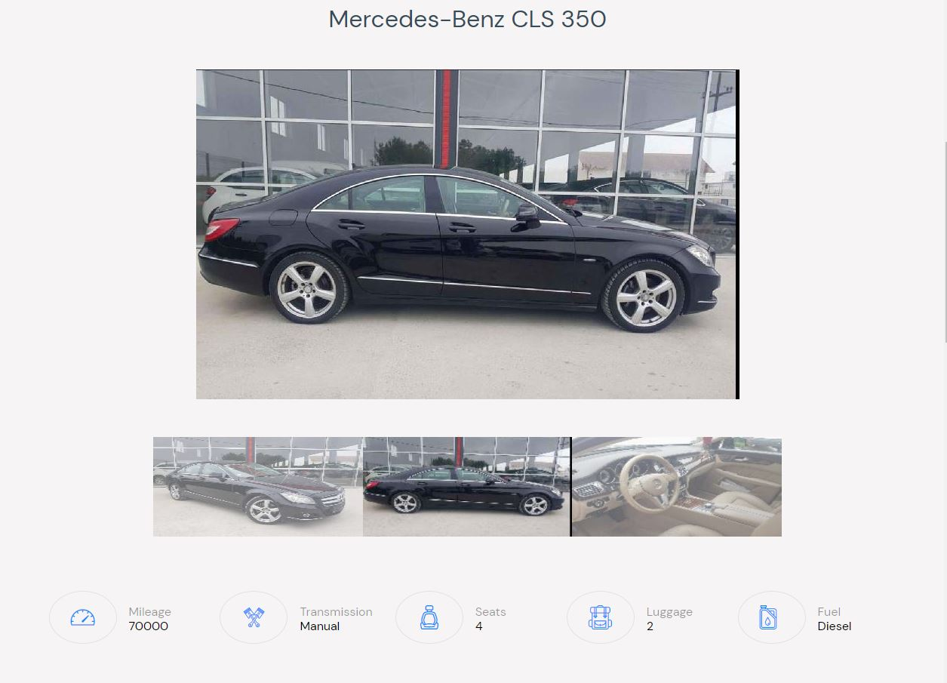

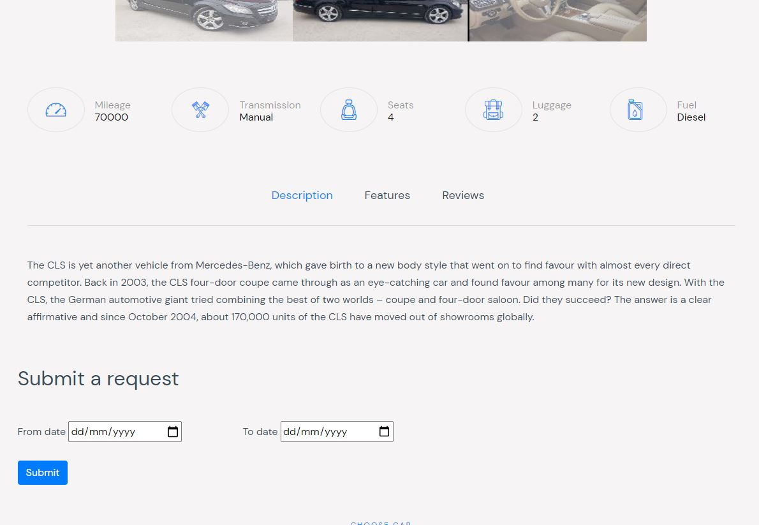

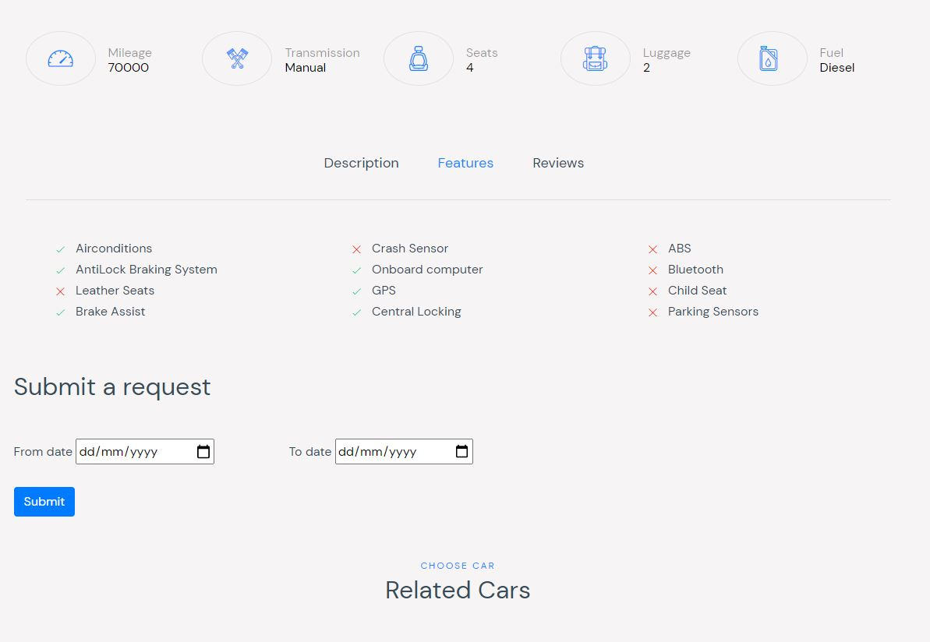

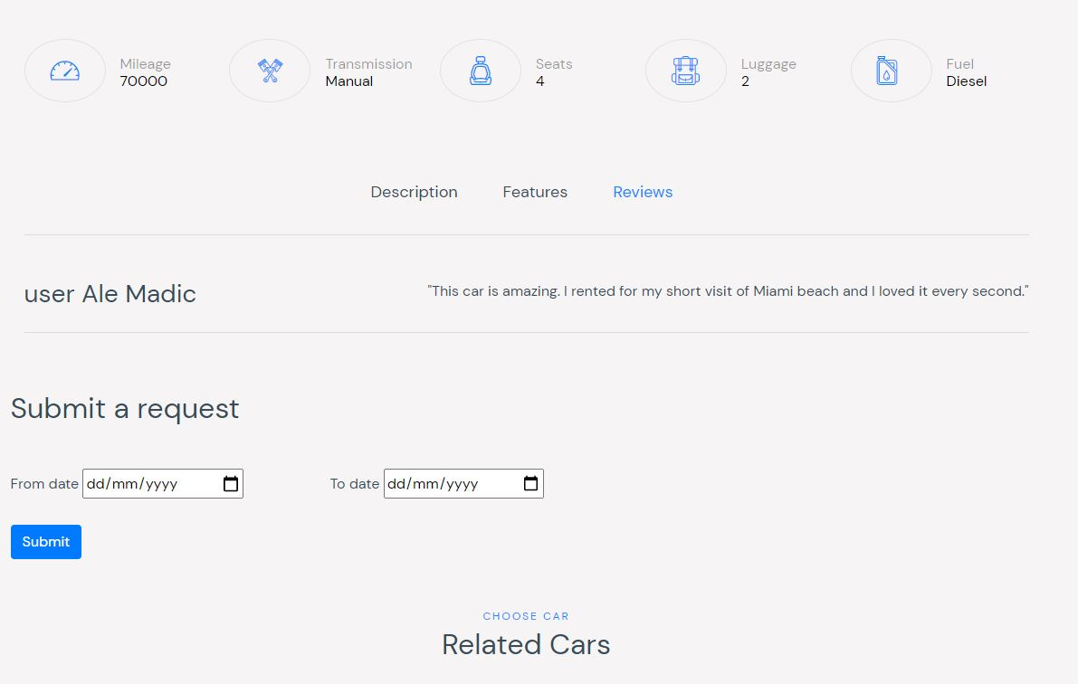

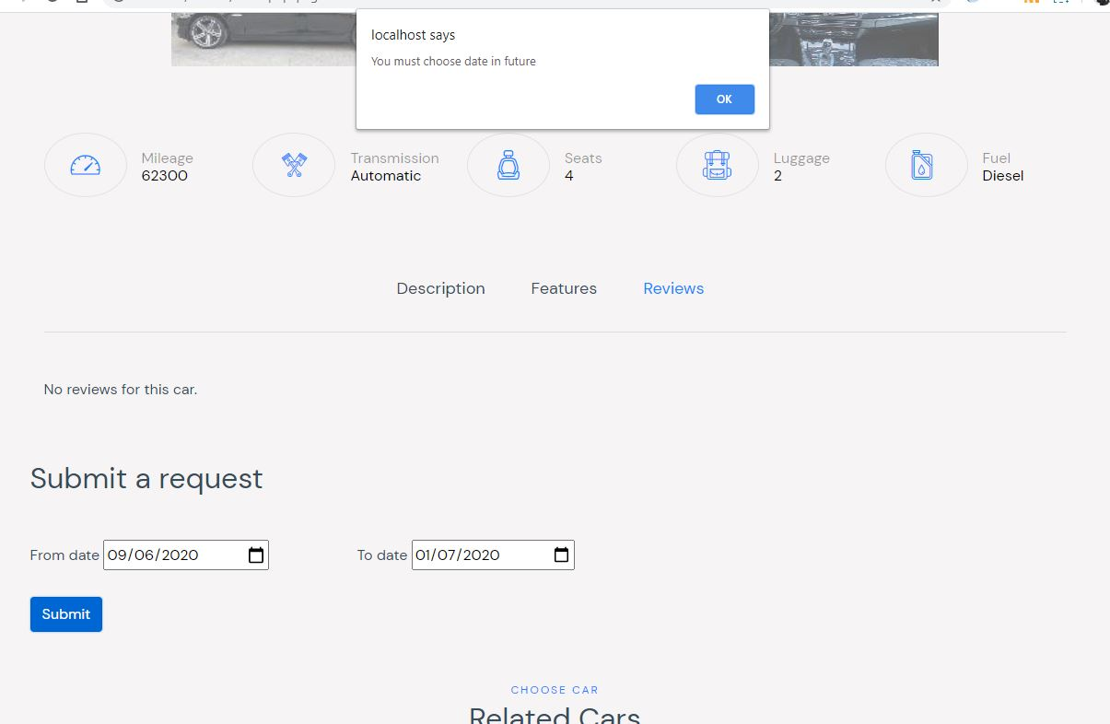

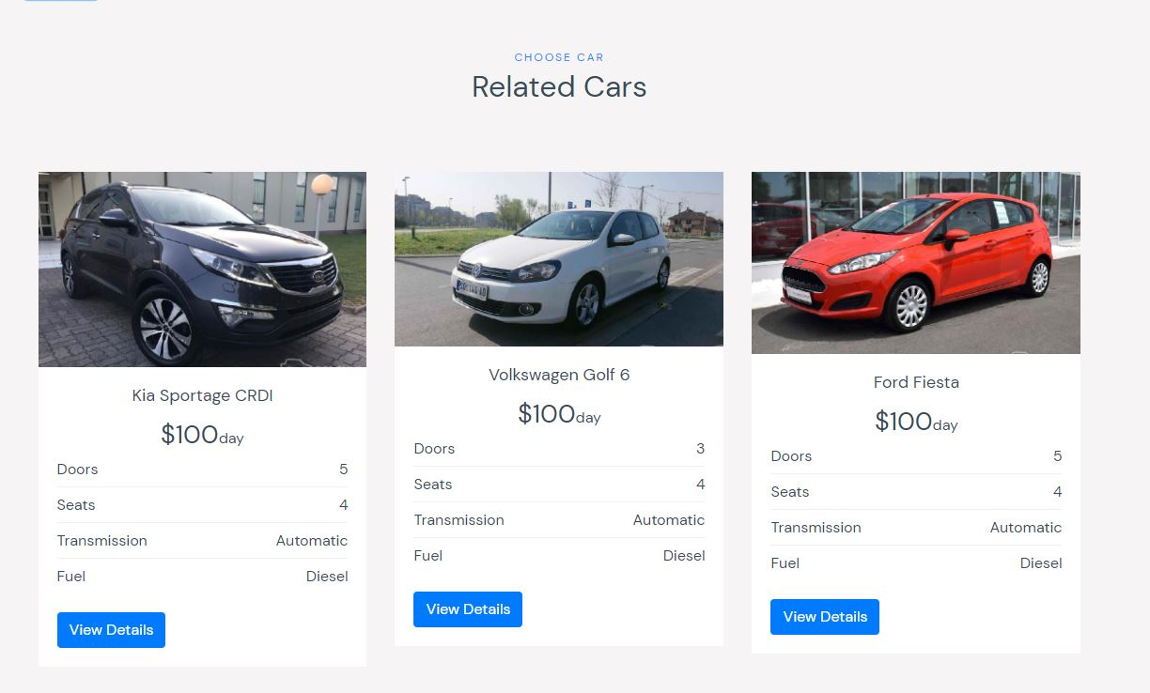

### 2.4.4 about strana

Na ovoj strani se nalazi staticki tekst o kompaniji

### 2.4.5 autor strana

Na ovoj strani se nalaze podaci o autoru. Takodje klikom na dugme moze se exportovati sadrzaj u word document. Ovo radi u localu, hosting ne prihvata com funkcije

### 2.4.6 contact strana

Na ovoj strani omogućeno je kontaktiranje admina popunjavanjem forme koja je validirana na klijentu i na serveru. Slanje mejla se vrsi pomoću PHPMailer-a

### 2.4.7 user strana

Ova strana namenjena je ulogovanim korisnicima koji mogu da prate status zahteva za iznajmljivanje auta. Omogućeno je da se otkaže zahtev. Omogućeno je da korisnik dodaje recenzije, ali samo za automobile koje je iznajmio. Moguća je izmena i brisanje recenzije.

Sve je realizovano ajaxom.

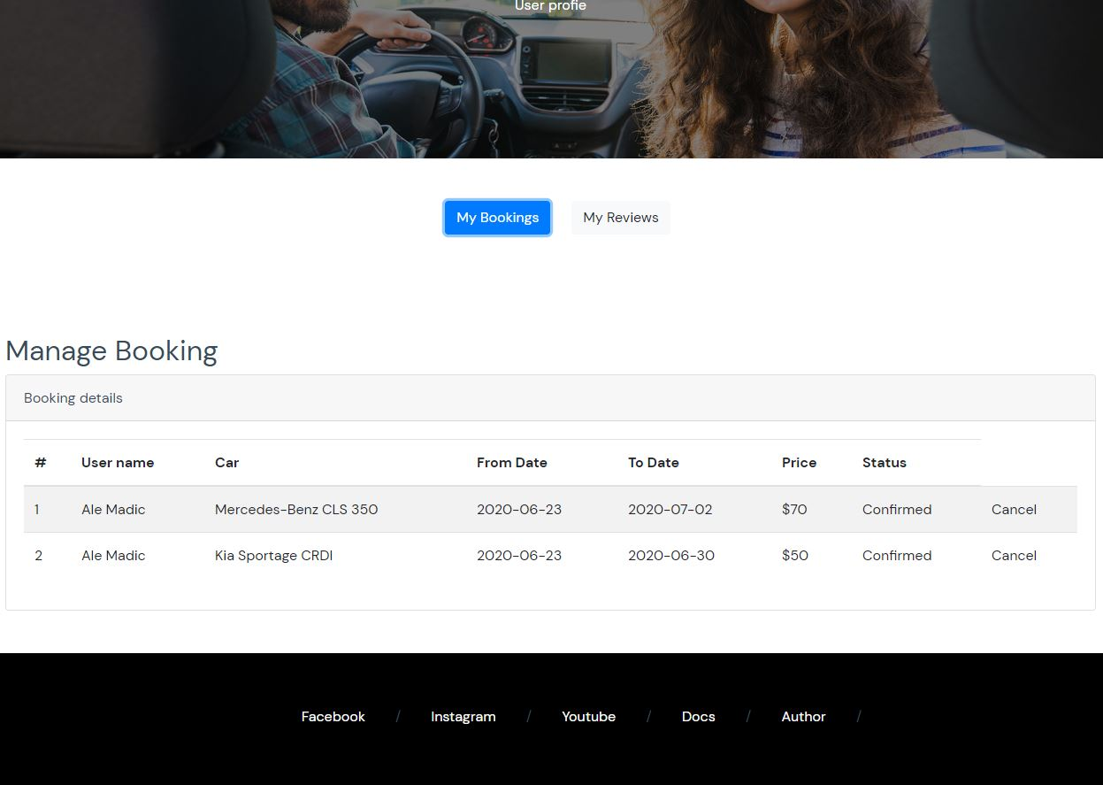

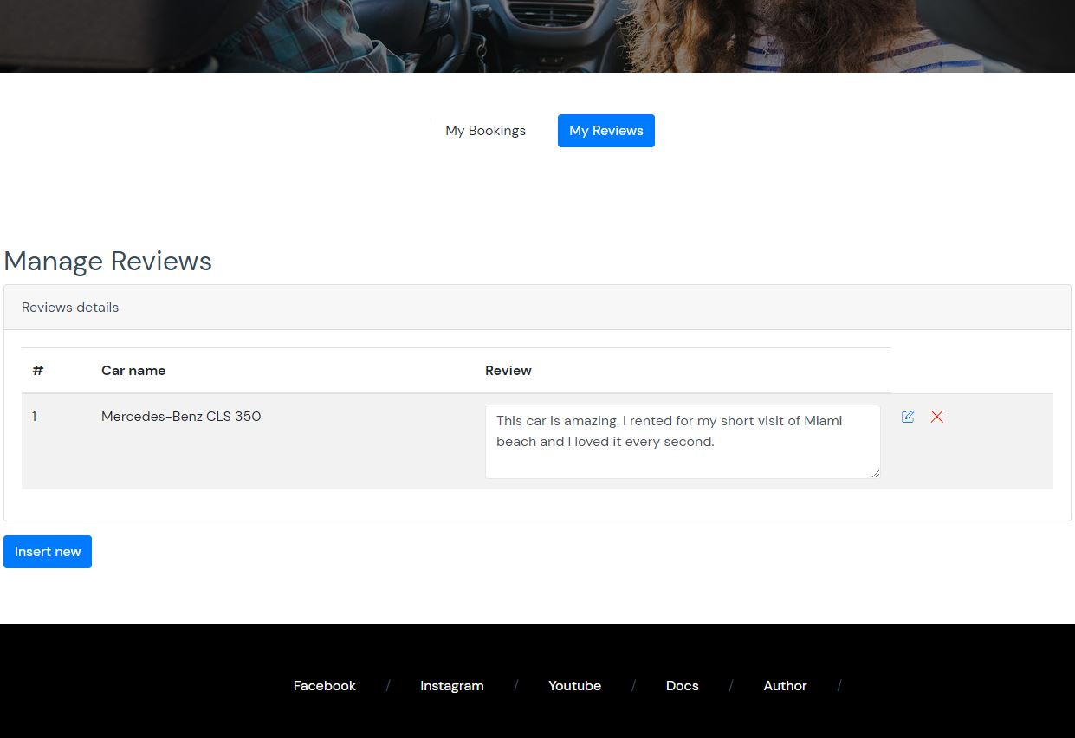

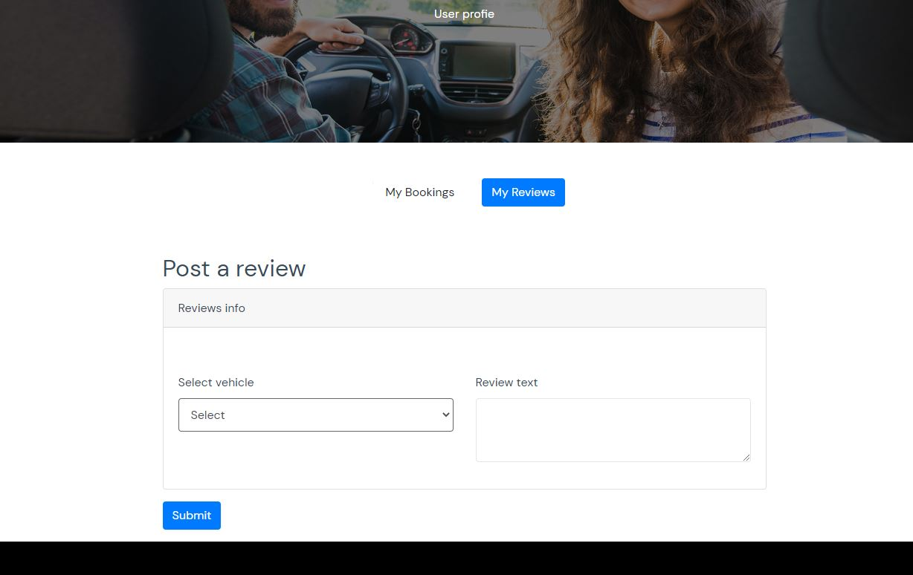

### 2.4.8 admin strana

Na ovoj strani omogućeno je upravljanje sadržajem sajta. CRUD operacije za automobile, prilikom inserta obrađuju se slike na dve veličine kako bi se kasnije prikazale u galeriji na stranici vezanoj za taj auto. CRUD operacije za brendove. Prikaz statistike pristupu stranicama. Upravljanje zahtevima za iznajmljivanje. Vrši se provera da jedan auto u jednom opsegu datuma može biti samo jednom iznajmljen. Tako da ako na primer admin pokuša da prihvati neki zahtev, zahtev će biti prihvaćen jedino ako taj auto nije već izdat u tom vremenskom intervalu. Upravljanje recenzijama, koje recenzije će biti vidljive na sajtu koje ne. Sve forme se validiraju na klijentu i na serveru. Omogućen je export podataka iz baze o automobilima u excel fajl.

Sve se realizuje ajaxom.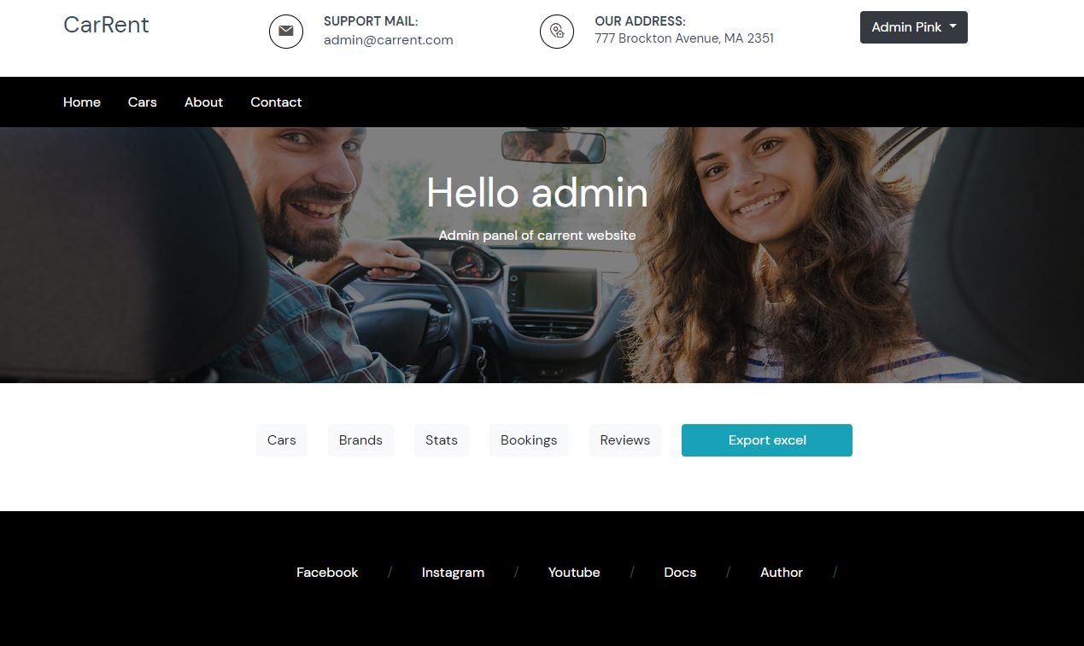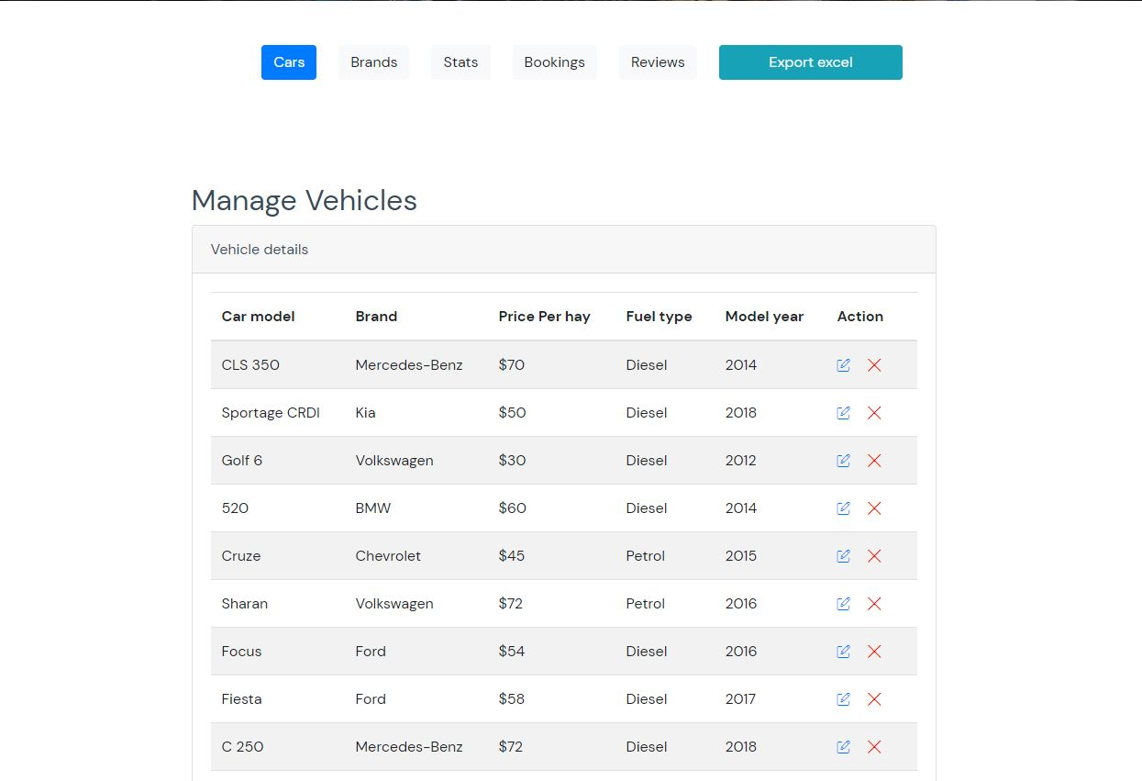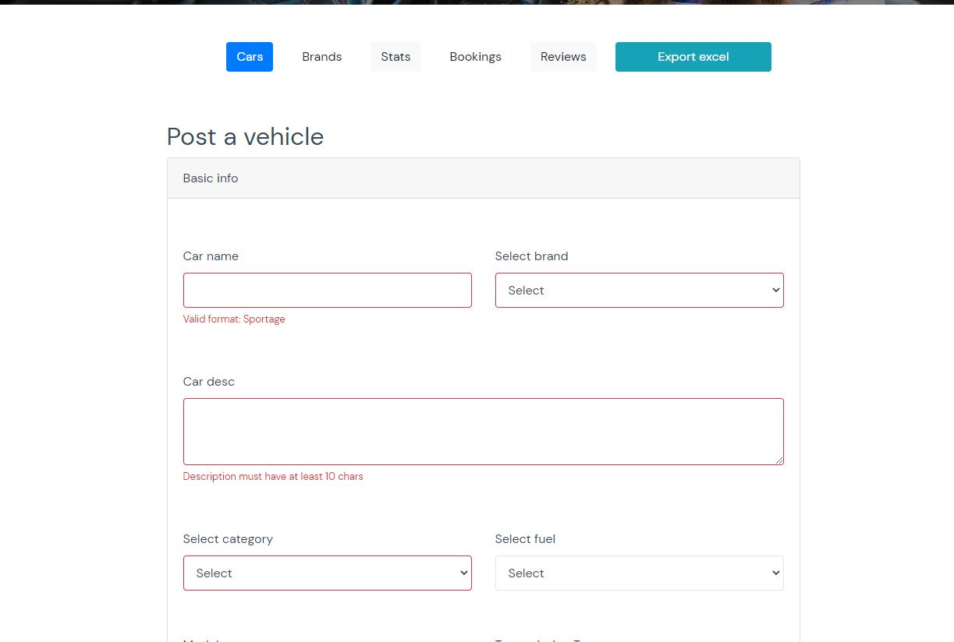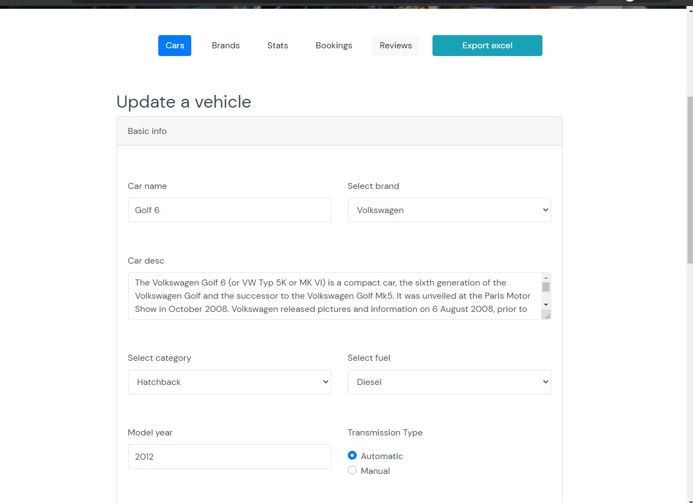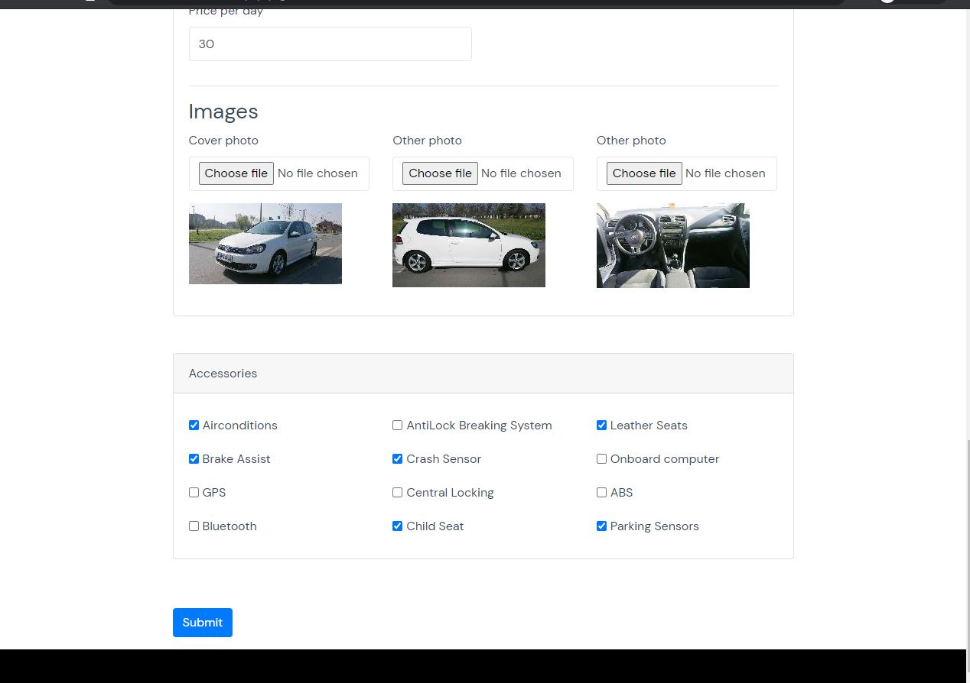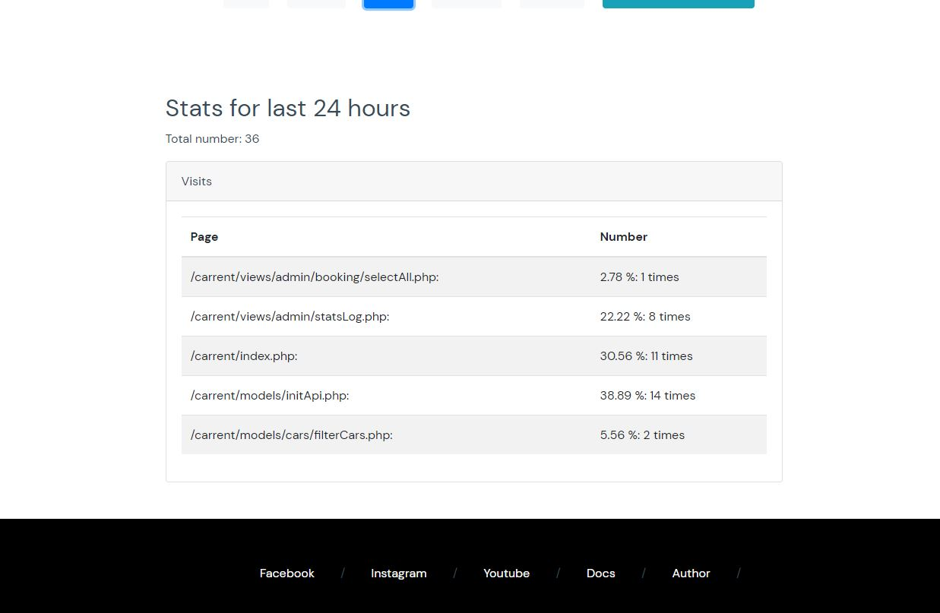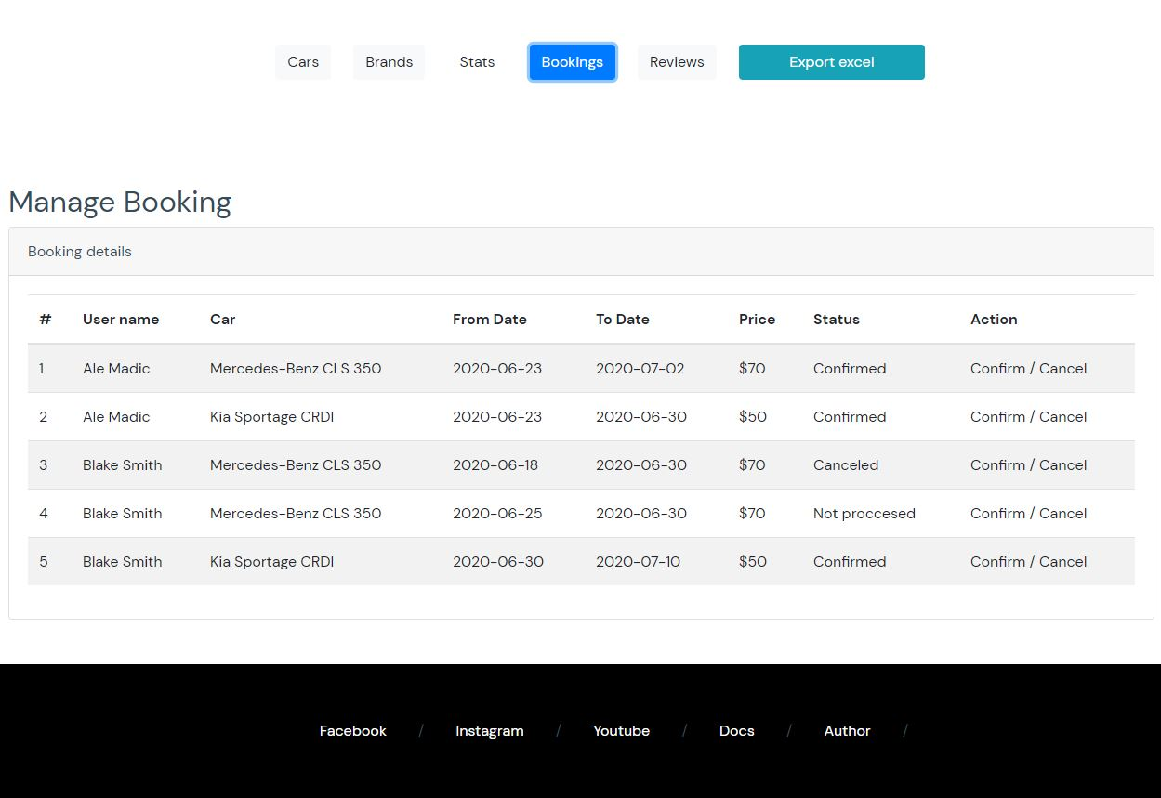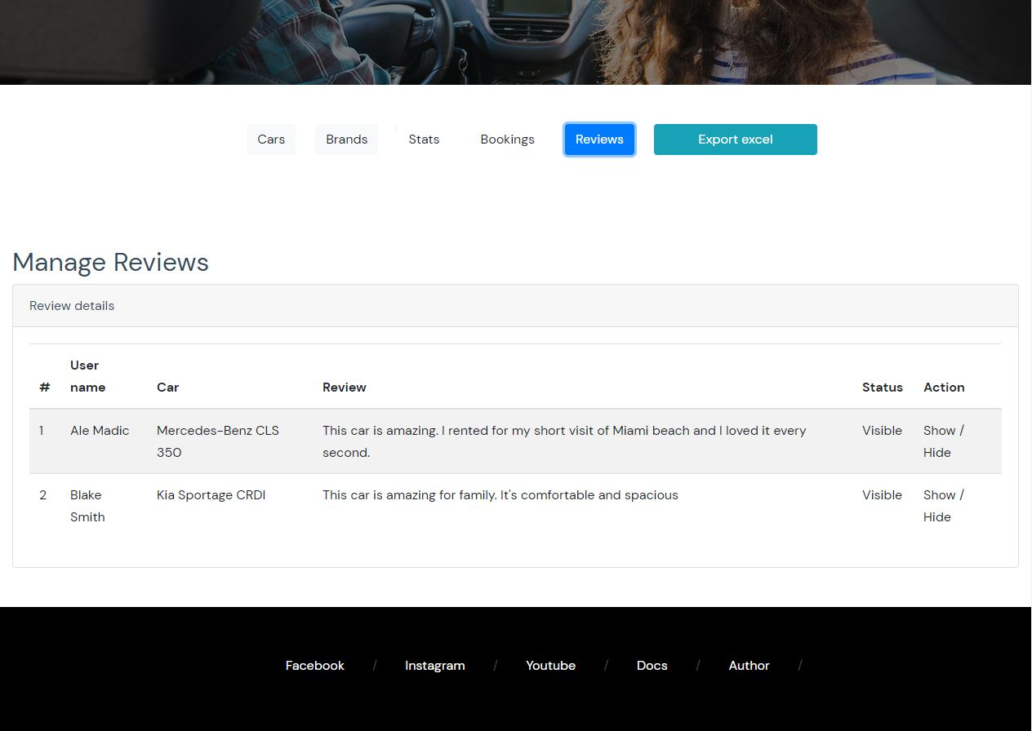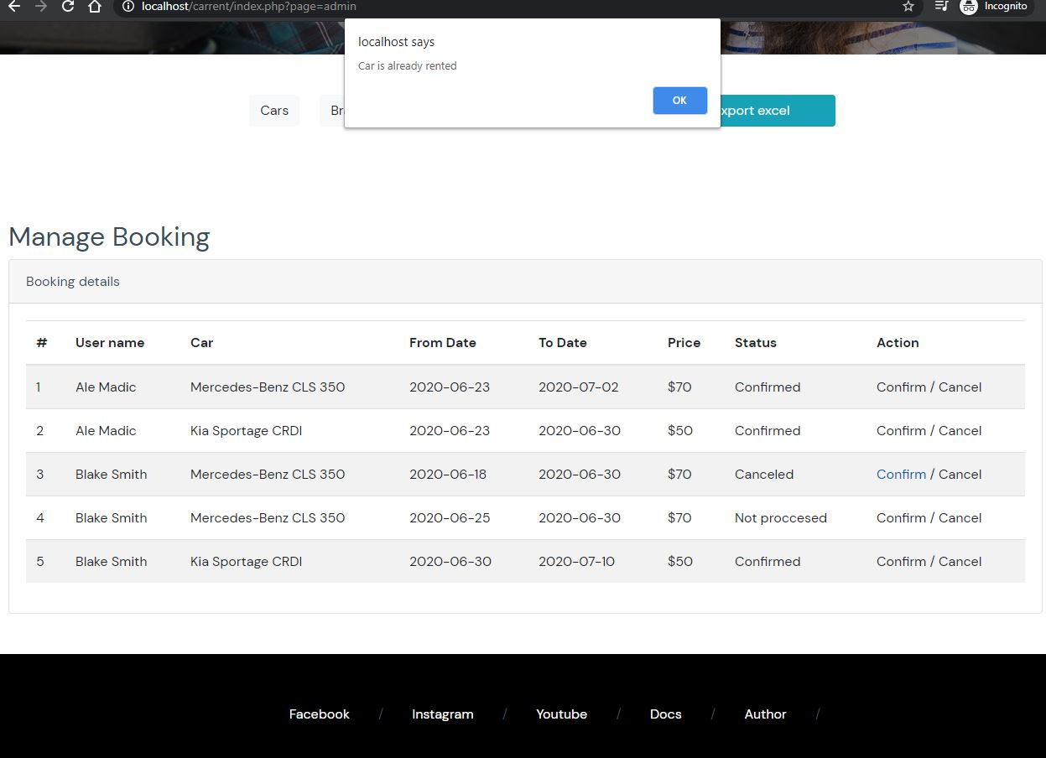

# Kodovi

## 3.1 PHP

### 3.1.1 index.php

<?php

    session_start();

    ob_start();

    require "config/connection.php";

    if(!isset($_GET['page'])) {

        $page = "index";

    } else {

        switch ($_GET['page']) {

            case 'cars':

                $page = "cars";

            break;

            case 'carDetails':

                $page = "carDetails";

            break;

            case 'services':

                $page = "services";

                break;

            case 'about':

                $page = "about";

            break;

            case 'contact':

                $page = "contact";

            break;

            case 'blog':

                $page = "blog";

            break;

            case 'login':

                $page = "login";

            break;

            case 'register':

                $page = "register";

            break;

            case 'logout':

                $page = "logout";

            break;

            case 'profile':

                if(isset($_SESSION['user']) && $_SESSION['user']['idRole'] == 2) {

                    $page = "profile";

                } else if (isset($_SESSION['user']) && $_SESSION['user']['idRole'] == 1) {

                    $page = "adminPanel";

                } else {

                    header("Location: index.php?page=login");

                }

            break;

            case "author":

                $page = "author";

            break;

            case 'admin':

                if(isset($_SESSION['user']) && $_SESSION['user']['idRole'] == 1) {

                    $page = "adminPanel";

                } else {

                    header("Location: index.php?page=login");

                }

            break;

            default:

                $page = "index";

            break;

        }

    }

    $metaPodaci = handleMetaData($page);

    require "views/fixed/head.php";

*// require "views/fixed/nav.php";*

    require "views/fixed/header.php";

*// var_dump($_SESSION['user']);*

    require "views/{$page}.php";

    require "views/fixed/footer.php";

?>

### 3.1.2 config/connection.php

<?php

    require "config.php";

    pristupStranici();

    try {

        $db = new PDO("mysql:host=" . SERVER . ";dbname=" . DBNAME . ";charset=utf8", USERNAME, PASSWORD);

        $db->setAttribute(PDO::ATTR_ERRMODE, PDO::ERRMODE_EXCEPTION);

    } catch(PDOException $ex) {

*// echo $ex->getMessage(); -> u log fajl*

        exit("We have issues with database, please try later");

    }

    function pristupStranici() {

        $fajl = fopen(LOG_FAJL, "a");

        if($fajl) {

            $datum = date("d-m-Y H:i:s");

            fwrite($fajl, $_SERVER['PHP_SELF'] . "\t" .  $datum . "\t" . $_SERVER['REMOTE_ADDR'] ."\t\n");

            fclose($fajl);

        }

    }

    function handleGresku($err) {

        $fajl = fopen(GRESKE, "a");

        if($fajl) {

            $datum = date("d-m-Y H:i:s");

            fwrite($fajl, $_SERVER['PHP_SELF'] . "\t" . $_SERVER['REQUEST_URI'] . "\t" .  $datum . "\t" . $err . "\t\n");

            fclose($fajl);

        }

    }

    function handleMetaData($page) {

        $meta = [

            "index" => [

                "title" => "Car Rent | Home",

                "titleForTag" => "",

                "desc" => "We are agency for rent a car. Here you can find best deals",

                "keys" => "carrent, rent a car, best car to rent"

            ],

            "cars" => [

                "title" => "Car Rent | Cars",

                "titleForTag" => "Our For Rent Cars ",

                "desc" => "Here you can see our rich offer of luxury and afordable cars (based on your budget)",

                "keys" => "cars for rent, luxury car, best deal for car rent"

            ],

            "carDetails" => [

                "title" => "Car Rent | Car details",

                "titleForTag" => "Car details",

                "desc" => "Find more information about single car",

                "keys" => "best car for rent, info about car"

            ],

            "about" => [

                "title" => "Car Rent | About",

                "titleForTag" => "About us",

                "desc" => "Find more information about CarRent",

                "keys" => "bio carrent, about, about carrent"

            ],

            "contact" => [

                "title" => "Car Rent | Contact",

                "titleForTag" => "Contact us",

                "desc" => "Contact us for any question you have and maybe negotiate about price",

                "keys" => "contact us, contanct carrent, contanct rent a car"

            ],

            "login" => [

                "title" => "Car Rent | Login",

                "titleForTag" => "Log in",

                "desc" => "Log in to submit request to rent a car",

                "keys" => "log in carrent"

            ],

            "logout" => [

                "title" => "Car Rent | Logout ",

                "titleForTag" => "Log out",

                "desc" => "Logout page of carrent",

                "keys" => "logout carrent, log out from car rent"

            ],

            "register" => [

                "title" => "Car Rent | register",

                "titleForTag" => "Register",

                "desc" => "Register here, to get a chance to rent a car",

                "keys" => "register carrent, register page of rent a car"

            ],

            "adminPanel" => [

                "title" => "Car Rent | Admin",

                "titleForTag" => "Hello admin",

                "desc" => "Admin panel of carrent website",

                "keys" => "adminpanel carrent, admin panel carrent"

            ],

            "profile" => [

                "title" => "Car Rent | User profie",

                "titleForTag" => "Hello user",

                "desc" => "User profie",

                "keys" => "profile at carrent, user at carrent"

            ],

            "author" => [

                "title" => "Car Rent | Author",

                "titleForTag" => "Author",

                "desc" => "Page about author of carrent website",

                "keys" => "about author of carrent, author carrent"

            ]

        ];

        return $meta[$page];

    }

?>

### 3.1.3 config/config.php

<?php

*// define("ABSOLUTE_PATH", $_SERVER['DOCUMENT_ROOT']);*

define("ABSOLUTE_PATH", $_SERVER['DOCUMENT_ROOT'] . "/carrent");

*// echo ABSOLUTE_PATH;*

define("ENV_FAJL", ABSOLUTE_PATH . "/config/.env");

*// define("CONNECTION", ABSOLUTE_PATH . "/config/connection.php");*

define("USER_SLIKE", ABSOLUTE_PATH . "/assets/img");

define("SLIKE_FOLDER", "assets/img/");

define("LOG_FAJL", ABSOLUTE_PATH . "/data/log.txt");

define("GRESKE", ABSOLUTE_PATH . "/data/errors.txt");

define("SEPARATOR", "\t");

define("SERVER", izvuciIzEnv("SERVER"));

define("DBNAME", izvuciIzEnv("DBNAME"));

define("USERNAME", izvuciIzEnv("USERNAME"));

define("PASSWORD", izvuciIzEnv("PASSWORD"));

function izvuciIzEnv($naziv) {

    $podaci = file(ENV_FAJL);

    $vrednost = "";

    foreach ($podaci as $key => $value) {

        $red = explode("=", $value);

        if($red[0] == $naziv) {

            $vrednost = trim($red[1]);

        }

    }

    return $vrednost;

}

### 3.1.4 models/account/login.php

<?php

  session_start();

  require "../../config/connection.php";

  if(isset($_POST['submitLogin'])) {

    $email = $_POST['email'];

    $pass = $_POST['password'];

    $regexEmail = "/^[A-z\d\.-]{5,100}\@[a-z]{2,10}\.[a-z]{2,20}$/";

    $greskeL = [];

    if(!preg_match($regexEmail, $email)) {

      $greskeL[] = "Email format: johnconnaly@gmail.com";

    }

    if(strlen($pass) < 5) {

      $greskeL[] = "Password must have 5 chars min";

    }

    if(count($greskeL) == 0) {

      $upit = "SELECT userId, firstName, lastName, email, idRole FROM users WHERE email = :email AND password = :pass";

      $stmt = $db->prepare($upit);

      $pass = md5($pass);

      try {

        $rez = $stmt->execute(["email" => $email, "pass" => $pass]);

        $user = $stmt->fetchAll();

*// echo $stmt->rowCount();*

        if($stmt->rowCount() == 1) {

          $_SESSION['user'] = $user[0];

          if($user[0]['idRole'] == 1) {

            header("Location: ../../index.php?page=admin");

          } else {

            header("Location: ../../index.php?page=cars");

          }

          var_dump($user[0]);

*// header("Location: ../../index.php?page=cars");*

        } else {

          $greskaMail = "Wrong combination of email/pass";

          $_SESSION['greskaMail'] = $greskaMail;

          header("Location: ../../index.php?page=login#formContainer");

        }

      } catch(PDOException $ex) {

        handleGresku($ex->getMessage());

      }

    }

  }

?>

### 3.1.5 models/account/register.php

<?php

    session_start();

    require "../../config/connection.php";

    if(isset($_POST['submitRegister'])) {

        $fname = $_POST['fname'];

        $lname = $_POST['lname'];

        $email = $_POST['email'];

        $password = $_POST['password'];

        $licenceNo = $_POST['licenceNo'];

        $yearsExp = $_POST['yearsExp'];

        $regexName = "/^[A-Z][a-z]{2,20}(\s[A-Z][a-z]{3,20}){0,2}$/";

        $regexEmail = "/^[A-z\d\.-]{5,100}\@[a-z]{2,10}\.[a-z]{2,20}$/";

        $regexLicenceNo = "/^[A-Z][\d]{3}-[\d]{3}-[\d]{2}-[\d]{3}-[\d]$/";

        $greskeR = [];

        if(!preg_match($regexName, $fname)) {

            $greskeR[] = "First Name format: John";

        }

        if(!preg_match($regexName, $lname)) {

            $greskeR[] = "Last name format: Connaly";

        }

        if(!preg_match($regexEmail, $email)) {

            $greskeR[] = "Email format: johnconnaly@gmail.com";

        }

        if(strlen($password) < 5) {

            $greskeR[] = "Password must have 5 chars min";

        }

        if(!preg_match($regexLicenceNo, $licenceNo)) {

            $greskeR[] = "Licence No format: F255-921-50-094-0";

        }

        if($yearsExp == "" || $yearsExp < 0) {

            $greskeR[] = "Years of Experience must be positive number";

        }

        if(count($greskeR) == 0) {

            $upit = "INSERT INTO users VALUES(NULL, :fname, :lname, :email, :pass, :licenceNo, :yearsOfExp, :datum, :idRole)";

            $stmt = $db->prepare($upit);

            $pass = md5($password);

            $datum = date("Y-m-d H:i:s");

            try {

                $rez = $stmt->execute(["fname" => $fname, "lname" => $lname, "email" => $email, "pass" => $pass, "licenceNo" => $licenceNo, "yearsOfExp" => $yearsExp, "datum" => $datum, "idRole" => 2]);

*// header lokacije na login*

                header("Location: ../../index.php?page=login");

            } catch(PDOException $ex) {

                handleGresku($ex->getMessage());

                $greskeR[] = "User with this licence number alredy exist";

                $_SESSION['greskeRegister'] = $greskeR;

                header("Location: ../../index.php?page=register");

            }

        } else {

            $_SESSION['greskeRegister'] = $greskeR;

            header("Location: ../../index.php?page=register");

        }

    }

?>

### 3.1.51 models/checkEmail.php

<?php

    header("Content-Type: application/json");

    require "../config/connection.php";

    if(isset($_POST['btnCheckEmail'])) {

        $email = $_POST['email'];

        $upit = "SELECT * FROM users WHERE email = :email";

        $stmt = $db->prepare($upit);

        $stmt->bindParam(":email", $email);

        try {

            $stmt->execute();

            $rez = $stmt->fetchAll();

            if($stmt->rowCount()) {

                $odg = "Email is already taken";

            } else {

                $odg = true;

            }

            http_response_code(200);

        } catch(PDOException $ex) {

            http_response_code(400);

            $odg = "Enter valid email";

        }

    } else {

        http_response_code(400);

        $odg = "Enter email first!";

    }

    echo json_encode(["odg" => $odg]);

?>

### 3.1.6 models/booking/canceluserBook.php

<?php

    header("Content-Type: application/json");

    require "../../config/connection.php";

    if(isset($_POST['btnUserCancel'])) {

        $bookId = $_POST['bookId'];

        $upitCancel = "UPDATE booking SET status = 2 WHERE bookId = :bookId";

        $stmt = $db->prepare($upitCancel);

        try {

            $stmt->execute(['bookId' => $bookId]);

            $odg = true;

        } catch(PDOException $ex) {

            handleGresku($ex->getMessage());

            $odg = "You can't cancel";

        }

        http_response_code(200);

    } else {

        http_response_code(400);

        $odg = "submit form first";

    }

    echo json_encode(['odg' => $odg]);

?>

### 3.1.7 models/booking/getAll.php

<?php

    function getAllBooking() {

*// $upit = "SELECT b.*, u.firstName, u.lastName, u.email, u.yearsOfExp, v.name, p.pricePerDay, br.brandName FROM booking b INNER JOIN users u ON b.userId = u.userId INNER JOIN vehicles v ON b.vehicleId = v.vehicleId INNER JOIN brands br ON v.brandId = br.brandId";*

        $upit = "SELECT b.*, v.name, p.pricePerDay, u.firstName, u.lastName, u.email, u.yearsOfExp, br.brandName FROM ( SELECT DISTINCT vehicleId, pricePerDay FROM prices order by date DESC) as p INNER JOIN vehicles v ON p.vehicleId = v.vehicleId INNER JOIN booking b ON v.vehicleId = b.vehicleId INNER JOIN brands br ON v.brandId = br.brandId INNER JOIN users u ON b.userId = u.userId GROUP BY p.vehicleId, b.status, u.userId ORDER BY u.userId";

        return izvrsiSelect($upit);

    }

    function getAllBookingUser() {

        $userId = $_SESSION['user']['userId'];

        $upit = "SELECT b.*, v.name, p.pricePerDay, u.firstName, u.lastName, u.email, u.yearsOfExp, br.brandName FROM ( SELECT DISTINCT vehicleId, pricePerDay FROM prices order by date DESC) as p INNER JOIN vehicles v ON p.vehicleId = v.vehicleId INNER JOIN booking b ON v.vehicleId = b.vehicleId INNER JOIN brands br ON v.brandId = br.brandId INNER JOIN users u ON b.userId = u.userId WHERE u.userId = $userId GROUP BY p.vehicleId";

        return izvrsiSelect($upit);

    }

?>

### 3.1.8 models/booking/handleBook.php

<?php

    header("Content-Type: application/json");

    require "../../config/connection.php";

    require "../functions.php";

    if(isset($_POST['btnHandleBook'])) {

        $bookId = $_POST['bookId'];

        $status = $_POST['btnHandleBook'];

        $upitIzvuciCarId = "SELECT vehicleId, fromDate FROM booking WHERE bookId = $bookId";

        $stmtCar = $db->prepare($upitIzvuciCarId);

        $stmtCar->execute();

        $carResult = $stmtCar->fetch();

        $carId = $carResult['vehicleId'];

        $bookDatum = $carResult['fromDate'];

        $upitSveRezervacijeZaAuto = "SELECT * FROM booking WHERE vehicleId = $carId AND status = 1";

        $stmtRezervacije = $db->prepare($upitSveRezervacijeZaAuto);

        $stmtRezervacije->execute();

        $rezDatumi = $stmtRezervacije->fetchAll();

        $odg = true;

        foreach($rezDatumi as $key => $singleRez) {

            if($bookDatum < $singleRez['toDate']) {

                $odg = false;

                $odgTxt = "Car is already rented";

                break;

            }

        }

        if($odg) {

            $odgTxt = "Moze da se renta";

            $upitUpdate = "UPDATE booking SET status = 1 WHERE bookId = $bookId";

            $stmtUpdate = $db->prepare($upitUpdate);

            try {

                $stmtUpdate->execute();

                $odg = true;

                $odgTxt = "Successfully approved";

            } catch(PDOException $ex) {

                handleGresku($ex->getMessage());

                $odg = false;

                $odgTxt = "Select valid booking item";

            }

        }

    } else {

        http_response_code(400);

        $odg = false;

        $odgTxt = "SUbmit forme prvo";

    }

    echo json_encode(['odgovor' => $odg, 'odgovorTxt' => $odgTxt]);

?>

### 3.1.9 models/booking/handleBookCancel.php

<?php

    header("Content-Type: application/json");

    require "../../config/connection.php";

    require "../functions.php";

    if(isset($_POST['btnHandleBook'])) {

        $bookId = $_POST['bookId'];

        $upitCancel = "UPDATE booking SET status = 2 WHERE bookId = $bookId";

        $stmtCancel = $db->prepare($upitCancel);

        try {

            $stmtCancel->execute();

            http_response_code(200);

            $odg = true;

            $odgTxt = "Successfully canceled booking";

        } catch(PDOException $ex) {

            $odg = false;

            $odgTxt = "Select valid booking item";

        }

    } else {

    }

    echo json_encode(['odgovor' => $odg, 'odgovorTxt' => $odgTxt]);

?>

### 3.1.10 models/brands/delete.php

<?php

    header("Content-Type: application/json");

    require "../../config/connection.php";

    require "../functions.php";

    if(isset($_POST['brandId'])) {

        $brandId = $_POST['brandId'];

        $upit = "DELETE FROM brands WHERE brandId = :brandId";

        $stmt = $db->prepare($upit);

        $stmt->bindParam(":brandId", $brandId);

        $status = "";

        try {

            $stmt->execute();

            $status = true;

            $text = "Successfully deleted";

            http_response_code(200);

        } catch(PDOException $ex) {

            handleGresku($ex->getMessage());

            $status = false;

            $text = "We don't have brand with specified id";

            http_response_code(400);

        }

        echo json_encode(["status" => $status, "text" => $text]);

    }

?>

### 3.1.11 models/brands/getAll.php

<?php

*// require "../functions.php";*

    function getAllBrands() {

        $upit = "SELECT * FROM brands ORDER BY brandId";

        return izvrsiSelect($upit);

    }

?>

### 3.1.12 models/brands/getSingle.php

<?php

    function getSingleBrand($brandId) {

        global $db;

        $upit = "SELECT * FROM brands WHERE brandId = :brandId";

        $stmt = $db->prepare($upit);

        $stmt->bindParam(":brandId", $brandId);

        try {

            $stmt->execute();

            $result = $stmt->fetch();

        } catch(PDOException $ex) {

            $result = "Sorry, we don't have brandy with specified  id";

        }

        return $result;

    }

?>

### 3.1.13 models/brands/insert.php

<?php

    session_start();

    header("Content-Type: application/json");

    require "../../config/connection.php";

    require "../functions.php";

    if(isset($_POST['btnInsert'])) {

        $brandName = $_POST['brandName'];

        $greske = [];

        $greskaBrand = "";

        $polje = [

            "type" => "input",

            "value" => $brandName,

            "regex" => "/^[A-Z][a-z\d\s\.]{3,40}$/",

            "example" => "Mercedes"

        ];

        proveriInput($polje);

        if(count($greske) == 0) {

            $upit = "INSERT INTO brands VALUES(NULL, :brandname)";

            $stmt = $db->prepare($upit);

            $stmt->bindParam(":brandname", $brandName);

            try {

                $rez = $stmt->execute();

*// echo "uneseno \t " . $rez;*

                $status = true;

                $text = "Successfully inserted";

                http_response_code(200);

            } catch(PDOException $ex) {

*// u log fajl exception*

                handleGresku($ex->getMessage());

                $text = "Brand with this name already exists";

                $status = false;

                http_response_code(400);

*// echo $greskaBrand;*

*// $_SESSION['greskaBrand'] = $greskaBrand;*

*// header("Location: index.php?page=admin&adminPage=brands");*

            }

        } else {

            $status = false;

            $text = "Error, example format: " . $polje['example'];

            http_response_code(400);

        }

        echo json_encode(["status" => $status, "text" => $text]);

    }

?>

### 3.1.14 models/brands/update.php

<?php

    header("Content-Type: application/json");

    require "../../config/connection.php";

    require "../functions.php";

    if(isset($_POST['brandId'])) {

        $brandId = $_POST['brandId'];

        $brandName = $_POST['brandName'];

        $upit = "UPDATE brands SET brandName = :brandName WHERE brandId = :brandId";

        $stmt = $db->prepare($upit);

        try {

            $rez = $stmt->execute(["brandId" => $brandId, "brandName" => $brandName]);

            $status = true;

            $text = "Successfully updated";

            http_response_code(200);

        } catch(PDOException $ex) {

            handleGresku($ex->getMessage());

            $status = false;

            $text = "Select valid brand";

            http_response_code(400);

        }

        echo json_encode(["status" => $status, "text" => $text]);

    }

?>

### 3.1.15 models/cars/carDetails.php

<?php

    function ispisiLiOpreme($data) {

        $out = "";

        foreach ($data as $key => $single) {

            $flatKlasa = "";

            if($single['featureValue'] == 1) {

                $flatKlasa = "flaticon-check";

            } else {

                $flatKlasa = "flaticon-cancel";

            }

            $out .= "

                <li class='check'>

                    <span class='$flatKlasa'></span>" . $single['featureName']

                . "</li>

            ";

        }

        echo $out;

    }

    if(isset($_GET['carId'])) {

        $carId = $_GET['carId'];

        $upitCar = "SELECT v.*, b.brandName, f.fuelType, p.pricePerDay, t.transmissionType, c.categoryName

        FROM ( SELECT DISTINCT vehicleId, pricePerDay FROM prices  order by date DESC) as p INNER JOIN  vehicles v ON p.vehicleId = v.vehicleId INNER JOIN brands b ON v.brandId = b.brandId INNER JOIN fuels f ON v.fuelId = f.fuelId INNER JOIN categories c ON v.categoryId = c.categoryId INNER JOIN transmissions t ON v.transmissionId = t.transmissionId WHERE v.vehicleId = :carId LIMIT 1";

        $stmt = $db->prepare($upitCar);

        $stmt->bindParam(":carId", $carId);

        $upitOprema = "SELECT vf.*, f.featureName FROM vehiclesfeatures vf INNER JOIN features f ON vf.featureId = f.featureId WHERE vehicleId = :carId";

        $stmtOprema = $db->prepare($upitOprema);

        $stmtOprema->bindParam(":carId", $carId);

        $upitReview = "SELECT r.reviewText, u.firstName, u.lastName FROM reviews r INNER JOIN users u ON r.userId = u.userId WHERE reviewStatus = 1 AND vehicleId = :carId";

        $stmtReview = $db->prepare($upitReview);

        $stmtReview->bindParam(":carId", $carId);

        $upitSlike = "SELECT * FROM images WHERE vehicleId = :carId";

        $stmtSlike = $db->prepare($upitSlike);

        $stmtSlike->bindParam(":carId", $carId);

        try {

            $stmt->execute();

            $car = $stmt->fetch();

            $stmtOprema->execute();

            $oprema = $stmtOprema->fetchAll();

*// var_dump($car);*

            $stmtReview->execute();

            $reviews = $stmtReview->fetchAll();

            $stmtSlike->execute();

            $slike = $stmtSlike->fetchAll();

            $relatedCars = handleRelated();

        } catch(PDOException $ex) {

*// nema auto sa tim id-jem*

        }

    }

    function handleRelated() {

        global $db;

        global $car;

*// $upitRelated = "SELECT * FROM cardetails WHERE fuelId = :carFuel AND transmissionId = :carTransmission AND vehicleId != :carId LIMIT 3";*

        $upitRelated = "SELECT v.*, b.brandName, f.fuelType, p.pricePerDay, t.transmissionType

        FROM ( SELECT DISTINCT vehicleId, pricePerDay FROM prices  order by date DESC) as p INNER JOIN  vehicles v ON p.vehicleId = v.vehicleId INNER JOIN brands b ON v.brandId = b.brandId INNER JOIN fuels f ON v.fuelId = f.fuelId INNER JOIN transmissions t ON v.transmissionId = t.transmissionId WHERE v.fuelId = :carFuel AND v.vehicleId != :carId LIMIT 3";

        $stmtRelated = $db->prepare($upitRelated);

        $stmtRelated->bindParam(":carFuel", $car['fuelId']);

*// $stmtRelated->bindParam(":carTransmission", $car['transmissionId']);*

        $stmtRelated->bindParam(":carId", $car['vehicleId']);

        try {

            $stmtRelated->execute();

            $rezRelated = $stmtRelated->fetchAll();

        } catch(PDOException $ex) {

        }

        return $rezRelated;

    }

?>

### 3.1.16 models/cars/delete.php

<?php

    require "../../config/connection.php";

    require "../functions.php";

    require "functionsCar.php";

    header("Content-Type: application/json");

    if(isset($_POST['btnDeleteCar'])) {

        $carId = $_POST['carId'];

        $upitDelete = "DELETE FROM vehicles WHERE vehicleId = :carId";

        $stmt = $db->prepare($upitDelete);

        try {

            $stmt->execute(["carId" => $carId]);

            $odg = true;

        } catch(PDOException $ex) {

            handleGresku($ex->getMessage());

            $odg = "Select valid car to delete";

        }

    } else {

        $odg = "Submit form first!";

    }

    echo json_encode(["odg" => $odg]);

?>

### 3.1.17 models/cars/filterCars.php

<?php

  header("Content-Type: application/json");

  require "../../config/connection.php";

*//   require "models/initLoad.php";*

  $limit = 6;

  $offset = 0;

  if(isset($_GET['pageNo'])) {

    $offset = ($_GET['pageNo'] - 1) * $limit;

  }

  $upitBrPoslova = "SELECT count(*) as total FROM vehicles";

  $pripremiBr = $db->prepare($upitBrPoslova);

  $pripremiBr->execute();

  $brojPoslova = $pripremiBr->fetch();

  $total = $brojPoslova[0];

  $brStrana = ceil($total / $limit);

  $queryStr = "";

  if(isset($_GET['btnFilter'])) {

    $upit = "SELECT v.*, b.brandName, CONCAT(b.brandName, ' ', v.name) as vehicleName, t.transmissionType, f.fuelType, p.pricePerDay as latestPrice FROM ( SELECT priceId, vehicleId, pricePerDay, date FROM prices ORDER BY date DESC) as p INNER JOIN  vehicles v ON p.vehicleId = v.vehicleId INNER JOIN brands b ON v.brandId = b.brandId INNER JOIN fuels f ON v.fuelId = f.fuelId INNER JOIN transmissions t ON v.transmissionId = t.transmissionId WHERE 1";

    if(isset($_GET['searchKey']) && $_GET['searchKey'] != "") {

      $key = addslashes(strtolower(($_GET['searchKey'])));

      $upit .= " AND LOWER(CONCAT(b.brandName, ' ', v.name)) LIKE '%$key%'";

      $queryStr .= "&searchKey=$key";

    }

    if(isset($_GET['category']) && $_GET['category'] != "0") {

      $cat = $_GET['category'];

      $upit .= " AND v.categoryId = $cat";

      $queryStr .= "&category=$cat";

    } else {

      $queryStr .= "&category=0";

    }

    if(isset($_GET['fuel']) && $_GET['fuel'] != "0") {

      $fuelId = $_GET['fuel'];

      $upit .= " AND v.fuelId = $fuelId";

      $queryStr .= "&fuel=$fuelId";

    } else {

      $queryStr .= "&fuel=0";

    }

    if(isset($_GET['transmission']) && $_GET['transmission'] != "0") {

      $transId = $_GET['transmission'];

      $upit .= " AND v.transmissionId = $transId";

      $queryStr .= "&transmission=$transId";

    } else {

      $queryStr .= "&transmission=0";

    }

    if(isset($_GET['minVal']) && !empty($_GET['minVal'])) {

      $minVal = $_GET['minVal'];

      $upit .= " AND p.pricePerDay >= $minVal";

      $queryStr .= "&minVal=$minVal";

    } else {

      $queryStr .= "&minVal=0";

    }

    if(isset($_GET['maxVal']) && !empty($_GET['maxVal'])) {

      $maxVal = $_GET['maxVal'];

      $upit .= " AND p.pricePerDay <= $maxVal";

      $queryStr .= "&maxVal=$maxVal";

    } else {

      $queryStr .= "&maxVal=0";

    }

    $upit .= " AND p.priceId = ( SELECT MAX(priceId) FROM prices where vehicleId = v.vehicleID)";

    $upitSvi = $upit;

    $pripremiSve = $db->prepare($upitSvi);

    $pripremiSve->execute();

    $rezSvi = $pripremiSve->fetchAll();

    $total = count($rezSvi);

    $brStrana = ceil($total / $limit);

    $upit .= " LIMIT $limit OFFSET $offset";

*// echo $upit;*

    $pripremi = $db->prepare($upit);

    $pripremi->execute();

    $cars = $pripremi->fetchAll();

  } else {

    $upit = "SELECT v.*, b.brandName, CONCAT(b.brandName, ' ', v.name) as vehicleName, t.transmissionType, f.fuelType, p.pricePerDay as latestPrice FROM ( SELECT DISTINCT vehicleId, pricePerDay FROM prices  order by date DESC) as p INNER JOIN  vehicles v ON p.vehicleId = v.vehicleId INNER JOIN brands b ON v.brandId = b.brandId INNER JOIN fuels f ON v.fuelId = f.fuelId INNER JOIN transmissions t ON v.transmissionId = t.transmissionId WHERE 1 GROUP BY p.vehicleId LIMIT $limit OFFSET $offset";

    $pripremi = $db->prepare($upit);

    $pripremi->execute();

    $cars = $pripremi->fetchAll();

  }

  $queryStr .= "&btnFilter=Submit";

*//   echo "<p>$upit</p>";*

*// echo "<p>$upitSvi</p>";*

  $rez = [

    "cars" => $cars,

    "queryStr" => $queryStr,

    "brStrana" => $brStrana,

    "upit" => $upit

  ];

  echo json_encode($rez);

?>

### 3.1.18 models/cars/filterFromIndex.php

<?php if(isset($_GET['btnFilterIndex'])): ?>

<script type="text/javascript">

  window.onload = function() {

    let searchKey = "<?= $_GET['searchKey'] ?>";

    let category = "<?= $_GET['category'] ?>";

    let fuel = "<?= $_GET['fuel'] ?>";

    var xhr = new XMLHttpRequest();

    xhr.open("GET", "models/cars/filterCars.php?page=cars&searchKey" + searchKey + "&category=" + category + "&fuel=" + fuel + "&btnFilter=true");

    xhr.onload = function() {

      let odg = JSON.parse(this.response);

      if(odg.cars.length) {

        cars = populateCarDiv(odg.cars);

      } else {

        cars = "<h3 class='mt-5'>We don't have any car for selected criteria</h3>";

      }

      document.querySelector("#carsContainer").innerHTML = cars;

      let paginacija = makePagination(odg);

      document.querySelector("#pagination").innerHTML = paginacija;

      document.querySelectorAll(".linkPagination").forEach(item => {

        item.addEventListener("click", promeniStranuPaginacija)

      });

    }

    xhr.send();

    document.querySelector("#searchKey").value = searchKey;

    document.querySelector("#category").value = category;

    document.querySelector("#fuel").value = fuel;

  }

</script>

<?php endif; ?>

### 3.1.19 models/cars/functionsCars.php

<?php

    function obradiVelicinuSlike($fajl, $novaPutanja) {

        list($sirina, $visina) = getimagesize($novaPutanja);

        $novaSirinaVelika = 720;

        $novaSirinaMala = 200;

        $procenatPromene = $novaSirinaVelika / $sirina;

        $novaVisina = $visina * $procenatPromene;

        $novaSlika = imagecreatetruecolor($novaSirinaVelika, $novaVisina);

        $izvor = "";

        if($fajl['type'] == "image/jpeg") {

            $izvor = imagecreatefromjpeg($novaPutanja);

        } else {

            $izvor = imagecreatefrompng($novaPutanja);

        }

        imagecopyresized($novaSlika, $izvor, 0, 0, 0, 0, $novaSirinaVelika, $novaVisina, $sirina, $visina);

        imagejpeg($novaSlika, $novaPutanja);

*// za malu sliku*

        $procenatMala = $novaSirinaMala / $sirina;

        $novaVisinaMala = $visina *  $procenatMala;

        $malaSlika = imagecreatetruecolor($novaSirinaMala, $novaVisinaMala);

        imagecopyresized($malaSlika, $izvor, 0, 0, 0, 0, $novaSirinaMala, $novaVisinaMala, $sirina, $visina);

        $nizIme = explode(".", $novaPutanja);

        $nizIme[0] .= "-small";

        $novoImeSlike = implode(".", $nizIme);

        imagejpeg($malaSlika, $novoImeSlike);

    }

?>

### 3.1.20 models/cars/getAll.php

<?php

*// require "../functions.php";*

    function getAllCars() {

        $upit = "SELECT v.*, b.brandName, f.fuelType, p.pricePerDay, t.transmissionType

        FROM ( SELECT DISTINCT vehicleId, pricePerDay FROM prices  order by date DESC) as p INNER JOIN  vehicles v ON p.vehicleId = v.vehicleId INNER JOIN brands b ON v.brandId = b.brandId INNER JOIN fuels f ON v.fuelId = f.fuelId INNER JOIN transmissions t ON v.transmissionId = t.transmissionId GROUP BY v.vehicleId";

        return izvrsiSelect($upit);

    }

?>

### 3.1.21 models/cars/getSingle.php

<?php

    function getSingleCar() {

        global $carId;

        $upit = "SELECT v.*, b.brandName, f.fuelType, p.pricePerDay, t.transmissionType, c.categoryName

        FROM ( SELECT DISTINCT vehicleId, pricePerDay FROM prices  order by date DESC) as p INNER JOIN  vehicles v ON p.vehicleId = v.vehicleId INNER JOIN brands b ON v.brandId = b.brandId INNER JOIN fuels f ON v.fuelId = f.fuelId INNER JOIN categories c ON v.categoryId = c.categoryId INNER JOIN transmissions t ON v.transmissionId = t.transmissionId WHERE v.vehicleId = $carId";

        $upitOprema = "SELECT vf.*, f.featureName FROM vehiclesfeatures vf INNER JOIN features f ON vf.featureId = f.featureId WHERE vehicleId = $carId";

        $upitSlike = "SELECT * FROM images WHERE vehicleId = $carId";

        $basicInfo = izvrsiSelect($upit);

        $oprema = izvrsiSelect($upitOprema);

        $slike = izvrsiSelect($upitSlike);

        $rez = ["basic" => $basicInfo[0], "oprema" => $oprema, "slike" => $slike];

        return $rez;

    }

    function getSingleIndex() {

        global $carId;

        global $db;

        $upit = "SELECT p.pricePerDay, v.*, b.brandName, f.fuelType, p.pricePerDay, t.transmissionType, c.categoryName

        FROM ( SELECT DISTINCT vehicleId, pricePerDay FROM prices  order by date DESC) as p INNER JOIN  vehicles v ON p.vehicleId = v.vehicleId INNER JOIN brands b ON v.brandId = b.brandId INNER JOIN fuels f ON v.fuelId = f.fuelId INNER JOIN categories c ON v.categoryId = c.categoryId INNER JOIN transmissions t ON v.transmissionId = t.transmissionId WHERE v.vehicleId = $carId";

        $stmt = $db->prepare($upit);

        $stmt->execute();

        return $stmt->fetch();

    }

?>

### 3.1.22 models/cars/handleBooking.php

<?php

    header("Content-Type: application/json");

    require "../../config/connection.php";

    if($_POST['btnRentRequest']) {

        $carId = $_POST['carId'];

        $userId = $_POST['userId'];

        $fromDate = $_POST['fromDate'];

        $toDate = $_POST['toDate'];

        $upitCheck = "SELECT * FROM booking WHERE vehicleId = ? AND userId = ? AND status = 0"; *//proveriti status dal mu je odobreno rentanje*

        $stmtCheck = $db->prepare($upitCheck);

        $stmtCheck->execute([$carId, $userId]);

        $rez = $stmtCheck->fetchAll();

        $odg = "Datumi su u redu";

        $statusOdg = true;

        foreach ($rez as $key => $single) {

            if($fromDate <= $single['toDate']) {

                $statusOdg = false;

                $odg = "You already submited request to this car";

                break;

            }

        }

*// if($fromDate <= $rez[0]['toDate']) {*

*//     $odg = "Vec ste rentali auto";*

*// } else {*

*//     $odg = "Datumi su u redu";*

*// }*

        if($statusOdg) {

            $upit = "INSERT INTO booking VALUES (NULL, :userId, :vehicleId, :fromDate, :toDate, :status, :currentDate)";

            $stmt = $db->prepare($upit);

            $status = 0;

            $datum = date("Y-m-d H:i:s");

            try {

                $rezRequest = $stmt->execute(["userId" => $userId, "vehicleId" => $carId, "fromDate" => $fromDate, "toDate" => $toDate, "status" => $status, "currentDate" => $datum]);

            } catch(PDOException $ex) {

                $odg = $ex->getMessage();

            }

            $odg = "You successfully requested. Wait for admin's approval";

        }

    } else {

        $statusOdg = false;

        $odg = "Ulazi u else ";

        http_response_code(400);

    }

    echo json_encode(['statusOdg' => $statusOdg, 'odg' => $odg]);

?>

### 3.1.23 models/cars/insert.php

<?php

    require "../../config/connection.php";

    require "../functions.php";

    require "functionsCar.php";

    header("Content-Type: application/json");

    if(isset($_POST['btnInsertCar'])) {

        extract($_POST);

*// var_dump($_POST, $_FILES);*

*// echo "<hr />";*

        $coverSlika = $_FILES['coverPhoto'];

        $sekSlika1 = $_FILES['otherPhoto'];

        $sekSlika2 = $_FILES['otherPhoto2'];

        $vrednosti = [

            [

                "type" => "input",

                "value" => $carName,

                "regex" => "/^[A-z\s\d\.]{2,30}$/",

                "example" => "Sportage"

            ],

            [

                "type" => "ddl",

                "value" => $brandName,

                "error" => "Select brand"

            ],

            [

                "type" => "ddl",

                "value" => $categoryName,

                "error" => "Select category"

            ],

            [

                "type" => "textarea",

                "value" => $desc,

                "error" => "Description must have at least 10 chars"

            ],

            [

                "type" => "text",

                "value" => $modelYear,

                "regex" => "/^(19|20)[0-9]{2}$/",

                "example" => "2000"

            ],

            [

                "type" => "number",

                "value" => $seats,

                "error" => "Enter positive number"

            ],

            [

                "type" => "number",

                "value" => $doors,

                "error" => "Enter positive number"

            ],

            [

                "type" => "ddl",

                "value" => $fuelType,

                "error" => "Select fuel type"

            ],

            [

                "type" => "ddl",

                "value" => $transmissiontype,

                "error" => "Select transmission type"

            ],

            [

                "type" => "number",

                "value" => $mileage,

                "error" => "Enter positive number"

            ],

            [

                "type" => "number",

                "value" => $luggage,

                "error" => "Enter positive number"

            ],

            [

                "type" => "numberPrice",

                "value" => $price,

                "error" => "Enter positive number between 10 and 500"

            ],

        ];

        $oprema = [

            [

                "idProp" => "aircondition",

                "text" => "Airconditions"

            ],

            [

                "idProp" => "breakSystem",

                "text" => "AntiLock Breaking System"

            ],

            [

                "idProp" => "leatherSeats",

                "text" => "Leather Seats"

            ],

            [

                "idProp" => "brakeAssist",

                "text" => "Brake Assist"

            ],

            [

                "idProp" => "crashSenson",

                "text" => "Crash Sensor"

            ],

            [

                "idProp" => "onboardPc",

                "text" => "Onboard computer"

            ],

            [

                "idProp" => "gps",

                "text" => "GPS"

            ],

            [

                "idProp" => "locking",

                "text" => "Central Locking"

            ],

            [

                "idProp" => "abs",

                "text" => "ABS"

            ],

            [

                "idProp" => "bluetooth",

                "text" => "Bluetooth"

            ],

            [

                "idProp" => "childSeat",

                "text" => "Child Seat"

            ],

            [

                "idProp" => "parkingSensor",

                "text" => "Parking Sensors"

            ]

        ];

        $greske = [];

        foreach ($vrednosti as $el) {

            if($el["type"] == "number" || $el['type'] == "ddl" || $el['type'] == "numberPrice") {

                proveriNumber($el);

            } else if($el['type'] == "input") {

                proveriInput($el);

            } else if($el['type'] == "textarea") {

                proveriTextarea($el);

            }

        }

        $opremaVrednosti = [];

        foreach($oprema as $single) {

            if(isset($_POST[$single['idProp']])) {

                $opremaVrednosti[] = 1;

            } else {

                $opremaVrednosti[] = 0;

            }

        }

        // var_dump($opremaVrednosti);

        // $folderCar = USER_SLIKE . "/$carName/";

        // if(!file_exists($folderCar)) {

        //     mkdir($folderCar, 0777, true);

        // } else {

        //     // echo "Folder already exists <br />";

        // }

        $folderCar = USER_SLIKE;

        $mainImg = $folderCar . "/" . $coverSlika['name'];

        $sekImg = $folderCar . "/" . $sekSlika1['name'];

        $sekImg2 = $folderCar . "/" . $sekSlika2['name'];

        $putanjaZaBazu ="/" . $coverSlika['name'];

        $putanjaZaBazu1 ="/" . $sekSlika1['name'];

        $putanjaZaBazu2 ="/" . $sekSlika2['name'];

        $rezSlike = move_uploaded_file($coverSlika['tmp_name'], $mainImg);

        $rezSekSlike = move_uploaded_file($sekSlika1['tmp_name'], $sekImg);

        $rezSekSlike2 = move_uploaded_file($sekSlika2['tmp_name'], $sekImg2);

        if(count($greske) == 0 || $rezSlike == 1) {

            obradiVelicinuSlike($_FILES['coverPhoto'], $mainImg);

            obradiVelicinuSlike($_FILES['otherPhoto'], $sekImg);

            obradiVelicinuSlike($_FILES['otherPhoto2'], $sekImg2);

            // echo "Uneli ste sve bez greske";

            $upit = "INSERT INTO vehicles VALUES(NULL, :carName, :brandId, :categoryId, :desc, :mainImg, :modelYear, :mileage, :transmissionId, :seats, :doors, :luggage, :fuelId, :insertedat)";

            $insertedat = date("Y-m-d H:i:s");

            $dataZaInsert = [

                "carName" => $carName,

                "brandId" => $brandName,

                "categoryId" => $categoryName,

                "desc" => $desc,

                "mainImg" => $putanjaZaBazu,

                "modelYear" => $modelYear,

                "mileage" => $mileage,

                "transmissionId" => $transmissiontype,

                "seats" => $seats,

                "doors" => $doors,

                "luggage" => $luggage,

                "fuelId" => $fuelType,

                "insertedat" => $insertedat

            ];

            // echo $rezSlike . " slika je premestena <br />";

            // $rezInsert = izvrsiInsert($upit, $dataZaInsert);

            $stmt = $db->prepare($upit);

            try {

                $stmt->execute($dataZaInsert);

            } catch(PDOException $ex) {

                handleGresku($ex->getMessage());

            }

            $vehicleId = $db->lastInsertId();

            // echo $rezInsert  . "<br />";

            // echo "Poslednji indeks je $vehicleId";

            $featureId = 7;

            foreach($opremaVrednosti as $key => $ovrednost) {

                $upitOprema = "INSERT INTO vehiclesfeatures VALUES (NULL, :featureId, :carId, :val)";

                $featuresData = [$featureId, $vehicleId, $ovrednost];

                // $rez = izvrsiInsert($upit, $featuresData);

                $stmtOprema = $db->prepare($upitOprema);

                try {

                    $stmtOprema->execute(["featureId" => $featureId, "carId" => $vehicleId, "val" => $ovrednost]);

                    // echo "uspesno insert u vehiclefeatures";

                } catch (PDOException $ex) {

                    echo $ex->getMessage();

                }

                $featureId++;

                // echo "$rez <br /> ";

                // echo $upit . "<<br />" . $featureId;

            }

            $upitCena = "INSERT INTO prices VALUES (NULL, :vehicleId, :price, :datum)";

            $stmtCena = $db->prepare($upitCena);

            $datum = date("Y-m-d H:i:s");

            try {

                $stmtCena->execute(["vehicleId" => $vehicleId, "price" => $price, "datum" => $datum]);

            } catch(PDOException $ex) {

                // $odg = ""

                echo $ex->getMessage();

            }

            $slikeZaBazu = [$putanjaZaBazu1, $putanjaZaBazu2];

            foreach ($slikeZaBazu as $key => $slika) {

                $upitSlike = "INSERT INTO images VALUES (NULL, ?, ?)";

                $stmtSlike = $db->prepare($upitSlike);

                $stmtSlike->execute([$slika, $vehicleId]);

            }

            http_response_code(200);

            $odg = true;

        } else {

            // echo "Ima gresaka";

            http_response_code(400);

            $odg = $greske;

        }

    } else {

        http_response_code(400);

        $odg = "Submit form first!";

    }

    echo json_encode(["odg" => $odg]);

?>

### 3.1.24 models/cars/update.php

<?php

    require "../../config/connection.php";

    require "../functions.php";

    require "functionsCar.php";

    header("Content-Type: application/json");

    if(isset($_POST['btnUpdateCar'])) {

        extract($_POST);

        require "dataForm.php";

        $greske = [];

        foreach ($vrednosti as $el) {

            if($el["type"] == "number" || $el['type'] == "ddl" || $el['type'] == "numberPrice") {

                proveriNumber($el);

            } else if($el['type'] == "input") {

                proveriInput($el);

            } else if($el['type'] == "textarea") {

                proveriTextarea($el);

            }

        }

        $opremaVrednosti = [];

        foreach($oprema as $single) {

            if(isset($_POST[$single['idProp']])) {

                $opremaVrednosti[] = 1;

            } else {

                $opremaVrednosti[] = 0;

            }

        }

        $folderCar = USER_SLIKE ;

        if(!file_exists($folderCar)) {

            mkdir($folderCar, 0777, true);

        }

        if(isset($_FILES['coverPhoto'])) {

            $coverSlika = $_FILES['coverPhoto'];

            $mainImg = $folderCar . "/" . $coverSlika['name'];

            $putanjaZaBazu ="/" . $coverSlika['name'];

            $rezSlike = move_uploaded_file($coverSlika['tmp_name'], $mainImg);

            oobradiVelicinuSlike($_FILES['coverPhoto'], $mainImg);

        }

        if(isset($_FILES['otherPhoto'])) {

            $sekSlika1 = $_FILES['otherPhoto'];

            $sekImg = $folderCar . "/" . $sekSlika1['name'];

            $putanjaZaBazu1 ="/" . $sekSlika1['name'];

            $rezSekSlike = move_uploaded_file($sekSlika1['tmp_name'], $sekImg);

            obradiVelicinuSlike($_FILES['otherPhoto'], $sekImg);

        }

        if(isset($_FILES['otherPhoto2'])) {

            $sekSlika2 = $_FILES['otherPhoto2'];

            $sekImg2 = $folderCar . strtolower($sekSlika2['name']);

            $putanjaZaBazu2 = "/" . strtolower($carName) . "/" . $sekSlika2['name'];

            $rezSekSlike2 = move_uploaded_file($sekSlika2['tmp_name'], $sekImg2);

            obradiVelicinuSlike($_FILES['otherPhoto2'], $sekImg2);

        }

        if(count($greske) == 0) {

            $upit = "UPDATE vehicles SET name = :carName, brandId = :brandId, categoryId = :categoryId, description = :desc,";

            if(isset($coverSlika)) {

                $upit .= " mainImg = $putanjaZaBazu,";

            }

            $upit .= " modelYear = :modelYear, mileage = :mileage, transmissionId = :transmissionId, seats = :seats, doors = :doors, luggage = :luggage, fuelId = :fuelId WHERE vehicleId = :carId";

            $dataZaUpdate = [

                "carName" => $carName,

                "brandId" => $brandName,

                "categoryId" => $categoryName,

                "desc" => $desc,

                "modelYear" => $modelYear,

                "mileage" => $mileage,

                "transmissionId" => $transmissiontype,

                "seats" => $seats,

                "doors" => $doors,

                "luggage" => $luggage,

                "fuelId" => $fuelType,

                "carId" => $carId

            ];

            $stmt = $db->prepare($upit);

            try {

                $stmt->execute($dataZaUpdate);

                // $odg = "promenjeno";

            } catch(PDOException $ex) {

                handleGresku($ex->getMessage());

                $odg = "You must select valid vehicle id";

            }

            $featureId = 7;

            foreach($opremaVrednosti as $key => $ovrednost) {

                $upitOprema = "UPDATE vehiclesfeatures SET featureValue = :val WHERE featureId = :featureId AND vehicleId = :carId";

                $featuresData = [$featureId, $carId, $ovrednost];

                // $rez = izvrsiInsert($upit, $featuresData);

                $stmtOprema = $db->prepare($upitOprema);

                try {

                    $stmtOprema->execute(["val" => $ovrednost, "featureId" => $featureId, "carId" => $carId]);

                    // echo "uspesno insert u vehiclefeatures";

                } catch (PDOException $ex) {

                    echo $ex->getMessage();

                }

                $featureId++;

            }

            $upitCena = "INSERT INTO prices VALUES (NULL, :vehicleId, :price, :datum)";

            $stmtCena = $db->prepare($upitCena);

            $datum = date("Y-m-d H:i:s");

            try {

                $stmtCena->execute(["vehicleId" => $carId, "price" => $price, "datum" => $datum]);

            } catch(PDOException $ex) {

                // $odg = ""

                echo $ex->getMessage();

            }

            http_response_code(200);

            $odg = true;

        } else {

            $odg = $greske;

        }

    } else {

        $odg = "Nije kliknuto na submit";

    }

    echo json_encode(["odg" => $odg]);

?>

### 3.1.25 models/reviews/changeState.php

<?php

    header("Content-Type: application/json");

    require "../../config/connection.php";

    require "../functions.php";

    if(isset($_POST['btnChangeState'])) {

        $reviewId = $_POST['reviewId'];

        $status = $_POST['reviewStatus'];

        $upit = "UPDATE reviews SET reviewStatus = :noviStatus WHERE reviewId = :reviewId";

        $stmt = $db->prepare($upit);

        try {

            $stmt->execute(["noviStatus" => $status, "reviewId" => $reviewId]);

            http_response_code(200);

            $odg = true;

        } catch(PDOException $ex) {

*//zabelezi gresku*

            handleGresku($ex->getMessage());

            http_response_code(400);

            $odg = $ex->getMessage();

            $odgTxt = "Select valid review item";

        }

    } else {

        http_response_code(400);

        $odg = false;

        $odgTxt = "SUbmit forme first!";

    }

    echo json_encode(['odg' => $odg]);

?>

### 3.1.26 models/reviews/getAll.php

<?php

    function getCarsByUser() {

        $userId = $_SESSION['user']['userId'];

        $upit = "SELECT r.*, v.name, b.brandName FROM reviews r INNER JOIN vehicles v ON r.vehicleId = v.vehicleId INNER JOIN brands b ON v.brandId = b.brandId WHERE userId = $userId";

        return izvrsiSelect($upit);

    }

    function getCarsForInsertReview() {

        $userId = $_SESSION['user']['userId'];

        $upit = "SELECT b.vehicleId, v.name, br.brandName

        FROM booking b

            INNER JOIN vehicles v ON b.vehicleId = v.vehicleId INNER JOIN brands br ON v.brandId = br.brandId

        WHERE userId = $userId AND status = 1 AND b.vehicleId NOT IN ( SELECT vehicleId FROM reviews WHERE userId = $userId)";

        return izvrsiSelect($upit);

    }

    function getReviewsAdmin() {

        $upit = "SELECT r.*, u.firstName, u.lastName, v.name, br.brandName

        FROM reviews r INNER JOIN users u ON r.userId = u.userId INNER JOIN vehicles v ON r.vehicleId = v.vehicleId INNER JOIN brands br ON v.brandId = br.brandId";

        return izvrsiSelect($upit);

    }

?>

### 3.1.27 models/reviews/userDelete.php

<?php

    header("Content-Type: application/json");

    require "../../config/connection.php";

    require "../functions.php";

    if(isset($_POST['deleteReviewBtn'])) {

        $reviewId = $_POST['reviewId'];

        $upit = "DELETE FROM reviews WHERE reviewId = :reviewId";

        $stmt = $db->prepare($upit);

        try {

            $stmt->execute(["reviewId" => $reviewId]);

            http_response_code(200);

            $odg = true;

        } catch(PDOException $ex) {

            handleGresku($ex->getMessage());

            http_response_code(400);

            $odg = "No review with specified id";

        }

    } else {

        http_response_code(400);

        $odg = "Submit form first";

    }

    echo json_encode(["odg" => $odg]);

?>

### 3.1.28 models/reviews/userInsert.php

<?php

    session_start();

    header("Content-Type: application/json");

    require "../../config/connection.php";

    require "../functions.php";

    if(isset($_POST['btnInsertReview'])) {

        $reviewTxt = $_POST['reviewTxt'];

        $userId = $_SESSION['user']['userId'];

        $vehicleId = $_POST['vehicleName'];

        $upit = "INSERT INTO reviews VALUES (NULL, :userId, :vehicleId, :reviewText, :reviewStatus)";

        $stmt = $db->prepare($upit);

        $reviewStatus = 0;

        try {

            $stmt->execute(['userId' => $userId, "vehicleId" => $vehicleId, "reviewText" => $reviewTxt, "reviewStatus" => $reviewStatus]);

            http_response_code(200);

            $odg = true;

        } catch(PDOException $ex) {

            handleGresku($ex->getMessage());

            http_response_code(400);

            $odg = "You can't add review to this vehicle";

        }

    } else {

        http_response_code(400);

        $odg = "Submit form first";

    }

    echo json_encode(["odg" => $odg]);

?>

### 3.1.29 models/reivews/userUpdate.php

<?php

    header("Content-Type: application/json");

    require "../../config/connection.php";

    require "../functions.php";

    if(isset($_POST['editReviewBtn'])) {

        $reviewId = $_POST['reviewId'];

        $reviewTxt = $_POST['reviewTxt'];

        $upit = "UPDATE reviews SET reviewText = :reviewTxt WHERE reviewId = :reviewId";

        $stmt = $db->prepare($upit);

        try {

            $stmt->execute(["reviewTxt" => $reviewTxt, "reviewId" => $reviewId]);

            http_response_code(200);

            $odg = true;

        } catch(PDOException $ex) {

            handleGresku($ex->getMessage());

            http_response_code(400);

            $odg = "You can't review this car";

        }

    } else {

        http_response_code(400);

        $odg = "Submit form first";

    }

    echo json_encode(["odg" => $odg]);

?>

### 3.1.30 models/functions.php

<?php

    function izvrsiSelect($upit) {

        global $db;

        $pripremi = $db->prepare($upit);

        $pripremi->execute();

        return $pripremi->fetchAll();

    }

*// ne moze jer mora drugaciji exception da se baca za razlicite op*

    function izvrsiInsert($upit, $data) {

        global $db;

        $stmt = $db->prepare($upit);

        $rez = "";

        try {

            $rez = $stmt->execute($data);

        } catch(PDOException $ex) {

            $rez = $ex->getMessage();

        }

        return $rez;

    }

    function popuniListe($data, $idProp, $valueProp) {

        $out = "";

        for ($i = 0; $i < count($data); $i++) {

            $out .= "<option value='" . $data[$i][$idProp] . "'>" . $data[$i][$valueProp] . "</option>";

*// $out .= "<option value=$data[$i][$idProp]>$data[$i][$valueProp]</option>"; zasto se ovde greska javlja*

        }

        return $out;

    }

    function stampajListu($data, $idProp, $valueProp, $text) {

        $out = "

            <div class='form-group'>

                <label for='seats'>$text</label>

                <select class='form-control' name='$valueProp' id='$valueProp'>

                    <option value='0'>Select </option>

        ";

        $out .= popuniListe($data, $idProp, $valueProp);

        $out .= "

                </select>

            </div>

        ";

        echo $out;

    }

*// STAMPANJE*

    function stampajInput($idAttr, $text, $inputType) {

        $out = "

            <div class='form-group'>

                <label for='seats'>$text</label>

                <input type='" . $inputType . "' class='form-control' name='$idAttr' id='$idAttr' />

                <small id='" . $idAttr . "Err' class='form-text text-danger error-field'>Valid format: </small>

            </div>

        ";

        echo $out;

    }

    function stampajChbs($data, $idProp, $valueProp, $text) {

        $out = "

            <div class='form-group'>

                <p>$text</p>

        ";

        for ($i = 0; $i < count($data); $i++) {

            $out .= "

                <div class='custom-control custom-radio'>

                    <input type='radio' class='custom-control-input' id='customRadio$i' name='" . str_replace(" ", "", $text) . "' value='" .$data[$i][$idProp] . "' />

                    <label class='custom-control-label' for='customRadio$i'>" . $data[$i][$valueProp] . "</label>

                </div>

            ";

        }

        $out .= "

                <small id='" . str_replace(" ", "", $text) . "Err' class='form-text text-danger error-field'>Select one option</small>

            </div>

        ";

        echo $out;

    }

    function stampajOpremu($opremaIzBaze = NULL) {

        $oprema = [

            [

                "idProp" => "aircondition",

                "text" => "Airconditions"

            ],

            [

                "idProp" => "breakSystem",

                "text" => "AntiLock Breaking System"

            ],

            [

                "idProp" => "leatherSeats",

                "text" => "Leather Seats"

            ],

            [

                "idProp" => "brakeAssist",

                "text" => "Brake Assist"

            ],

            [

                "idProp" => "crashSenson",

                "text" => "Crash Sensor"

            ],

            [

                "idProp" => "onboardPc",

                "text" => "Onboard computer"

            ],

            [

                "idProp" => "gps",

                "text" => "GPS"

            ],

            [

                "idProp" => "locking",

                "text" => "Central Locking"

            ],

            [

                "idProp" => "abs",

                "text" => "ABS"

            ],

            [

                "idProp" => "bluetooth",

                "text" => "Bluetooth"

            ],

            [

                "idProp" => "childSeat",

                "text" => "Child Seat"

            ],

            [

                "idProp" => "parkingSensor",

                "text" => "Parking Sensors"

            ]

        ];

        $out = "";

*// var_dump($accessories[1]['idProp'], $accessories[1]['text']);*

        for ($i = 0; $i < count($oprema); $i++) {

            if(isset($opremaIzBaze) && $opremaIzBaze[$i]['featureValue'] == 1) {

                $cekirano = "checked='checked'";

            } else {

                $cekirano = "";

            }

            $out .= "

                <div class='col-md-4 my-2'>

                    <div class='form-check form-check-inline'>

                        <input class='oprema form-check-input' type='checkbox' id='" . $oprema[$i]["idProp"] . "' name='" . $oprema[$i]["idProp"] . "' value='1' $cekirano />

                        <label class='form-check-label' for='" . $oprema[$i]["idProp"] . "'> ". $oprema[$i]["text"] . "</label>

                    </div>

                </div>

            ";

        }

        echo $out;

    }

    function stampajFajl($idProp, $textProp) {

        $out = "

            <label for='$idProp'>$textProp</label>

            <input type='file' class='form-control' name='$idProp' id='$idProp' />

            <small id='" . $idProp . "Err' class='form-text text-danger error-field'>Attach photo</small>

        ";

        echo $out;

    }

*// PROVERE*

    function proveriInput($el) {

        global $greske;

        if(!preg_match($el['regex'], $el['value'])) {

            $greske[] = "Valid format: " + $el['example'];

        }

    }

    function proveriNumber($el) {

        global $greske;

        if($el['type'] == "ddl" || $el['type'] == "number") {

            if(!isset($el['value']) || $el['value'] < 1) {

                $greske[] = $el['error'];

            }

        } else {

            if(!isset($el['value']) || $el['value'] < 10 || $el['value'] > 500) {

                $greske[] = $el['error'];

            }

        }

    }

    function proveriTextarea($el) {

        global $greske;

        if(!isset($el['value']) || strlen($el['value']) < 10) {

            $greske[] = $el['error'];

        }

    }

?>

### 3.1.31 models/initApi.php

<?php

    header("Content-Type: application/json;");

    require "../config/connection.php";

    require "functions.php";

    $upitCars = "SELECT * FROM vehicles";

    $cars = izvrsiSelect($upitCars);

    // var_dump($cars);

    $upitBrands = "SELECT * FROM brands";

    $brands = izvrsiSelect($upitBrands);

    $upitCats = "SELECT * FROM categories";

    $cats = izvrsiSelect($upitCats);

    $upitFuels = "SELECT * FROM fuels";

    $fuels = izvrsiSelect($upitFuels);

    $upitTransmision = "SELECT * FROM transmissions";

    $transmission = izvrsiSelect($upitTransmision);

    $upitGlavniMeni = "SELECT * from menu WHERE priority = 1";

    $glavniMeni = izvrsiSelect($upitGlavniMeni);

    $upitMeniKor = "SELECT * FROM menu WHERE priority = 2";

    $korMeni = izvrsiSelect($upitMeniKor);

    $rez = [

        "cars" => $cars,

        "brands" => $brands,

        "cats" => $cats,

        "fuels" => $fuels,

        "transmission" => $transmission,

        "glavniMeni" => $glavniMeni,

        "korMeni" => $korMeni

    ];

    http_response_code(200);

    // var_dump($rez);

    echo json_encode($rez);

?>

### 3.1.32 models/createExcel

<?php

    require "../config/connection.php";

    $output = '';

    $upit = "SELECT v.name, c.categoryName, br.brandName, v.description FROM vehicles v INNER JOIN categories c on v.categoryId = c.categoryId INNER JOIN brands br ON v.brandId = br.brandId";

    $stmt = $db->query($upit)->fetchAll();

    if(count($stmt) > 0){

        $output .= "<table class='excelTable'>

                        <thead>

                            <tr>

                                <td>Vehicle Name</td>

                                <td>Category</td>

                                <td>Description</td>

                            </tr>

                        </thead>

                        <tbody>";

        foreach($stmt as $rez){

            $output .= "<tr>

                <td>" . $rez['brandName'] . " " . $rez['name'] . "</td>

                <td>" . $rez['categoryName'] . "</td>

                <td>" . $rez['description'] . "</td>

            </tr>";

        }

        $output .= "</tbody></table>";

    }

    header("Content-Type: application/xls");

    header("Content-Disposition: attachment; filename=vehicles.xls");

    echo $output;

?>

### 3.1.33 models/createWord.php

<?php

    session_start();

    $word = new COM("word.application") or die("Unable to instantiate Word");

    $word->Visible=0;

    $word->Documents->Add();

    $txt = "Aleksandar Madic";

    $txt1 = "I am currently a student at the ICT College. I was born in Bor, where I finished elementary and high school. In high school, I first encountered web design and a little bit of programming and I liked it. It made me choose this college. In my spare time, I like to play basketball, go to the theater, travel and explore new things.";

    $result = $txt."\n\n\n".$txt1."\n";

    $word->Selection->TypeText($result);

    $filename = tempnam(sys_get_temp_dir(), "word");

    $word->Documents[1]->SaveAs($filename);

    $word->Quit();

    $word = null;

    header("Content-type: application/vnd.ms-word");

    header("Content-Disposition: attachment;Filename=AleksandarMadic.doc");

    readfile($filename);

    unlink($filename);

?>

### 3.1.34 models/initLoad.php

<?php

*// require "../config/connection.php";*

    require "functions.php";

    $upitCars = "SELECT * FROM vehicles";

    $cars = izvrsiSelect($upitCars);

*// var_dump($cars);*

    $upitBrands = "SELECT * FROM brands";

    $brands = izvrsiSelect($upitBrands);

    $upitCats = "SELECT * FROM categories";

    $cats = izvrsiSelect($upitCats);

    $upitFuels = "SELECT * FROM fuels";

    $fuels = izvrsiSelect($upitFuels);

    $upitTransmision = "SELECT * FROM transmissions";

    $transmission = izvrsiSelect($upitTransmision);

    $upitGlavniMeni = "SELECT * from menu WHERE priority = 1";

    $glavniMeni = izvrsiSelect($upitGlavniMeni);

    $rez = [

        "cars" => $cars,

        "brands" => $brands,

        "cats" => $cats,

        "fuels" => $fuels,

        "transmission" => $transmission,

        "glavniMeni" => $glavniMeni

    ];

*// var_dump($rez);*

?>

### 3.1.35 models/statsLog.php

<?php

    $open = fopen(LOG_FAJL, "r");

    if($open) {

        $podaci = file(LOG_FAJL);

        fclose($open);

        $n = count($podaci);

        define("DANSEKUNDE", 24 * 60 * 60);

        $logLast24h = [];

        for($i = 0; $i < $n; $i++) {

            $red = explode("\t", $podaci[$i]);

            $t = $red[1];

            $pre24h = time() - DANSEKUNDE;

            $utT = strtotime($t);

            if($utT >= $pre24h) {

                $logLast24h[] = $red[0];

            }

        }

        $n = count($logLast24h);

        $logLast24hDistinct = [];

        for($i = 0; $i < $n; $i++) {

            if(!in_array($logLast24h[$i], $logLast24hDistinct )) {

                $logLast24hDistinct[] = $logLast24h[$i];

            }

        }

        $arrFinal = [];

        foreach($logLast24hDistinct as $k => $v) {

            $arrFinal[$v] = 0;

        }

        foreach($arrFinal as $k => $v) {

            foreach($logLast24h as $log) {

                if($k == $log) {

                    $arrFinal[$k] += 1;

                }

            }

        }

        $total = 0;

        foreach($arrFinal as $ar) {

            $total += $ar;

        }

    }

?>

### 3.1.36 views/about.php

    <div class="site-section">

      <div class="container">

        <div class="row">

          <div class="col-lg-6 mb-5 mb-lg-0 order-lg-2">

            <img src="assets/images/hero_2.jpg" alt="Image" class="img-fluid" />

          </div>

          <div class="col-lg-4 mr-auto">

            <h2>Car Company</h2>

            <p>

            CarRent combines the strength of one of the world’s largest car rental brands together with the detailed local knowledge, flexibility and great value for money you need.

            </p>

            <p>

            For your peace of mind all our vehicles are safety checked and cleaned before every rental. And because we are constantly renewing our fleet you’ll be driving some of the very latest model vehicles all at low prices.

            </p>

          </div>

        </div>

      </div>

    </div>

    <div class="site-section">

      <div class="container">

        <div class="row">

          <div class="col-lg-6 mb-5 mb-lg-0">

            <img src="assets/images/hero_1.jpg" alt="Image" class="img-fluid" />

          </div>

          <div class="col-lg-4 ml-auto">

            <h2>Our History</h2>

            <p>

            Established in 1990, the CarRent brand is licenced within Europe, the Middle East and Africa to Zodiac Europe Ltd (a subsidiary of Avis Budget EMEA Ltd). Budget locations are either directly owned or franchised to local operators across the region.

            </p>

            <p>

            As our name suggests we’ve always been synonymous with great value for money. We now offer a range of fully inclusive rates, pre-payment options and charge facilities designed to keep you in control and help you save money.

            </p>

          </div>

        </div>

      </div>

    </div>

    <div class="container site-section mb-5">

      <div class="row justify-content-center text-center">

        <div class="col-7 text-center mb-5">

          <h2>How it works</h2>

          <p>

            With these simple steps get you to your dream ride

          </p>

        </div>

      </div>

      <div class="how-it-works d-flex">

        <div class="step">

          <span class="number"><span>01</span></span>

          <span class="caption">Time &amp; Place</span>

        </div>

        <div class="step">

          <span class="number"><span>02</span></span>

          <span class="caption">Car</span>

        </div>

        <div class="step">

          <span class="number"><span>03</span></span>

          <span class="caption">Details</span>

        </div>

        <div class="step">

          <span class="number"><span>04</span></span>

          <span class="caption">Checkout</span>

        </div>

        <div class="step">

          <span class="number"><span>05</span></span>

          <span class="caption">Done</span>

        </div>

      </div>

    </div>

### 3.1.37 views/adminPanel.php

<div class="container py-5">

        <div class="mx-auto w-50">

            <?php

            ?>

            <ul class="d-flex justify-content-center" id="adminItems">

                <li>

                    <a href="#" data-pagename="cars" class="panelItem mr-4 btn btn-light"> Cars</a>

                </li>

                <li>

                    <a href="#" data-pagename="brands" class="panelItem mr-4 btn btn-light"> Brands</a>

                </li>

                <li>

                    <a href="#" data-pagename="stats" class="panelItem mr-4 btn btn-light"> Stats</a>

                </li>

                <li>

                    <a href="#" data-pagename="bookings" class="panelItem mr-4 btn btn-light">Bookings</a>

                </li>

                <li>

                    <a href="#" data-pagename="adminReview" class="panelItem mr-4 btn btn-light">Reviews</a>

                </li>

                <li>

                    <a href="models/createExcel.php" class="btn btn-info">Export excel</a>

                </li>

            </ul>

        </div>

    </div>

    <?php

*// require "models/statsLog.php";*

    ?>

    <section id="mainContent">

    </section>

### 3.1.38 views/author.php

    <div class="container py-5">

        <div class="row">

            <div class="col-md-12 mx-auto text-center my-5">

                <h2>Aleksandar Madić 2/18</h2>

            </div>

            <div class="col-md-6">

                <img class="img-fluid" src="assets/images/author.jpg" alt="Author picture" />

            </div>

            <div class="col-md-6">

                <p> I am currently a student at the ICT College. I was born in Bor, where I finished elementary and high school. In high school, I first encountered web design and a little bit of programming and I liked it. It made me choose this college. In my spare time, I like to play basketball, go to the theater, travel and explore new things.</p>

                <a class="btn btn-primary" href="models/createWord.php">Download word</a>

            </div>

        </div>

    </div>

### 3.1.39 views/carDetails.php

<?php

    require "models/cars/carDetails.php";

    require "models/functions.php";

?>

<?php if(isset($car['name'])): ?>

    <div class="site-section bg-light">

        <div class="container">

            <div class="text-center">

                <div class="mx-auto">

                    <p class="text-uppercase categoryTitle"><?= $car['categoryName'] ?></p>

                    <h2><?= $car['brandName'] . " \t " . $car['name']?></h2>

                </div>

                <div class="mx-auto mt-5 mb-5 w-75" id="car-gallery">

                    <img src="<?= SLIKE_FOLDER . $car['mainImg']?>" alt="car" class="gallery-highlight img-fluid" />

                    <div class="car-preview">

                        <?php

                            $srcGlavna = explode(".", $car['mainImg']);

                            $srcGlavna[0] .= "-small";

                            $noviSrc = implode(".", $srcGlavna);

                            $maleSlike = [$car['mainImg'], $slike[0]['imageName'], $slike[1]['imageName']];

                            foreach($maleSlike as $mala):

                                $noviSrc = explode(".", $mala);

                                $noviSrc[0] .= "-small";

                                $noviSrc = implode(".", $noviSrc); ?>

                                <img src="<?= SLIKE_FOLDER . $noviSrc ?>" alt="<?= $mala ?>" />

                            <?php endforeach ?>

*<!-- <img src="<3?= SLIKE_FOLDER . $noviSrc?>" alt="" /> -->*

*<!-- <img src="<3?= SLIKE_FOLDER ?>test/small-car3.jpg" alt="" /> -->*

                    </div>

                </div>

            </div>

*<!-- <div class="text-center mt-5">*

*<p>C H E V R L O T</p>*

*<h2>Mercedes Grand Sedan</h2>*

*</div> -->*

            <div class="row">

            <?php

                $mainFeatures = [

                    ["Mileage", "flaticon-dashboard", $car['mileage']],  ["Transmission", "flaticon-piston", $car['transmissionType']],

                    ["Seats", "flaticon-safety-seat", $car['seats']],

                    ["Luggage", "flaticon-backpack", $car['luggage']],

                    ["Fuel", "flaticon-diesel", $car['fuelType']]

                ];

                for($i = 0; $i < count($mainFeatures); $i++): ?>

                <div class="col-md d-flex align-self-stretch ftco-animate">

                    <div class="media block-6 features">

                        <div class="media-body py-md-4">

                            <div class="d-flex mb-3 align-items-center">

                                <div class="icon d-flex align-items-center justify-content-center"><span class="<?= $mainFeatures[$i][1]?>"></span></div>

                                <div class="text mb-2">

                                    <h3 class="heading pl-3">

                                        <?= $mainFeatures[$i][0] ?>

                                        <span class="featureValue"><?= $mainFeatures[$i][2]?></span>

                                    </h3>

                                </div>

                            </div>

                        </div>

                    </div>

                </div>

            <?php endfor; ?>

            </div>

            <div class="row mx-auto justify-content-center mt-4" id="tabs-container">

                <ul class="d-flex pb-3" id="list-container">

                    <li class="tabs active-tab" data-tabname="desc">Description</li>

                    <li class="tabs" data-tabname="features">Features</li>

                    <li class="tabs" data-tabname="reviews">Reviews</li>

                </ul>

            </div>

            <div class="tab-content mt-5">

                <div class="row">

                    <div class="col-md-12 tab-item" id="desc">

                        <p><?= $car['description'] ?></p>

                    </div>

                    <div class="col-md-12 tab-item" id="features">

                        <div class="row">

                            <div class="col-md-4">

                                <ul class="features">

*<!-- <li class="check"><span class="flaticon-tick"></span>Airconditions</li>*

*<li class="check"><span class="flaticon-cancel"></span>Child Seat</li>*

*<li class="check"><span class="ion-ios-checkmark"></span>GPS</li>*

*<li class="check"><span class="ion-ios-checkmark"></span>Luggage</li>*

*<li class="check"><span class="ion-ios-checkmark"></span>Music</li> -->*

                                    <?php

*// var_dump($oprema);*

                                        $prvih = array_slice($oprema, 0, 4);

*// foreach ($prvih as $key => $oprema1) {*

*//     $flatKlasa = "";*

*//     if($oprema1['value'] == 1) {*

*//         $flatKlasa = "flaticon-tick";*

*//     } else {*

*//         $flatKlasa = "flaticon-cancel";*

*//     }*

*//     echo "<li class='check'><span class='$flatKlasa'></span>" . $oprema1['featureName'] . "</li>";*

*// }*

                                        ispisiLiOpreme($prvih);

                                    ?>

                                </ul>

                            </div>

                            <div class="col-md-4">

                                <ul class="features">

                                    <?php

                                        $srednji = array_slice($oprema, 4, 4);

                                        ispisiLiOpreme($srednji);

                                    ?>

                                </ul>

                            </div>

                            <div class="col-md-4">

                                <ul class="features">

                                <?php

                                        $poslednji = array_slice($oprema, 8);

                                        ispisiLiOpreme($poslednji);

                                ?>

                                </ul>

                            </div>

                        </div>

                    </div>

                    <div class="col-md-12 tab-item" id="reviews">

                        <?php

                            if(count($reviews)):

                                foreach($reviews as $review): ?>

                                    <div class="d-flex justify-content-between">

                                        <h3>user <?= $review['firstName'] . " " . $review['lastName'] ?></h3>

                                        <p>"<?= $review['reviewText'] ?>"</p>

                                    </div>

                                    <hr />

                                <?php endforeach; ?>

                            <?php else: ?>

                                <p> No reviews for this car.</p>

                            <?php endif; ?>

                    </div>

                    <div class="my-5">

                        <?php if(isset($_SESSION['user'])): ?>

                            <h2>Submit a request</h2>

                            <form>

                            <div class="d-flex mt-5 mb-2">

                                    <div class="form-group mr-5">

                                        <label for="fromDate">From date</label>

                                        <input type="date" id="fromDate" name="fromDate" />

                                    </div>

                                    <div class="form-group mx-5">

                                        <label for="toDate">To date</label>

                                        <input type="date" id="toDate" name="toDate" />

                                    </div>

                            </div>

                                <div id="dateErr" class="form-text text-danger error-field mb-2">Date From must be lower than date to</div>

                                <input class="btn btn-primary" type="button" name="submitRequest" id="submitRequest" value="Submit" data-userid="<?= $_SESSION['user']['userId'] ?>" data-vehicleid="<?= $car['vehicleId'] ?>" />

                            </form>

                        <?php else: ?>

                            <h2>Log in to submit a request</h2>

                        <?php endif; ?>

                    </div>

                </div>

            </div>

            <div class="row justify-content-center text-center mb-5 section-2-title">

                <div class="col-md-6">

                <span class="sub-heading">choose car</span>

                <h2 class="mb-4">Related Cars</h2>

                </div>

            </div>

            <div class="row" id="relatedCars">

                <?php if(count($relatedCars)): ?>

                    <?php foreach($relatedCars as $key => $relatedCar): ?>

                    <div class="col-md-4 mb-4">

                        <div class="item-1">

                            <img src="<?= SLIKE_FOLDER . $relatedCar['mainImg'] ?>" alt="Image car" class="img-fluid">

                            <div class="item-1-contents">

                            <div class="text-center">

                            <h3><?= $relatedCar['brandName'] . " \t " . $relatedCar['name']?></h3>

                            <div class="rent-price"><span>$100</span>day</div>

                            </div>

                            <ul class="specs">

                                <li>

                                <span>Doors</span>

                                <span class="spec"><?= $relatedCar['doors'] ?></span>

                                </li>

                                <li>

                                <span>Seats</span>

                                <span class="spec"><?= $relatedCar['seats'] ?></span>

                                </li>

                                <li>

                                <span>Transmission</span>

                                <span class="spec"><?= $relatedCar['transmissionType'] ?></span>

                                </li>

                                <li>

                                <span>Fuel</span>

                                <span class="spec"><?= $relatedCar['fuelType'] ?></span>

                                </li>

                            </ul>

                            <div class="d-flex action">

                                <a href="index.php?page=carDetails&carId=<?= $relatedCar['vehicleId'] ?>" class="btn btn-primary">View Details</a>

                            </div>

                            </div>

                        </div>

                    </div>

                    <?php endforeach; ?>

                <?php else : ?>

                    <p>There is no related cars </p>

                <?php endif; ?>

            </div>

*<!-- KRAJ REDA -->*

        </div>

    </div>

<?php else:  ?>

    <h2>Select valid car</h2>

<?php endif; ?>

### 3.1.40 views/cars.php

<?php

  require "models/initLoad.php";

?>

    <div class="site-section bg-light">

      <div class="container">

        <div class="row">

          <div class="col-md-3 bg-white">

            <h3>Filter</h3>

            <form action="<?= $_SERVER['PHP_SELF'] ?>" method="GET" class="filterForma mt-4">

              <input type="text" id="searchKey" name="searchKey" class="form-control" placeholder="Search" />

              <select id="category" name="category" class="form-control">

                <option value="0">Select category</option>

                <?php

                    $kategorije = $rez['cats'];

                    foreach ($kategorije as $key => $kat): ?>

                      <option value="<?= $kat['categoryId'] ?>"><?= $kat['categoryName'] ?></option>

                <?php endforeach; ?>

              </select>

              <select name="fuel" id="fuel" class="form-control">

                <option value="0">Select Fuel</option>

                <?php

                    $fuels = $rez['fuels'];

                    foreach ($fuels as $key => $fuel): ?>

                      <option value="<?= $fuel['fuelId'] ?>"><?= $fuel['fuelType'] ?></option>

                <?php endforeach; ?>

              </select>

              <input type="hidden" id="minVal" name="minVal" value="" />

              <input type="hidden" id="maxVal" name="maxVal" value="" />

              <div>

                <label for="amount">Price range:</label>

                <input type="text" id="amount" readonly />

              </div>

              <div id="slider-range"></div>

              <input type="button" name="btnFilter" id="btnFilter" class="btn btn-primary" value="Submit" />

            </form>

          </div>

          <div class="col-md-9">

            <h3>Car listing</h3>

            <div class="row mt-4" id="carsContainer"></div>

              <div id="pagination">

                <!-- <span class="p-3">1</span>

                <a href="#" class="p-3">2</a>

                <a href="#" class="p-3">3</a>

                <a href="#" class="p-3">4</a> -->

              </div>

          </div>

        </div>

      </div>

    </div>

<?php

  require "models/cars/filterFromIndex.php";

?>

### 3.1.41 views/contact.php

    <?php

      require "models/functions.php";

    ?>

    <div class="site-section bg-light" id="contact-section">

      <div class="container">

        <div class="row justify-content-center text-center">

        <div class="col-7 text-center mb-5">

          <h2>Contact Us </h2>

        </div>

      </div>

        <div class="row">

          <div class="col-lg-8 mb-5" >

            <form action="phpMailer/index.php" method="post" onSubmit="return proveriContact()">

              <div class="form-group row">

                <div class="col-md-6 mb-4 mb-lg-0">

*<!-- <input type="text" class="form-control" placeholder="First name"> -->*

                  <?php

                    stampajInput("firstName", "First Name", "text");

                  ?>

                </div>

                <div class="col-md-6">

                  <?php

                    stampajInput("lastName", "Last Name", "text");

                  ?>

                </div>

              </div>

              <div class="form-group row">

                <div class="col-md-12">

                  <?php

                    stampajInput("email", "Email", "text");

                  ?>

                </div>

              </div>

              <div class="form-group row">

                <div class="col-md-12">

                  <div class='form-group'>

                    <label for='msg'>Message</label>

                    <textarea name="msg" id="msg" class="form-control" cols="30" rows="10"></textarea>

                    <small id='msgErr' class='form-text text-danger error-field'>Valid format: </small>

                </div>

                </div>

              </div>

              <div class="form-group row">

                <div class="col-md-6 mr-auto">

                  <input type="submit" class="btn btn-block btn-primary text-white py-3 px-5" id="btnContact" name="btnContact" value="Send Message">

                </div>

              </div>

            </form>

          </div>

          <div class="col-lg-4 ml-auto">

            <div class="bg-white p-3 p-md-5">

              <h3 class="text-black mb-4">Contact Info</h3>

              <ul class="list-unstyled footer-link">

                <li class="d-block mb-3">

                  <span class="d-block text-black">Address:</span>

                  <span>777 Brockton Avenue, MA 2351

</span></li>

                <li class="d-block mb-3"><span class="d-block text-black">Phone:</span><span>+1 242 4942 290</span></li>

                <li class="d-block mb-3"><span class="d-block text-black">Email:</span><span>admin@carrent.com</span></li>

              </ul>

            </div>

          </div>

        </div>

      </div>

    </div>

### 3.1.42 views/index.php

<?php

  require "models/initLoad.php";

?>

    <div class="site-section pt-0 pb-0 bg-light">

      <div class="container">

        <div class="row">

          <div class="col-12">

              <form class="trip-form" action="index.php" method="GET">

                <div class="row align-items-center mb-4">

                  <div class="col-md-6">

                    <h3 class="m-0">Begin your trip here</h3>

                  </div>

                  <div class="col-md-6 text-md-right">

                    <span class="text-primary" id="numberCars">32</span> <span>cars in our offer</span></span>

                  </div>

                </div>

                <div class="row">

                  <div class="form-group col-md-4">

                    <input type="hidden" name="page" value="cars" />

                    <input type="text" id="searchKey" name="searchKey" class="form-control" placeholder="Search" />

                  </div>

                  <div class="form-group col-md-4">

                  <select id="category" name="category" class="form-control">

                    <option value="0">Select category</option>

                    <?php

                      $kategorije = $rez['cats'];

                      foreach ($kategorije as $key => $kat): ?>

                        <option value="<?= $kat['categoryId'] ?>"><?= $kat['categoryName'] ?></option>

                      <?php endforeach; ?>

                  </select>

                    <!-- <select name="transmission" id="transmission" class="form-control">

                      <option value="0">Select Transmission</option>

                    </select> -->

                  </div>

                  <div class="form-group col-md-4">

                    <select name="fuel" id="fuel" class="form-control">

                      <option value="0">Select Fuel</option>

                      <?php

                        $fuels = $rez['fuels'];

                        foreach ($fuels as $key => $fuel): ?>

                          <option value="<?= $fuel['fuelId'] ?>"><?= $fuel['fuelType'] ?></option>

                      <?php endforeach; ?>

                    </select>

                  </div>

                </div>

                <div class="row">

                  <div class="col-lg-6">

                    <input type="submit" name="btnFilterIndex" id="btnFilterIndex" value="Submit" class="btn btn-primary">

                  </div>

                </div>

              </form>

            </div>

        </div>

      </div>

    </div>

    <div class="site-section bg-light">

      <div class="container">

        <div class="row">

          <div class="col-lg-3">

            <h3>Our Offer</h3>

            <p class="mb-4">Create account, look for perfect car, submit request and wait for admin's approval</p>

            <p>

              <a href="#" class="btn btn-primary custom-prev">Previous</a>

              <span class="mx-2">/</span>

              <a href="#" class="btn btn-primary custom-next">Next</a>

            </p>

          </div>

          <div class="col-lg-9">

            <div class="nonloop-block-13 owl-carousel" id="carItems">

              <?php

                require "models/cars/getAll.php";

                $allCars = getAllCars();

                foreach ($allCars as $car): ?>

              <div class="item-1">

                <img src="<?= SLIKE_FOLDER . "" . $car['mainImg'] ?>" alt="Image <?= $car['name'] ?>" class="img-fluid">

                <div class="item-1-contents">

                  <div class="text-center">

                  <h3><?= $car['brandName'] . " " . $car['name'] ?></h3>

                  <div class="rent-price"><span>$<?= $car['pricePerDay']?>/</span>day</div>

                  </div>

                  <ul class="specs">

                    <li>

                      <span>Transmission</span>

                      <span class="spec"><?= $car['transmissionType']?></span>

                    </li>

                    <li>

                      <span>Fuel</span>

                      <span class="spec"><?= $car['fuelType'] ?></span>

                    </li>

                    <li>

                      <span>Doors</span>

                      <span class="spec"><?= $car['doors'] ?></span>

                    </li>

                    <li>

                      <span>Seats</span>

                      <span class="spec"><?= $car['seats'] ?></span>

                    </li>

                  </ul>

                  <div class="d-flex action">

                    <a href="index.php?page=carDetails&carId=<?= $car['vehicleId'] ?>" class="btn btn-primary">View more</a>

                  </div>

                </div>

              </div>

                <?php endforeach; ?>

            </div>

          </div>

        </div>

      </div>

    </div>

    <div class="site-section section-3" style="background-image: url('assets/images/call.jpg');">

      <div class="container">

        <div class="row">

          <div class="col-12 text-center mb-5">

            <h2 class="text-white">Check our amazing offer</h2>

            <p class="text-white my-3">We have cars for every need. Everyone can find car corresponding to their budget.</p>

            <a class="btn btn-light" href="index.php?page=cars">View more</a>

          </div>

        </div>

      </div>

    </div>

    <div class="container site-section mb-5">

      <div class="row red justify-content-center text-center">

        <div class="col-7 text-center mb-5">

          <h2>How it works</h2>

          <p>With these simple steps get you to your dream ride</p>

        </div>

      </div>

      <div class="how-it-works d-flex">

        <div class="step">

          <span class="number"><span>01</span></span>

          <span class="caption">Time &amp; Place</span>

        </div>

        <div class="step">

          <span class="number"><span>02</span></span>

          <span class="caption">Car</span>

        </div>

        <div class="step">

          <span class="number"><span>03</span></span>

          <span class="caption">Details</span>

        </div>

        <div class="step">

          <span class="number"><span>04</span></span>

          <span class="caption">Request</span>

        </div>

        <div class="step">

          <span class="number"><span>05</span></span>

          <span class="caption">Admin aprove</span>

        </div>

      </div>

    </div>

### 3.1.43 views/login.php

<?php

  require "models/functions.php";

?>

<div class="container-fluid py-5" id="formContainer">

    <?php

        if(isset($rez) && $rez == "") {

            foreach($greskeL as $g) {

                echo "<p>$g</p>";

            }

        }

        unset($greskeL);

        if(isset($_SESSION['greskaMail'])) {

          echo "<p>{$_SESSION['greskaMail']}</p>";

        }

        unset($_SESSION['greskaMail']);

    ?>

    <form action="models/account/login.php" method="POST" onSubmit="return proveriLogin();">

        <?php

          stampajInput("email", "Email", "email");

          stampajInput("password", "Password", "password");

        ?>

*<!-- <input type="email" id="email" name="email" class="form-control" placeholder="Email address" />*

*<input type="password" id="password" name="password" class="form-control" placeholder="Password"> -->*

        <input type="submit" class="btn btn-primary" name="submitLogin" value="Submit" />

    </form>

    <p class="mt-5">

      Don't have account?

      <a class="text-primary" href="index.php?page=register">Sign Up here</a>

    </p>

</div>

### 3.1.44 views/logout.php

<?php

    if(isset($_SESSION['user'])) {

        unset($_SESSION['user']);

        header("Location: index.php");

    } else {

        echo "Vec nema usera";

        header("Location: index.php");

    }

?>

### 3.1.45 views/profile.php

    <div class="container py-5">

        <div class="mx-auto w-50">

            <?php

            ?>

            <ul class="d-flex justify-content-center">

                <li>

                    <a href="#" data-pagename="userBook" class="panelItem mr-4 btn btn-light"> My Bookings</a>

                </li>

                <li>

                    <a href="#" data-pagename="userReview" class="panelItem mr-4 btn btn-light"> My Reviews</a>

                </li>

            </ul>

        </div>

    </div>

    <?php

*// require "models/statsLog.php";*

    ?>

    <section id="mainContent">

    </section>

### 3.1.45 views/register.php

<?php

    require "models/functions.php";

?>

    <div class="container my-5">

        <div class="row">

            <div class="offset-md-2 col-md-8">

                <?php

                    if(isset($_SESSION['greskeRegister'])) {

                        foreach ($_SESSION['greskeRegister'] as $key => $greska) {

                            echo "<p class='text-danger'>$greska</p>";

                        }

                        unset($_SESSION['greskeRegister']);

                    }

                ?>

                <form action="models/account/register.php" method="POST" onSubmit="return proveriRegister();">

                    <div class="row">

                        <div class="col-md-6">

                            <?php

                                stampajInput("fname", "First name", "text");

                            ?>

                        </div>

                        <div class="col-md-6">

                            <?php

                                stampajInput("lname", "Last name", "text");

                            ?>

                        </div>

                    </div>

                    <?php

                        stampajInput("email", "Email", "email");

                        stampajInput("password", "Password", "password");

                    ?>

                    <div class="row">

                        <div class="col-md-6">

                            <?php

                                stampajInput("licenceNo", "Driver licence No", "text");

                            ?>

                        </div>

                        <div class="col-md-6">

                            <?php

                                stampajInput("yearsExp", "Years of Experience", "number");

                            ?>

                        </div>

                    </div>

                    <input type="submit" class="btn btn-primary" name="submitRegister" value="Submit" />

                </form>

            </div>

        </div>

    </div>

## 3.2 JS

### 3.2.1 main.js

$(document).ready(function () {

  var currentPage = location.href;

  console.log(currentPage);

  initMeni();

  if (currentPage.indexOf("page") == -1 || currentPage.indexOf("page=index") != -1) {

    initIndex();

    $(".owl-nav").hide();

  }

  if (currentPage.indexOf("cars") != -1) {

    ajaxZahtev("models/initApi.php", function (data) {

*// let cats = populateList(data.cats);*

*// $("#category").append(cats);*

*// let fuels = populateList(data.fuels);*

*// $("#fuel").append(fuels);*

      let transmissions = printChbs(data.transmission);

      $(transmissions).insertAfter("#fuel");

      $(".prenos").click(function (e) {

        if (e.ctrlKey) {

          $(this).prop("checked", false);

        }

      })

    });

    ajaxZahtev("models/cars/filterCars.php", function (data) {

      let cars = populateCarDiv(data.cars);

      $("#carsContainer").html(cars);

      let paginacija = makePagination(data);

      $("#pagination").html(paginacija);

      $(".linkPagination").click(promeniStranuPaginacija);

    });

    $("#btnFilter").click(filterCars);

    $("#slider-range").slider({

      range: true,

      min: 0,

      max: 200,

      values: [0, 200],

      slide: function (event, ui) {

        $("#amount").val("$" + ui.values[0] + " - $" + ui.values[1]);

        $("#minVal").val(ui.values[0]);

        $("#maxVal").val(ui.values[1]);

      }

    });

    $("#amount").val("$" + $("#slider-range").slider("values", 0) +

      " - $" + $("#slider-range").slider("values", 1));

  }

  if (currentPage.indexOf("carDetails") != -1) {

    imageGallery();

    $(".tabs").click(changeTab);

    $(".tab-item:not(:first)").hide();

    $(".error-field").hide();

    $("#submitRequest").click(saljiRentZahtev);

  }

  if (currentPage.indexOf("login") != -1 || currentPage.indexOf("register") != -1 || currentPage.indexOf("contact")) {

    $(".error-field").hide();

  }

  if (currentPage.indexOf("profile") != -1) {

    $(".panelItem").click(promeniStranu);

  }

  if (currentPage.indexOf("register") != -1) {

    $("#email").blur(checkEmail);

  }

*// za admin panel*

  if (currentPage.indexOf("formaZaInsert") != -1) {

    $(".error-field").hide();

    $(".tabs").click(changeTab);

    $(".tab-item:not(:first)").hide();

  }

  initFooter();

});

function promeniStranu(e) {

  e.preventDefault();

  let strana = $(this).data("pagename");

  $(".panelItem").removeClass("btn-primary");

  $(this).removeClass("btn-light");

  $(this).addClass("btn-primary");

  let url = "";

  switch (strana) {

    case "cars":

      let kola = new Car();

      kola.stampajZaCars();

      break;

    case "brands":

      let brand = new Brand();

      brand.stampajZaBrand();

      break;

    case "bookings":

      let booking = new Booking();

      booking.stampajZaBooking();

      break;

    case "stats":

      let stats = new Stats();

      stats.stampajStats();

      break;

    case "userBook":

      let userBooking = new UserBook();

      userBooking.stampajZaUserBooking();

      break;

    case "userReview":

      let userReview = new UserReview();

      userReview.stampajUserReview();

      break;

    case "adminReview":

      let adminReview = new AdminReview();

      adminReview.stampajAdminReview();

      break;

    default:

      break;

  }

*// console.log(url);*

}

*/* INICIJALNA UCITAVANJA */*

function ajaxZahtev(url, callback) {

  $.ajax({

    url: url,

    success: callback,

    error: function (xhr, error, status) {

      console.log(xhr, error, status);

    },

  });

}

function ajaxZahtevPost(url, data, callback) {

  $.ajax({

    url: url,

    type: "POST",

    dataType: "json",

    data: data,

    success: callback,

    error: function (xhr) {

      console.log(xhr);

      if (xhr.responseJSON.odg) {

        alert(xhr.responseJSON.odg);

      }

      if (xhr.responseJSON.text) {

        alert(xhr.responseJSON.text);

      }

    }

  })

}

function initIndex() {

  ajaxZahtev("models/initApi.php", (data) => {

    let carsOut = populateCarDiv(data.cars.slice(0, 4));

*// $("#carItems").html(carsOut);*

    let numberOfCars = data.cars.length;

    console.log(numberOfCars);

    $("#numberCars").html(numberOfCars);

  });

}

function initMeni() {

  ajaxZahtev("models/initApi.php", data => {

    printGlavniMeni(data.glavniMeni);

    printKorMeni(data.korMeni);

    $("#glavniMeni li a").each(function () {

*// if (currentPage.indexOf($(this).attr("href")) != -1) {*

*//   $(this).addClass("active");*

*// }*

*// console.log($(this).attr("href"));*

      let glavnaStrana = location.href.split("=")[1];

      let strana = $(this).attr("href").split("=")[1];

      console.log(glavnaStrana, strana);

      if (glavnaStrana == strana) {

        $(this).addClass("activeLink");

      }

      if (glavnaStrana == undefined || glavnaStrana == 1) {

        $("#glavniMeni li a:first").addClass("activeLink");

      }

    });

  })

}

function printGlavniMeni(data) {

  let out = "";

  for (const el of data) {

    out += `

        <li class="nav-item">

          <a class="nav-link" href="index.php?page=${el.href}">${el.text}</a>

        </li>

    `;

  }

  $("#glavniMeni").html(out);

}

function printKorMeni(data) {

  let out = "";

  for (const el of data) {

    if (el.href == "logout") {

      out += `

        <a class="dropdown-item" href="index.php?page=${el.href}">${el.text}</a>

      `;

    } else {

      out += `

        <a class="dropdown-item" href="index.php?page=profile&userPage=${el.href}">${el.text}</a>

      `;

    }

  }

  $("#korMeni").html(out);

}

function initFooter() {

  let socials = [

    ["Facebook", "https://www.facebook.com"],

    ["Instagram", "https://www.instagram.com"],

    ["Youtube", "https://www.youtube.com"],

    ["Docs", "docs.pdf"],

    ["Author", "index.php?page=author"]

  ];

  let out = "";

  for (const el of socials) {

    out += `

      <li>

        <a href="${el[1]}" target="_blank">${el[0]}</a>

      </li> <i class="slash"> &#47; </i>

    `;

  }

  $("#social").html(out);

}

*// function changeTab() {*

*//   let tabName = $(this).data("tabname");*

*//   $(".tabs").removeClass("active-tab");*

*//   $(this).addClass("active-tab");*

*//   $(".tab-item").hide();*

*//   $("#" + tabName).fadeIn();*

*// }*

function checkEmail() {

  let email = $(this).val();

  let podaciMail = {

    email: email,

    btnCheckEmail: true

  }

  ajaxZahtevPost("models/checkEmail.php", podaciMail, data => {

    if (data.odg != true) {

      let out = `<small class='form-text text-danger error-field' id='wrongEmail'>${data.odg}</small>`;

      $(out).insertAfter("#email");

      $("#email").addClass("border-danger");

    } else {

      $("#wrongEmail").remove();

      $("#email").removeClass("border-danger");

      $("#emailErr").hide();

    }

  })

}

function filterCars() {

  let keyword = $("#searchKey").val();

  let catId = $("#category").val();

  let fuelId = $("#fuel").val();

  let transId = $("input[name='transmission']:checked").val() ? $("input[name='transmission']:checked").val() : "0";

  let minVal = $("#minVal").val();

  let maxVal = $("#maxVal").val();

  let btnVal = $(this).val();

  let podaci = [];

  podaci.push(keyword, catId, fuelId, transId, minVal, maxVal, btnVal);

  $.ajax({

    url: "models/cars/filterCars.php?page=cars&searchKey=" + keyword + "&category=" + catId + "&fuel=" + fuelId + "&transmission=" + transId + "&minVal=" + minVal + "&maxVal=" + maxVal + "&btnFilter=true",

    success: function (data) {

      console.log(data);

      let cars = "";

      if (data.cars.length) {

        cars = populateCarDiv(data.cars);

      } else {

        cars = "<h3 class='mt-5'>We don't have any car for selected criteria</h3>";

      }

      $("#carsContainer").html(cars);

      let paginacija = makePagination(data);

      $("#pagination").html(paginacija);

      $(".linkPagination").click(promeniStranuPaginacija);

    },

    error: function (xhr) {

      console.log(xhr);

    }

  })

}

function makePagination(data) {

  let out = "";

  for (let i = 1; i <= data.brStrana; i++) {

    out += `

      <a class="p-2 linkPagination" href="index.php?page=cars&pageNo=${i}${data.queryStr}">${i}</a>

    `;

  }

*// console.log(out, data.brStrana);*

  return out;

}

function promeniStranuPaginacija(e) {

  e.preventDefault();

  let hrefAttr = $(this).attr("href").split("&");

  let queryStr = "";

  for (let i = 1; i < hrefAttr.length; i++) {

*// queryStr += "" + hrefAttr[i];*

    if (i == 1) {

      queryStr += hrefAttr[i];

    } else {

      queryStr += "&" + hrefAttr[i];

    }

  }

  $.ajax({

    url: "models/cars/filterCars.php?" + queryStr,

    success: function (data) {

      console.log(data);

      let cars = populateCarDiv(data.cars);

      $("#carsContainer").html(cars);

    },

    error: function (xhr) {

      console.log(xhr);

    }

  })

}

function changeTab() {

  let tabName = $(this).data("tabname");

  $(".tabs").removeClass("active-tab");

  $(this).addClass("active-tab");

  $(".tab-item").hide();

  $("#" + tabName).fadeIn();

}

function imageGallery() {

  let highlight = $(".gallery-highlight");

  let previews = $(".car-preview img");

  previews.click(function () {

    let smallSrc = $(this).attr("src");

    let bigSrc = smallSrc.replace("small", "").replace("-", "").replace("//", "/");

    highlight.attr("src", bigSrc);

    previews.removeClass("car-active");

    $(this).addClass("car-active");

  });

}

function saljiRentZahtev() {

  let carId = $(this).data("vehicleid");

  let userId = $(this).data("userid");

  let fromDate = $("#fromDate").val();

  let toDate = $("#toDate").val();

  const current = new Date();

  const currentTmp = Date.UTC(current.getFullYear(), current.getMonth(), current.getDate());

  const date1 = new Date(fromDate);

  const date2 = new Date(toDate);

  const tmp1 = Date.UTC(date1.getFullYear(), date1.getMonth(), date1.getDate());

  const tmp2 = Date.UTC(date2.getFullYear(), date2.getMonth(), date2.getDate());

  if (tmp1 < currentTmp || tmp2 < currentTmp) {

    alert("You must choose date in future");

    return false;

  }

  if (isNaN(tmp1) || isNaN(tmp2)) {

    alert("You must choose both dates");

    return false;

  }

  if (tmp1 > tmp2 || tmp1 == tmp2) {

    $("#dateErr").html("From date must be lower than date to");

    $("#dateErr").fadeIn();

    return false;

  } else {

    console.log("OKEJ SU DATUMI");

    $("#dateErr").fadeOut();

  }

  let podaci = {

    carId,

    userId,

    fromDate,

    toDate,

    btnRentRequest: true

  };

  ajaxZahtevPost("models/cars/handleBooking.php", podaci, data => {

    if (data.statusOdg) {

      alert(data.odg);

      $("#dateErr").fadeOut();

    } else {

      console.log(data.odg)

      $("#dateErr").html(data.odg);

      $("#dateErr").fadeIn();

    }

  });

}

*/* FUNKCIJE ADMIN PANEL */*

*/* STAMPANJE */*

function populateCarDiv(data) {

  let out = "";

  for (const el of data) {

    out += `

      <div class="col-sm-12 col-md-6 mb-4">

        <div class="item-1">

            <img src="assets/img/${el.mainImg}" alt="Image" class="img-fluid" />

            <div class="item-1-contents">

              <div class="text-center">

              <h3>${el.brandName} ${el.name}</h3>

              <div class="rent-price"><span>$${el.latestPrice}/</span>day</div>

              </div>

              <ul class="specs">

                <li>

                  <span>Doors</span>

                  <span class="spec">${el.doors}</span>

                </li>

                <li>

                  <span>Seats</span>

                  <span class="spec">${el.seats}</span>

                </li>

                <li>

                  <span>Transmission</span>

                  <span class="spec">${el.transmissionType}</span>

                </li>

                <li>

                  <span>Fuel</span>

                  <span class="spec">${el.fuelType}</span>

                </li>

              </ul>

              <div class="d-flex action">

                <a href="index.php?page=carDetails&carId=${el.vehicleId}" class="btn btn-primary">View Details</a>

              </div>

            </div>

          </div>

      </div>

    `;

  }

  return out;

}

function populateList(data) {

  let out = "";

  for (const el of data) {

    if (el.hasOwnProperty("categoryId")) {

      out += `

        <option value="${el.categoryId}">${el.categoryName}</option>

      `;

    } else if (el.hasOwnProperty("fuelType")) {

      out += `

        <option value="${el.fuelId}">${el.fuelType}</option>

      `;

    }

  }

  return out;

}

function printChbs(data) {

  let out = "<p>Transmission type <br /> <small>Press ctrl and click to deselect</small></p>";

  for (let i = 0; i < data.length; i++) {

    out += `

      <div class="custom-control custom-radio">

        <input type="radio" class="custom-control-input prenos" id="customRadio${i}" name="transmission" value="${data[i].transmissionId}" />

        <label class="custom-control-label" for="customRadio${i}">${data[i].transmissionType}</label>

      </div>

    `;

  }

  return out;

}

*/* PROVERE FORME */*

var podaci = [];

var greske = [];

var regexName = /^[A-Z][a-z]{2,20}(\s[A-Z][a-z]{3,20}){0,2}$/;

var regexEmail = /^[A-z\d\.-]{5,100}\@[a-z]{2,10}\.[a-z]{2,20}$/;

var regexLicenceNo = /^[A-Z][\d]{3}-[\d]{3}-[\d]{2}-[\d]{3}-[\d]$/;

var objValid = {

  fname: "John",

  lname: "Conally",

  email: "johnconnaly@gmail.com",

  licenceNo: "F255-921-50-094-0",

};

function proveriPolje(regex, polje) {

  if (regex.test(polje.val())) {

    podaci.push(polje.val());

    polje.removeClass("border-danger");

  } else {

    greske.push(polje.attr("id") + " nije dobro");

    polje.val("");

    polje.addClass("border border-danger");

    let pId = polje.attr("id");

    polje.attr("placeholder", objValid[pId]);

    return false;

  }

}

function proveriRegister() {

  podaci = [];

  greske = [];

  let fname = $("#fname");

  let lname = $("#lname");

  let email = $("#email");

  let password = $("#password");

  let licenceNo = $("#licenceNo");

  let yearsExp = $("#yearsExp");

*// proveriPolje(regexName, fname);*

*// proveriPolje(regexName, lname);*

*// proveriPolje(regexEmail, email);*

*// proveriPolje(regexLicenceNo, licenceNo);*

*// if (password.val().length < 5) {*

*//   password.attr("placeholder", "Password must have 5 chars min");*

*//   password.addClass("border border-danger");*

*//   greske.push("Password must have 5 chars min");*

*// } else {*

*//   password.removeClass("border-danger");*

*// }*

*// if (yearsExp.val() < 0 || yearsExp.val() == "") {*

*//   yearsExp.attr("placeholder", "Years must be positive number");*

*//   yearsExp.val("");*

*//   yearsExp.addClass("border border-danger");*

*//   greske.push("Years of experience must be positive number");*

*// } else {*

*//   yearsExp.removeClass("border-danger");*

*// }*

  let polja = [

    {

      selector: "#fname",

      regex: /^[A-Z][a-z]{2,20}(\s[A-Z][a-z]{3,20}){0,2}$/,

      type: "input",

      example: "John"

    },

    {

      selector: "#lname",

      regex: /^[A-Z][a-z]{2,20}(\s[A-Z][a-z]{3,20}){0,2}$/,

      type: "input",

      example: "Connaly"

    },

    {

      selector: "#email",

      regex: /^[A-z\d\.-]{5,100}\@[a-z]{2,10}\.[a-z]{2,20}$/,

      type: "input",

      example: "johnconnaly@gmail.com"

    },

    {

      selector: "#password",

      regex: /^[A-z\d\.-]{5,100}\@[a-z]{2,10}\.[a-z]{2,20}$/,

      type: "password",

      example: "johnconnaly@gmail.com"

    },

    {

      selector: "#licenceNo",

      regex: /^[A-Z][\d]{3}-[\d]{3}-[\d]{2}-[\d]{3}-[\d]$/,

      type: "input",

      example: "F255-921-50-094-0"

    },

    {

      selector: "#yearsExp",

      type: "number",

      example: "Enter positive number"

    },

  ]

  for (const polje of polja) {

    if (polje.type == "input") {

      proveriInputPolje(polje);

    } else if (polje.type == "number") {

      proveriNumberPolje(polje);

    } else if (polje.type == "password") {

      proveriInputPass(polje);

    }

  }

  console.log(greske);

  if (greske.length == 0 && !$("#wrongEmail").length) {

    return true;

  } else {

    return false;

  }

}

function proveriLogin() {

  podaci = [];

  greske = [];

  let email = $("#email");

  let password = $("#password");

*// proveriPolje(regexEmail, email);*

*// if (password.val().length < 5) {*

*//   password.attr("placeholder", "Password must have 5 chars min");*

*//   password.addClass("border border-danger");*

*//   greske.push("Password must have 5 chars min");*

*// } else {*

*//   password.removeClass("border-danger");*

*// }*

  let polja = [

    {

      selector: "#email",

      regex: /^[A-z\d\.-]{5,100}\@[a-z]{2,10}\.[a-z]{2,20}$/,

      type: "text",

      example: "somebody12@gmail.com"

    },

    {

      selector: "#password",

      type: "password"

    }

  ];

  for (const el of polja) {

    if (el.type == "text") {

      proveriInputPolje(el);

    } else if (el.type == "password") {

      proveriInputPass(el);

    }

  }

  console.log(greske);

  if (greske.length == 0) {

    return true;

  } else {

    return false;

  }

}

var podaciCar = new FormData();

var poljaCar = [

  {

    selector: "#carName",

    regex: /^[A-z\s\d\.]{2,30}$/,

    type: "input",

    example: "Sportage"

  },

  {

    selector: "#brandName",

    regex: "",

    type: "ddl"

  },

  {

    selector: "#categoryName",

    regex: "",

    type: "ddl"

  },

  {

    selector: "#desc",

    regex: "",

    type: "textarea"

  },

  {

    selector: "#modelYear",

    regex: /^(19|20)[0-9]{2}$/,

    type: "input",

    example: 2000

  },

  {

    selector: "#seats",

    regex: "",

    type: "number"

  },

  {

    selector: "#doors",

    regex: "",

    type: "number"

  },

  {

    selector: "#fuelType",

    regex: "",

    type: "ddl"

  },

  {

    selector: "input[name=transmissiontype]",

    regex: "",

    type: "radio",

    errSelector: "#transmissiontypeErr",

    name: "transmissiontype"

  },

  {

    selector: "#mileage",

    regex: "",

    type: "number"

  },

  {

    selector: "#luggage",

    regex: "",

    type: "number"

  },

  {

    selector: "#coverPhoto",

    regex: "",

    type: "file"

  },

  {

    selector: "#otherPhoto",

    regex: "",

    type: "file"

  },

  {

    selector: "#otherPhoto2",

    regex: "",

    type: "file"

  },

  {

    selector: "#price",

    regex: "",

    type: "number"

  }

];

function proveriFormuCar() {

  greske = [];

  for (const el of poljaCar) {

    if (el.type == "input") {

      proveriInputPolje(el, podaciCar);

*// let propName = el.selector.substr(1);*

    } else if (el.type == "number") {

      proveriNumberPolje(el, podaciCar);

    } else if (el.type == "ddl") {

      proveriDdl(el, podaciCar);

    } else if (el.type == "radio") {

      let radio = $(el.selector + ":checked");

      if (radio.length == 0 || radio.val() == "") {

        greske.push("Select one option");

        $(el.errSelector).fadeIn();

        return false;

      } else {

        $(el.errSelector).hide();

        podaciCar.append(el.name, radio.val());

      }

    } else if (el.type == "textarea") {

      let area = $(el.selector);

      if (area.val().length < 10 || !area.val().trim().length) {

        greske.push("Desc must have at least 10 chars");

        area.addClass("border border-danger");

        $(el.selector + "Err").fadeIn();

        return false;

      } else {

        $(el.selector + "Err").hide();

        area.removeClass("border-danger");

        let propName = el.selector.substr(1);

        podaciCar.append(propName, area.val());

      }

    } else if (el.type == "file") {

      if (!$(el.selector).val()) {

        greske.push("Upload photo err");

        $(el.selector + "Err").fadeIn();

        return false;

      } else {

        $(el.selector + "Err").hide();

        let slika = document.querySelector(el.selector).files[0];

        let propName = el.selector.substr(1);

        podaciCar.append(propName, slika);

      }

    }

  }

  let oprema = $(".oprema:checked");

  if (oprema.length) {

    let opremaNiz = Array.from(oprema);

    for (const el of opremaNiz) {

      let elId = $(el).attr("id");

      let elVal = $(el).val();

      podaciCar.append(elId, elVal);

    }

  }

  console.log(greske);

  if (greske.length) {

    return greske;

  } else {

    podaciCar.append("btnInsertCar", "true");

    return podaciCar;

  }

}

var podaciCarUpdate = new FormData();

function proveriFormuCarUpdate() {

  podaciCarUpdate.append("carId", $("#carId").val());

  for (const el of poljaCar) {

    if (el.type == "input") {

      proveriInputPolje(el, podaciCarUpdate);

*// let propName = el.selector.substr(1);*

    } else if (el.type == "number") {

      proveriNumberPolje(el, podaciCarUpdate);

    } else if (el.type == "ddl") {

      proveriDdl(el, podaciCarUpdate);

    } else if (el.type == "radio") {

      let radio = $(el.selector + ":checked");

      if (radio.length == 0 || radio.val() == "") {

        greske.push("Select one option");

        $(el.errSelector).fadeIn();

        return false;

      } else {

        $(el.errSelector).hide();

        podaciCarUpdate.append(el.name, radio.val());

      }

    } else if (el.type == "textarea") {

      let area = $(el.selector);

      if (area.val().length < 10) {

        greske.push("Desc must have at least 10 chars");

        area.addClass("border border-danger");

        $(el.selector + "Err").fadeIn();

        return false;

      } else {

        $(el.selector + "Err").hide();

        area.removeClass("border-danger");

        let propName = el.selector.substr(1);

        podaciCarUpdate.append(propName, area.val());

      }

    } else if (el.type == "file") {

      if ($(el.selector).val()) {

        $(el.selector + "Err").hide();

        let slika = document.querySelector(el.selector).files[0];

        let propName = el.selector.substr(1);

        podaciCarUpdate.append(propName, slika);

      }

    }

  }

  let oprema = $(".oprema:checked");

  if (oprema.length) {

    let opremaNiz = Array.from(oprema);

    for (const el of opremaNiz) {

      let elId = $(el).attr("id");

      let elVal = $(el).val();

      podaciCarUpdate.append(elId, elVal);

    }

  }

  console.log(greske);

  if (greske.length) {

    return greske;

  } else {

    podaciCarUpdate.append("btnUpdateCar", "true");

    return podaciCarUpdate;

  }

}

function proveriContact() {

  greske = [];

  let polja = [

    {

      selector: "#firstName",

      regex: /^[A-Z][a-z]{2,20}(\s[A-Z][a-z]{3,20}){0,2}$/,

      type: "input",

      example: "John"

    },

    {

      selector: "#lastName",

      regex: /^[A-Z][a-z]{2,20}(\s[A-Z][a-z]{3,20}){0,2}$/,

      type: "input",

      example: "Smith"

    },

    {

      selector: "#email",

      regex: /^[A-z\d\.-]{5,100}\@[a-z]{2,10}\.[a-z]{2,20}$/,

      type: "input",

      example: "johnsmith@gmail.com"

    },

    {

      selector: "#msg",

      type: "textarea",

      example: "Your message must have at least 10 chars"

    }

  ];

  for (const el of polja) {

    if (el.type == "input") {

      proveriInputPolje(el);

    } else if (el.type == "textarea") {

      let area = $(el.selector);

      if (area.val().length < 10) {

        greske.push("Message must have at least 10 chars");

        area.addClass("border border-danger");

        $(el.selector + "Err").html(el.example);

        $(el.selector + "Err").fadeIn();

        return false;

      } else {

        $(el.selector + "Err").hide();

        area.removeClass("border-danger");

      }

    }

  }

  console.log(greske);

  if (greske.length) {

    return false;

  } else {

    return true;

  }

}

function proveriInputPolje(el, podaci = new FormData()) {

  let polje = $(el.selector);

  let regex = el.regex;

  let poljeErr = $(el.selector + "Err");

  let propName = el.selector.substr(1);

  if (regex.test(polje.val())) {

    polje.removeClass("border-danger");

    poljeErr.hide();

    podaci.append(propName, polje.val());

  } else {

    greske.push(el.selector + " not in right format");

    polje.val("");

    polje.addClass("border border-danger");

    poljeErr.html("Valid format: " + el.example);

    poljeErr.fadeIn();

    return false;

  }

}

function proveriNumberPolje(el, podaci = new FormData()) {

  let polje = $(el.selector);

  let poljeErr = $(el.selector + "Err");

  let propName = el.selector.substr(1);

  if (polje.val() < 0 || polje.val() == "") {

    polje.addClass("border border-danger");

    greske.push(el.selector + " enter positive number");

    poljeErr.html("Valid format: enter positive number");

    poljeErr.fadeIn();

    return false;

  } else {

    polje.removeClass("border-danger");

    poljeErr.hide();

    podaci.append(propName, polje.val());

  }

}

function proveriDdl(el, podaci = new FormData()) {

  let polje = $(el.selector);

  let propName = el.selector.substr(1);

  if (polje.val() == 0) {

    polje.addClass("border border-danger");

    greske.push(el.selector + " select one element");

    return false;

  } else {

    polje.removeClass("border-danger");

    podaci.append(propName, polje.val());

  }

}

function proveriInputPass(el, podaci = new FormData()) {

  let polje = $(el.selector);

  let propName = el.selector.substr(1);

  console.log(polje.val());

  if (polje.val() == "" || polje.val().length < 5) {

    let greskaPolje = $(el.selector + "Err");

    greskaPolje.fadeIn();

    greskaPolje.html("Password must have 5 chars min");

    greske.push("Password has less than 5 chars");

    polje.addClass("border border-danger");

    return false;

  } else {

    polje.removeClass("border-danger");

    podaci.append(propName, polje.val());

  }

}

*// KLASE*

class UserBook {

  stampajZaUserBooking() {

    let url = "views/user/booking/selectAll.php";

    ajaxZahtev(url, data => {

      $("#mainContent").html(data);

      $(".cancelBookingUser").click((e) => {

        e.preventDefault();

        let bookId = e.target.dataset.bookingid;

        this.saljiCancelBooking(bookId);

      })

    });

  }

  saljiCancelBooking(bookId) {

    let status = $("#status").data("statusid");

    if (status == 1) {

      let url = "models/booking/cancelUserBook.php";

      let podaciCancel = {

        bookId: bookId,

        btnUserCancel: true

      };

      $.ajax({

        url: url,

        type: "POST",

        dataType: "json",

        data: podaciCancel,

        success: data => {

          if (data.odg) {

            alert("You successfully canceled");

            this.stampajZaUserBooking();

          } else {

            alert("You can't cancel");

          }

        },

        error: function (xhr) {

          console.log(xhr);

        }

      })

    } else {

      alert("Admin didn't aproved your request, you can't cancel yet");

    }

  }

}

class UserReview {

  stampajUserReview() {

    let url = "views/user/reviews/selectAll.php";

    ajaxZahtev(url, data => {

      $("#mainContent").html(data);

      $(".editReview").click(e => {

        e.preventDefault();

        let reviewId = e.target.parentElement.dataset.reviewid;

        this.handleEditReview(reviewId);

      });

      $(".deleleReview").click(e => {

        e.preventDefault();

        let reviewId = e.target.parentElement.dataset.reviewid;

        this.handleDeleteReview(reviewId);

      });

      $(".insertReview").click(() => {

        this.stampajInsertReview();

      })

    });

  }

  handleEditReview(reviewId) {

    let reviewTxt = $("#review" + reviewId);

*// let regexReview = /^[A-z](A-z\d\..)*$/;*

    if (reviewTxt.val().trim().length) {

      let url = "models/reviews/userUpdate.php";

      let podaciReview = {

        reviewId: reviewId,

        reviewTxt: reviewTxt.val(),

        editReviewBtn: true

      };

      ajaxZahtevPost(url, podaciReview, data => {

        if (data.odg) {

          alert("Updated successfully");

          this.stampajUserReview();

        } else {

          alert(data.odg);

        }

      });

    } else {

      alert("Enter valid text");

    }

  }

  handleDeleteReview(reviewId) {

    let url = "models/reviews/userDelete.php";

    let podaci = {

      reviewId: reviewId,

      deleteReviewBtn: true

    };

    ajaxZahtevPost(url, podaci, data => {

      if (data.odg) {

        alert("Succesfully deleted");

        this.stampajUserReview();

      } else {

        alert(data.odg);

      }

    });

  }

  stampajInsertReview() {

    let url = "views/user/reviews/insertForm.php";

    ajaxZahtev(url, data => {

      $("#mainContent").html(data);

      $(".error-field").hide();

      $("#btnInsertReview").click(() => this.proveriInsertReview());

    });

  }

  proveriInsertReview() {

    greske = [];

    let podaciReview = {};

    let polja = [

      {

        selector: "#vehicleName",

        type: "ddl"

      },

      {

        selector: "#reviewTxt",

        regex: "",

        type: "textarea"

      }

    ];

    for (const el of polja) {

      let propName = el.selector.substr(1);

      if (el.type == "ddl") {

        if ($(el.selector).val() != 0) {

          $(el.selector + "Err").hide();

          $(el.selector).removeClass("border-danger");

          podaciReview[propName] = $(el.selector).val();

        } else {

          greske.push(el.selector + " you must choose");

          $(el.selector).addClass("border border-danger");

          return false;

        }

      } else {

        let area = $(el.selector);

        if (area.val().length < 10 || !area.val().trim().length) {

          greske.push("Review must have at least 10 chars");

          area.addClass("border border-danger");

          $(el.selector + "Err").fadeIn();

          return false;

        } else {

          $(el.selector + "Err").hide();

          area.removeClass("border-danger");

          podaciReview[propName] = area.val();

        }

      }

    }

    if (!$("#vehicleName").length) {

      console.log("Ne postoji ddl na strani");

      return false;

    }

    podaciReview.btnInsertReview = true;

    if (greske.length) {

      return false;

    }

    let url = "models/reviews/userInsert.php";

    ajaxZahtevPost(url, podaciReview, data => {

      if (data.odg) {

        alert("Successfully inserted review");

        this.stampajUserReview();

      } else {

        alert(data.odg);

      }

    });

  }

}

### 3.2.2 admin.js

window.onload = function () {

    let currentPage = location.href;

    $(".panelItem").click(promeniStranu);

}

*// function ajaxZahtev(url, callback) {*

*//     $.ajax({*

*//         url: url,*

*//         success: callback,*

*//         error: function (xhr) {*

*//             console.log(xhr);*

*//         }*

*//     })*

*// }*

class Car {

    stampajZaCars() {

        let url = "views/admin/cars/selectAll.php";

        ajaxZahtev(url, data => {

*// console.log(data);*

*// console.log(this);*

            $("#mainContent").html(data);

            $(".editCar").click((e) => {

                e.preventDefault();

                let carId = e.target.parentElement.dataset.carid;

                this.stampajUpdateCar(carId);

            });

            $(".deleteCar").click((e) => {

                e.preventDefault();

                let carId = e.target.parentElement.dataset.carid;

                console.log(carId);

                this.saljiZahtevZaDelete(carId);

            });

            $(".insertCar").click(() => this.stampajInsertCar());

        });

    }

    stampajInsertCar() {

        let url = "views/admin/cars/insertForm.php";

        ajaxZahtev(url, data => {

            $("#mainContent").html(data);

            $(".error-field").hide();

*// $(".tabs").click(changeTab);*

*// $(".tab-item:not(:first)").hide();*

            $("#btnInsertCar").click(() => this.saljiFormuZaInsert());

*// $("#btnInsertCar").click(this.saljiFormuZaInsert);*

        });

    }

    saljiFormuZaInsert() {

        let podaciCar = proveriFormuCar();

        $.ajax({

            url: "models/cars/insert.php",

            method: "POST",

            data: podaciCar,

            contentType: false,

            processData: false,

            success: (odgovor) => {

                if (odgovor.odg) {

                    alert("Successfully inserted!");

                    this.stampajZaCars();

                    console.log(this);

                } else {

                    console.log(odgovor.odg);

                }

            },

            error: function (xhr) {

                console.log(xhr);

            }

        });

    }

    saljiZahtevZaDelete(carId) {

        let podaci = {

            carId: carId,

            btnDeleteCar: true

        }

        ajaxZahtevPost("models/cars/delete.php", podaci, data => {

            if (data.odg) {

                alert("Successfuly deleted");

                this.stampajZaCars();

            }

        });

    }

    stampajUpdateCar(carId) {

        let url = "views/admin/cars/updateForm.php?carId=" + carId;

        ajaxZahtev(url, data => {

            $("#mainContent").html(data);

            $(".error-field").hide();

            $("#btnUpdateCar").click(() => this.saljiZahtevZaUpdate());

        })

    }

    saljiZahtevZaUpdate() {

        let podaciCar = proveriFormuCarUpdate();

        console.log(podaciCar);

*//provera slike koci*

        $.ajax({

            url: "models/cars/update.php",

            method: "POST",

            data: podaciCar,

            contentType: false,

            processData: false,

            success: (data) => {

                console.log(data);

                if (data.odg) {

                    alert("Updated successfully");

                    this.stampajZaCars();

                } else {

                    alert("Updated error, try again");

                }

            },

            error: function (xhr) {

                console.log(xhr);

            }

        });

    }

}

class Brand {

    stampajZaBrand() {

        let url = "views/admin/brands/selectAll.php";

        ajaxZahtev(url, data => {

            $("#mainContent").html(data);

            $(".editBrand").click((e) => {

                e.preventDefault();

                let brandId = e.target.parentElement.dataset.brandid;

                console.log(brandId, "Parent element je " + e.target.parentElement);

                this.prikaziFormuZaEdit(brandId);

            });

            $(".deleteBrand").click((e) => {

                e.preventDefault();

                let brandId = e.target.parentElement.dataset.brandid;

                console.log(brandId);

                this.saljiZahtevZaDelete(brandId);

            });

            $(".insertBrand").click(() => this.prikaziFormuZaInsert());

        });

    }

    prikaziFormuZaEdit(brandId) {

*// let brandId = $(this).data("brandid");*

        let url = "views/admin/brands/insertForm.php?brandId=" + brandId;

        ajaxZahtev(url, data => {

            $("#mainContent").html(data);

            $(".error-field").hide();

*// let brandForm = document.querySelector("#brandForm");*

*// brandForm.addEventListener("submit", this.proveriBrandFormu);*

            $("#btnInsert").click(() => this.proveriBrandFormu());

        });

    }

    prikaziFormuZaInsert() {

        let url = "views/admin/brands/insertForm.php";

        ajaxZahtev(url, data => {

            $("#mainContent").html(data);

            $(".error-field").hide();

            console.log(this);

*// let brandForm = document.querySelector("#brandForm");*

*// brandForm.addEventListener("submit", this.proveriBrandFormu);*

            $("#btnInsert").click(() => this.proveriBrandFormu());

        })

    };

    proveriBrandFormu(e) {

        console.log("jel se poziva");

        let greske = [];

        let polje = {

            selector: "#brandName",

            regex: /^[A-Z][a-z\d\s\.]{3,40}$/,

            type: "input",

            example: "Mercedes"

        }

        proveriInputPolje(polje);

        let podaci = {

            brandName: $("#brandName").val(),

            btnInsert: true

        }

        let url = "models/brands/insert.php";

        if ($("#brandId").length) {

            podaci.brandId = $("#brandId").val();

            url = "models/brands/update.php";

        }

        console.log(greske, url);

        if (greske.length) {

            e.preventDefault();

        }

        ajaxZahtevPost(url, podaci, data => {

            console.log(data);

            if (data.status) {

                alert(data.text);

                this.stampajZaBrand();

            } else {

                alert(data.status);

            }

        });

    }

    saljiZahtevZaDelete(brandId) {

        let url = "models/brands/delete.php";

*// ajaxZahtev(url, data => {*

*//     console.log(data);*

*// })*

        let podaci = {

            brandId: brandId,

            btnInsert: true

        }

        ajaxZahtevPost(url, podaci, data => {

            console.log(data);

            if (data.status) {

                alert(data.text);

                this.stampajZaBrand();

            }

        })

    }

}

class Booking {

    stampajZaBooking() {

        let url = "views/admin/booking/selectAll.php";

        ajaxZahtev(url, data => {

            $("#mainContent").html(data);

            $(".confirmBooking").click((e) => {

                e.preventDefault();

                let bookId = e.target.dataset.bookingid;

                this.saljiPotvrduBooking(bookId);

            });

            $(".cancelBooking").click((e) => {

                e.preventDefault();

                let bookId = e.target.dataset.bookingid;

                this.saljiCancelBooking(bookId);

            })

        });

    }

    saljiPotvrduBooking(bookId) {

        let url = "models/booking/handleBook.php";

        let podaci = {

            bookId: bookId,

            btnHandleBook: "true"

        };

        ajaxZahtevPost(url, podaci, data => {

            alert(data.odgovorTxt);

            this.stampajZaBooking();

        })

    }

    saljiCancelBooking(bookId) {

        let url = "models/booking/handleBookCancel.php";

        let podaci = {

            bookId: bookId,

            btnHandleBook: "false"

        };

        ajaxZahtevPost(url, podaci, data => {

            alert(data.odgovorTxt);

            this.stampajZaBooking();

        })

    }

}

class Stats {

    stampajStats() {

        console.log("jel se radi ovde nesto");

        let url = "views/admin/statsLog.php";

        ajaxZahtev(url, data => {

            $("#mainContent").html(data);

        });

    }

}

class AdminReview {

    stampajAdminReview() {

        let url = "views/admin/reviews/selectAll.php";

        ajaxZahtev(url, data => {

            $("#mainContent").html(data);

            $(".changeStatus").click((e) => {

                e.preventDefault();

                let reviewId = e.target.dataset.reviewid;

                let reviewStatus = e.target.dataset.reviewstatus;

                this.changeReviewStatus(reviewId, reviewStatus);

            });

        });

    }

    changeReviewStatus(reviewId, reviewStatus) {

        let url = "models/reviews/changeState.php";

        let podaci = {

            reviewId: reviewId,

            reviewStatus: reviewStatus,

            btnChangeState: true

        };

        ajaxZahtevPost(url, podaci, data => {

            if (data.odg) {

                alert("State successfully changed");

                this.stampajAdminReview();

            }

        });

    }

}